Lab:Electrical Network Analysis
Week 3
Experiment :- Transient Response Analysis of Series RLC Circuit
Software used:-Electronic workbench
Procedure:-Transient response is the response of the system to change from equilibrium or steady state. Transient response is not necessarily tied to on /off events but any event that affects the equilibrium of a system. A 10 ohms resistor is connected in series with 1 milli Henry inductor and 1 micro farad capacitor and a 12v DC source was attached to the circuit.
Steps:-
- Open the software and add new file.
- From the tool bar select the desired components. In this experiment resistor, inductor, ground and dc power supply is used.
- Connect all the components with the help of cursor. When the cursor select the terminal a black spot will appear. Hold it by clicking the left mouse button and join it with the required component.
- Now when the circuit is complete go to Circuit>Schematic option>show nodes. This will select the nodes and number it.
- Now go to Analysis>Transient>Set to zero>Add nodes and Accept it.
- Now again select Analysis>Transient and Simulate in dialog box.
- This will display the graph of transient response on a screen. You can edit the title, axis and grid from graph dialog box.

After performing this experiment on electronic workbench software students will be able to understand the basic concept of series RLC circuit. They will understand that when we increase the resistor, capacitor and inductor values, the output signal expands.

EXPERIMENT#5
TRANSIENT RESPONSE ANALYSIS OF SERIES RLC CIRCUIT

OBJECTIVE:
The basic purpose of this lab is to know about the fundamentals of basic component resistor, inductor and capacitor; also when they are connected in series what would be the transient response of a circuit.
THEORY:
RESISTOR:
A resistor is a passive two-terminal electrical component that implements electrical resistance as a circuit element. Resistors act to reduce current flow, and, at the same time, act to lower voltage levels within circuits. Fixed resistors have resistances that only change slightly with temperature, time or operating voltage. Variable resistors can be used to adjust circuit elements (such as a volume control or a lamp dimmer), or as sensing devices for heat, light, humidity, force, or chemical activity.

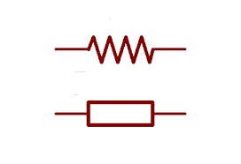
INDUCTOR:
An inductor, also called a coil or reactor, is a passive two-terminal electrical component which resists changes in electric current passing through it. It consists of a conductor such as a wire, usually wound into a coil. When a current flows through it, energy is stored temporarily in a magnetic field in the coil. When the current flowing through an inductor changes, the time-varying magnetic field induces a voltage in the conductor.
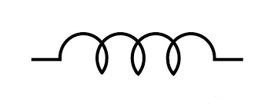

CAPACITOR:
A capacitor is a passive two-terminal electrical component used to store electrical energy temporarily in an electric field. The forms of practical capacitors vary widely, but all contain at least two electrical conductors separated by a dielectric (i.e. an insulator that can store energy by becoming polarized). The conductors can be thin films, foils or sintered beads of metal or conductive electrolyte, etc. The non-conducting dielectric acts to increase the capacitor's charge capacity. Unlike a resistor, an ideal capacitor does not dissipate energy. Instead, a capacitor stores energy in the form of an electrostatic field between its plates.
When there is a potential difference across the conductors (e.g., when a capacitor is attached across a battery), an electric field develops across the dielectric, causing positive charge +Q to collect on one plate and negative charge −Q to collect on the other plate. If a battery has been attached to a capacitor for a sufficient amount of time, no current can flow through the capacitor. However, if a time-varying voltage is applied across the leads of the capacitor, a displacement current can flow.
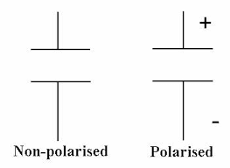

CIRCUIT RESPONSE:
Output response of a circuit is mainly composed of two types.
- Transient response
- Steady state response
TRANSIENT RESPONSE:
In electrical engineering, a transient response or natural response is the response of a system to a change from equilibrium. The transient response is not necessarily tied to "on/off" events but to any event that affects the equilibrium of the system. The impulse response and step response are transient responses to a specific input. It’s a temporary response.

STEADY STATE RESPONSE:
In electronics, steady state is an equilibrium condition of a circuit or network that occurs as the effects of transients are no longer important. It’s a permanent response.
DAMPING:
The response can be classified as one of three types of damping that describes the output in relation to the steady-state response.
- UNDER-DAMPED:
An under-damped response is one that oscillates within a decaying envelope. The more under-damped the system, the more oscillations and longer it takes to reach steady-state. Here damping ratio is always <1.
- CRITICALLY DAMPED:
A critically damped response is the response that reaches the steady-state values the fastest without being under-damped. It is related to critical points in the sense that it straddles the boundary of under-damped and over-damped responses. Here, damping ratio is always equal to one. There should be no oscillation about the steady state value in the ideal case.
- OVER-DAMPED:
An over-damped response is the response that does not oscillate about the steady-state value but takes longer to reach than the critically damped case. Here damping ratio is >1 it is the response of a system with respect to the input as a function of time.

TRANSIENT RESPONSE OF SERIES RC CIRCUIT:
A RLC circuit is an electrical circuit consisting of a resistor (R), an inductor (L), and a capacitor(C), connected in series.
The circuit forms a harmonic oscillator for current, and resonates in a similar way as an LC circuit. Introducing the resistor increases the decay of these oscillations, which is also known as damping. The resistor also reduces the peak resonant frequency. An important property of this circuit is its ability to resonate at a specific frequency, the resonance frequency.
RESONANCE FREQUENCY:
The resonance frequency is defined as the frequency at which the impedance of the circuit is at a minimum. Equivalently, it can be defined as the frequency at which the impedance is purely real (that is, purely resistive). This occurs because the impedances of the inductor and capacitor at resonance are equal but of opposite sign and cancel out.
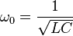

DAMPING RATIO:
The damping ratio is a dimensionless measure describing how oscillations in a system decay after a disturbance.
For series RLC circuit damping ratio is given as;
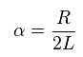
Under damped
<
Critically damped
=
Over damped
>
DAMPED RESONANCE FREQUENCY:

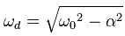

PROCEDURE:
- Open the software and add new file.
- From the tool bar select the desired components. In this experiment resistor, inductor, ground and dc power supply is used.
- Connect all the components with the help of cursor. When the cursor select the terminal a black spot will appear. Hold it by clicking the left mouse button and join it with the required component.
- Now when the circuit is complete go to Circuit>Schematic option>show nodes. This will select the nodes and number it.
- Now go to Analysis>Transient>Set to zero>Add nodes and Accept it.
- Now again select Analysis>Transient and Simulate in dialog box.
- This will display the graph of transient response on a screen. You can edit the title, axis and grid from graph dialog box.

SERIES RLC CIRCUIT:
SCHEMATIC DIAGRAM AND ANALYSIS GRAPH (1):
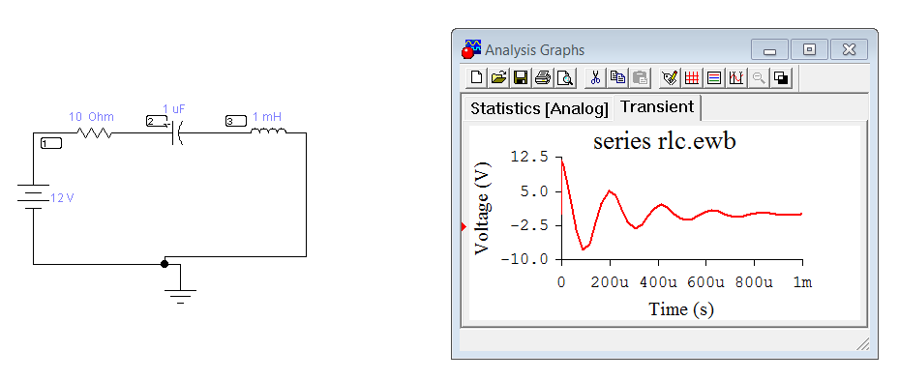

SCHEMATIC DIAGRAM AND ANALYSIS GRAPH (2):

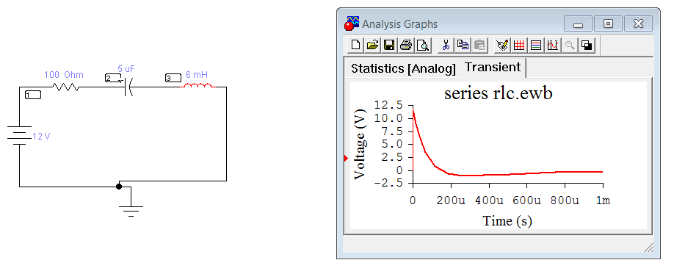
OBSERVATIONS AND CALCULATIONS:

CALCULATE:
=
=
₌
CONCLUSIONS:

LAB TASK:
- Change the value of inductor, capacitor, and resistor and repeat the whole procedure.
- Observe the effect of graph.
- Calculate the α,ω₀ and ω_{d.}

