**Lab:Electrical Network Analysis**

**Week 7**

**Experiment :-** Frequency response analysis of Band stop filter

**Software used:-**Electronic workbench

**Procedure:-**. A band-stop filter or band-rejection filter is a [filter](https://en.wikipedia.org/wiki/Filter_%28signal_processing%29) that passes most [frequencies](https://en.wikipedia.org/wiki/Frequency) unaltered, but [attenuates](https://en.wikipedia.org/wiki/Attenuate) those in a specific range to very low levels. It is the opposite of a [band-pass filter](https://en.wikipedia.org/wiki/Band-pass_filter). A notch filter is a band-stop filter with a narrow [stop band](https://en.wikipedia.org/wiki/Stopband).

**Steps:-**

* Open the software and add new file.
* From the tool bar select the desired components. In this experiment resistor, inductor, ground and dc power supply is used.
* Connect all the components with the help of cursor. When the cursor select the terminal a black spot will appear. Hold it by clicking the left mouse button and join it with the required component.
* Now when the circuit is complete go to Circuit>Schematic option>show nodes. This will select the nodes and number it.
* Now go to Analysis>AC frequency>Add nodes and Accept it.
* Now again select Analysis>AC frequency and Simulate in dialog box.
* This will display the graph of frequency response on a screen. You can edit the title, axis and grid from graph dialog box.

.

After performing this experiment on electronic workbench software students will able to understand the basic concept of band stop filter.

**EXPERIMENT#11**

**FREQUENCY RESPONSE ANALYSIS OF BAND STOP FILTER**

**OBJECTIVE:**

The basic purpose of this lab is to know about the fundamentals of basic component resistor, inductor and capacitor; also when they are connected in parallel what would be the transient response of a circuit.

**THEORY:**

**FILTERS:**

**Filters** are circuits which are used to remove unwanted frequency components from the signal, to enhance wanted ones, or both. [Filters](https://en.wikipedia.org/wiki/Filter_%28signal_processing%29) can be [active](https://en.wikipedia.org/wiki/Active_filter), [high-pass](https://en.wikipedia.org/wiki/High-pass_filter), [low-pass](https://en.wikipedia.org/wiki/Low-pass_filter), [band-pass](https://en.wikipedia.org/wiki/Band-pass_filter), [band-stop](https://en.wikipedia.org/wiki/Band-stop_filter) etc.

**PASSSIVE FILTERS:**

Passive implementations of linear filters are based on combinations of [resistors](https://en.wikipedia.org/wiki/Resistor) (R), [inductors](https://en.wikipedia.org/wiki/Inductor) (L) and [capacitors](https://en.wikipedia.org/wiki/Capacitor) (C). These types are collectively known as *passive filters*, because they do not contain active components such as transistors.

Inductors block high-frequency signals and conduct low-frequency signals, while [capacitors](https://en.wikipedia.org/wiki/Capacitor) do the reverse. [Resistors](https://en.wikipedia.org/wiki/Resistor) on their own have no frequency-selective properties, but are added to inductors and capacitors to determine the *time-constants* of the circuit, and therefore the frequencies to which it responds.

**ACTIVE FILTERS:**

[Active filters](https://en.wikipedia.org/wiki/Active_filter) are implemented using a combination of passive and active (amplifying) components, and require an outside power source. [Operational amplifiers](https://en.wikipedia.org/wiki/Operational_amplifier) are frequently used in active filter designs.

**BAND STOP FILTER:**

A band-stop filter or band-rejection filter is a [filter](https://en.wikipedia.org/wiki/Filter_%28signal_processing%29) that passes most [frequencies](https://en.wikipedia.org/wiki/Frequency) unaltered, but [attenuates](https://en.wikipedia.org/wiki/Attenuate) those in a specific range to very low levels. It is the opposite of a [band-pass filter](https://en.wikipedia.org/wiki/Band-pass_filter). A notch filter is a band-stop filter with a narrow [stop band](https://en.wikipedia.org/wiki/Stopband) (high [Q factor](https://en.wikipedia.org/wiki/Q_factor))

**CUTOFF FREQUENCY:**

Cutoff frequency applies to an edge in a [low pass](https://en.wikipedia.org/wiki/Lowpass), [high pass](https://en.wikipedia.org/wiki/Highpass), [band pass](https://en.wikipedia.org/wiki/Bandpass), or [band-stop](https://en.wikipedia.org/wiki/Band-stop) characteristic .A frequency characterizing a boundary between a pass band and a stop band.
\omega_\mathrm{c} = {1 \over \tau} = {1 \over R C}


**PROCEDURE:**

* Open the software and add new file.
* From the tool bar select the desired components. In this experiment resistor, inductor, ground and dc power supply is used.
* Connect all the components with the help of cursor. When the cursor select the terminal a black spot will appear. Hold it by clicking the left mouse button and join it with the required component.
* Now when the circuit is complete go to Circuit>Schematic option>show nodes. This will select the nodes and number it.
* Now go to Analysis>AC frequency>Add nodes and Accept it.
* Now again select Analysis>AC frequency and Simulate in dialog box.
* This will display the graph of frequency response on a screen. You can edit the title, axis and grid from graph dialog box.

**BAND STOP FILTER:**

**SCHEMATIC DIAGRAM AND ANALYSIS GRAPH (1):**

**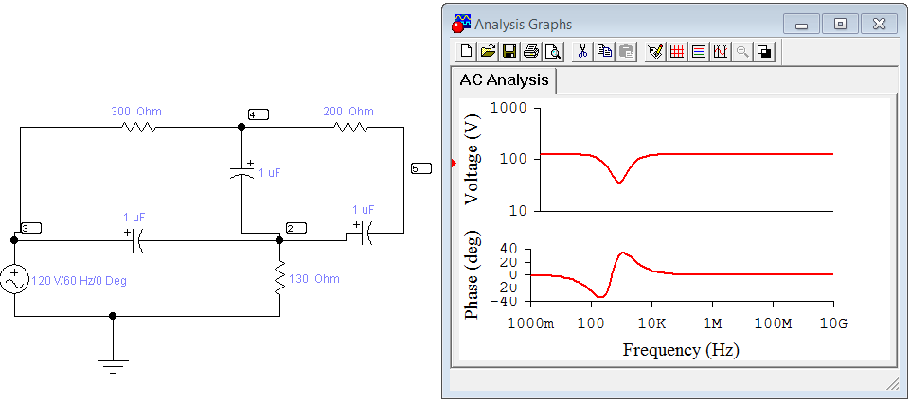**

**OBSERVATIONS AND CALCULATIONS:**

**CALCULATE:**

**FC1=**

**FC2=**

**CONCLUSIONS:**

**LAB TASK:**

* **Change the value of capacitor and resistor and repeat the whole procedure.**
* **Observe the effect of graph.**
* **Calculate the FC1 and FC2.**

.