Geotechnical lab

Experiment No.12
Standard test method to determine moisture content of a given soil by speedy moisture test.
Apparatus
- Speedy moisture test kit which includes balance, speedy moisture content meter
- Measuring spoon
- Steel balls
- Speedy absorbable weight
- Small brush
Procedure
- Set up apparatus in kit. Clean the cap and body moisture meter with brush.
- Place three measure of speedy absorbent into body of moisture meter and also two steel balls.
- Weight 26 grams of soil testing (the scale is calibrated to balance at exactly 26gm) and place sample to be tested in cap of meter.
- With meter in horizontal position put cap of meter.
- Tip speedy meter to vertical position so absorbent contacts the soil, then return it to the horizontal position. Holding it with both hands, begin a circular motion so that balls are put into orbit inside the meter. Rotate for 10second- rest for 20 second.
- Repeat the rotate rest cycle until dial remains steady (usually about 3 minutes). Hold meter in horizontal position and read dial when it comes to rest.
- Then reading on the dial is the moisture content based on the wet-weight of soil. Convert it to the dry-weight basis with formula.

Observation and calculation
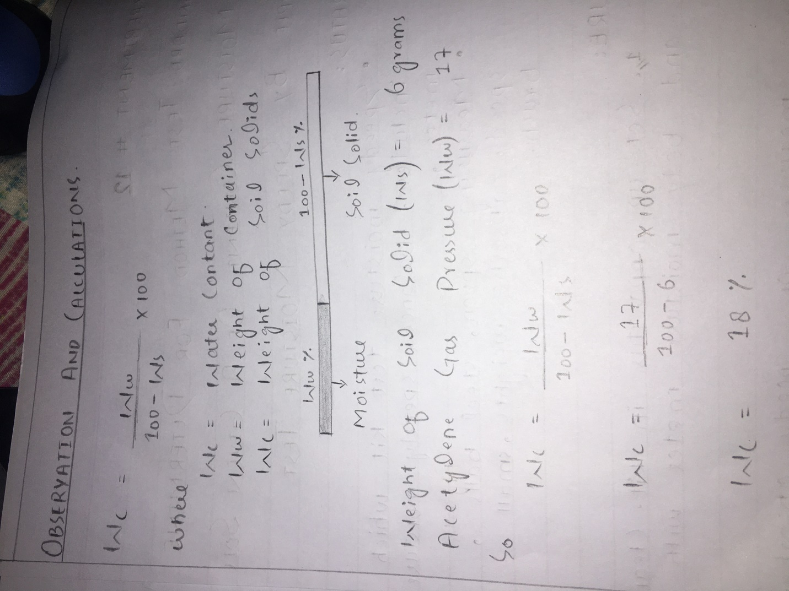
https://www.youtube.com/watch?v=VUeXHPM1w4c

