Bearing Stress

Bearing stress is the contact pressure between the separate bodies. It differs from compressive stress, as it is an internal stress caused by compressive forces.
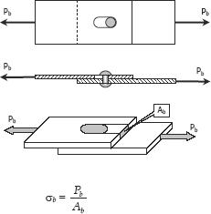

SOLVED PROBLEMS IN BEARING STRESS

Problem 125

In Fig. 1-12, assume that a 20-mm-diameter rivet joins the plates that are each 110

- wide. The allowable stresses are 120 MPa for bearing in the plate material and 60 MPa for shearing of rivet. Determine (a) the minimum thickness of each plate; and (b) the largest average tensile stress in the plates.
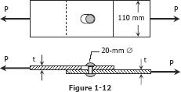

Solution 125
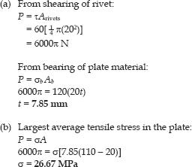

Problem 126

The lap joint shown in Fig. P-126 is fastened by four ¾-in.-diameter rivets. Calculate the maximum safe load P that can be applied if the shearing stress in the rivets is limited to 14 ksi and the bearing stress in the plates is limited to 18 ksi. Assume the applied load is uniformly distributed among the four rivets.
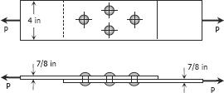

Solution 126
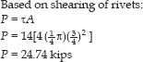
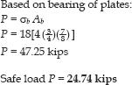

Problem 127

In the clevis shown in Fig. 1-11b, find the minimum bolt diameter and the minimum thickness of each yoke that will support a load P = 14 kips without exceeding a shearing stress of 12 ksi and a bearing stress of 20 ksi.
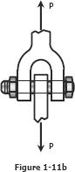

Solution 127
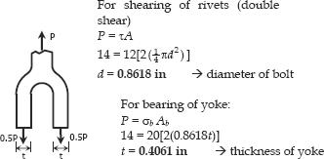

Problem 128

A W18 × 86 beam is riveted to a W24 × 117 girder by a connection similar to that in Fig. 1-13. The diameter of the rivets is 7/8 in., and the angles are each 4 × 31/2 × 3/8 in. For each rivet, assume that the allowable stresses are τ = 15 ksi and σ_{b} = 32 ksi. Find the allowable

load on the connection.
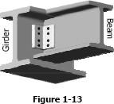

Solution 128

Note: Textbook is Strength of Materials 4th edition by Pytel and Singer
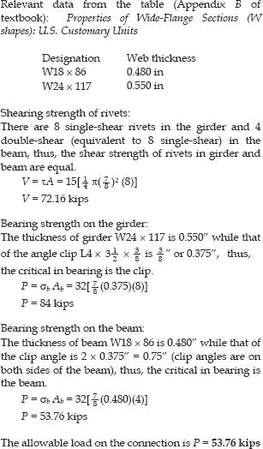

Problem 129

A 7/8-in.-diameter bolt, having a diameter at the root of the threads of 0.731 in., is used to fasten two timbers together as shown in Fig. P-129. The nut is tightened to cause a tensile stress of 18 ksi in the bolt. Compute the shearing stress in the head of the bolt and in the threads. Also, determine the outside diameter of the washers if their inside diameter is 9/8 in. and the bearing stress is limited to 800 psi.
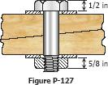

Solution 129
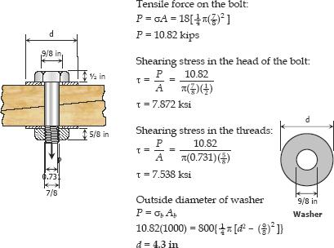

Problem 130

Figure P-130 shows a roof truss and the detail of the riveted connection at joint B. Using allowable stresses of τ = 70 MPa and σ_{b}= 140 MPa, how many 19-mm diameter rivets are required to fasten member BC to the gusset plate? Member BE? What is the largest average tensile or compressive stress in BC and BE?
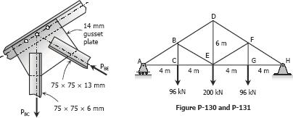

Solution 130
