DEAR STUDENTS! This is further reading in intercultural communication. It is about intercultural adaptation, the competence and adjustments it requires and the strategies essential for its effectiveness. Earlier to this we discussed culture and communication and the mutual relations between the two, as well as levels of cultures. Let me remind you the levels of cultures as they are very important to be understood, in order to grasp intercultural adaptability.
Any culture has two levels….the surface or objective level; and, deep or subjective level.
We use surface culture, also called objective culture, to describe the tangible aspects of culture, such as people, buildings, artefacts, art, dances, music, songs, food, dress, language, behaviour, actions and gestures.
The deep culture, also called subjective culture, refers to the intangible aspects of culture, such as feelings, emotions, values and attitudes. The deep culture is hidden and difficult to see at the surface level and yet it is what primarily determines how the people behave and communicate with each other, and how we interpret our experiences.
Try to understand this excerpt below………………………………………………………………..
“Culture shapes our communication behaviour and communication in turn shapes culture. They are mutually inclusive and interrelated. Intercultural communication is therefore anchored on the interface or conjuncture of culture and communication. Therefore, it is important to understand the basic theories and concepts of both culture and com- munication. Communication and culture are both extremely complex because we are both similar and different. We are similar because as human beings, we share certain universal values and beliefs. People in one culture share most of the values and beliefs of that culture. However, people from other cultures do not have much in common in their cultural values and assumptions. Cultural disparities arise from differences in values, perceptions, norms and expectations. These cultural differences may cause com- munication barriers when we receive, process and interpret the message being sent. Many factors can affect our interpretation and negotiation of the meaning, such as an individual’s cultural knowledge, language and communication skills, experience and contexts. Some traits such as stereotypes, prejudice and ethnocentrism can blind our eyes and prevent us from successful intercultural communication. To communicate ef- fectively with people from other groups or cultures, not only do we need to be aware of the dark side of these traits, but we also need to take proactive actions to avoid them or to reduce their negative impact. Cultures are presented at both surface and deep levels. Just like the two sides of a coin, they coexist. The deep culture requires the surface presentation and the surface culture is a manifestation of the meanings of the deep culture. Understanding the deep culture, however, requires efforts and constant learning. All cultures use symbols to communicate with the members of their cultures or other cultures. The meanings of symbols can be learned, shared and transmitted. The most important cultural symbol is language. Symbols that are deemed important to one culture may not make any sense to other cultures. Understanding symbolic representations of a culture, verbal or nor-verbal or graphic, helps us to understand the deep root of that culture. Intercultural communication involves interaction with people from different cultural backgrounds. The cultural flow in the form of migration, media, finance, technology and ideology has quickened the pace of globalization. The process of globalization is therefore forcing us as global citizens to rethink our intercultural communication strategies to bridge cultural differences and address our common concerns by building a global community.”

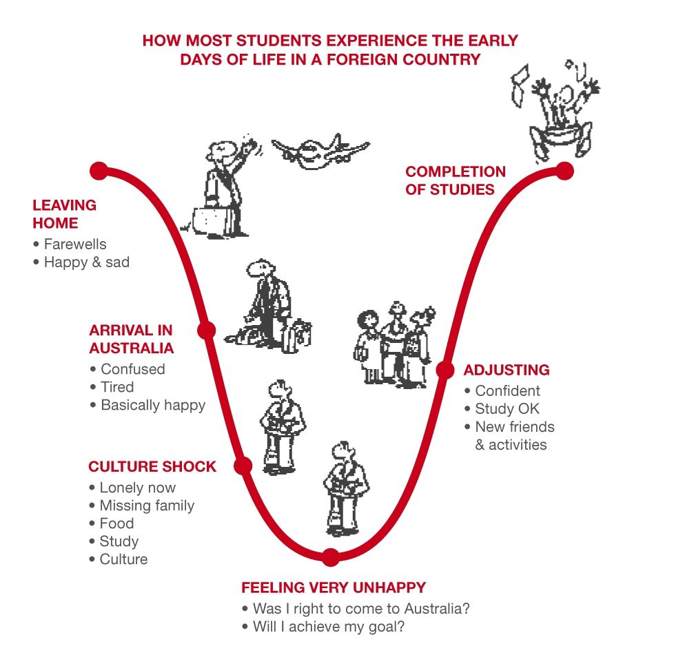
INTERCULTURAL ADAPTATION

- The Intercultural Adaptation describes how one person adjusts their communication with persons perceived to be from a different culture based on previous experiences. The model describes the adaptation process during initial cross-cultural encounters between individuals.
- It is concerned with demonstrating how persons may or may not achieve understanding during initial intercultural encounters.
- Researchers interested in cross-cultural adaptation have examined the psychological phases people go through when entering a foreign culture, the traits that contribute to adjustment in a new culture, and the process of becoming an intercultural or bi-cultural individual
- For example, a person goes through a process of stress and adaptation that leads to growth in intercultural communication skills over time.
- most persons in most situations adapt to the stress of cultural differences.
- We can define intercultural adaptation as the process through which persons in cross-cultural interactions change their communicative behavior to facilitate understanding.
intercultural adaptation refers to the adjustment of communicative behavior to decrease the probability of being misunderstood when speaking with someone from a different culture.
INTERCULTURAL COMPETENCE
- Intercultural Competence means that you have the ability to analyse the situation and select the appropriate mode of behavior
- appropriateness and effectiveness are important aspects of intercultural competence
- Klyukanov (2005) identifies three important components of inter- cultural communication competence:
- cognitive (thought/knowledge);
- affective (emotional/attitude) and
- behavioural (action).
- To be inter- culturally competent and to ensure the appropriate and effective man- agement of any intercultural communication encounter, all three components will have to be adequately satisfied.
- Many of the problems in intercultural communication arise out of inadequate and inaccurate information and ignorance about diverse cultures.
INTERCULTURAL ENCOUNTERS
- a cross-cultural encounter as one composed of two individuals who enact significantly different communicative behavior based on social norms that derive from groups which possess unique sets of values and beliefs (cultures).
- We contend that intercultural adaptation is a particular type of communicative adjustment that occurs in cross-cultural encounters. We acknowledge that adaptation can occur in conversations between persons of the same culture.
- However, adaptation that occurs between persons of different cultural backgrounds is likely to require more severe or extreme adjustment to reduce miscommunication than adaptation in conversations between individuals of similar cultures.
STRATEGIES
- convergence is used to improve communication clarity and comprehension
- “interpretability strategies” such as simplifying syntax (Grammar), decreasing the diversity of vocabulary, and changing pitch and loudness, are used to improve clarity.
- if persons believe that their conversational partner is a non-native speaker of their language, then they are more likely to adapt their message earlier in the interaction rather than later
CONCLUSION
Samovar and Porter (2004: 23) claim that ‘successful intercultural communication appreciates similarities and accepts differences’. Are we ready to shift our focus from differences to similarities and from negative to more favourable notions of cross-cultural encounters that enhance intercultural communication and view it as an enriching ex- perience? Building strong cultural communities globally, based on an understanding and respect for the deep institutions of culture that are the fundamental pillars of intercultural communication, requires com- mitment from all participating cultures. Dominance and subjugation of cultures cannot be part of that relationship among cultures. Cooper, Calloway-Thomas and Simonds (2007: 87) contend that ‘in the twenty- first century we must search for a way out of the limiting and confining aspects of cultural identity’. This should become our goal in building global communities that can flourish within creative and open spaces in which they will build new shared and negotiated identities based on mutual respect.

