Art History

Sculpture
- Sculpted portraits of pharaohs are meant to impress and overwhelm
- Limestone is the primary stone used for sculpting aside from gypsum and sand stone
- Wood sculptures are painted
- Copper and iron are also used in sculpture
- Megalith structure like the Great Sphinx are carved on site from the local available rock
- Sphinx is God of Sun 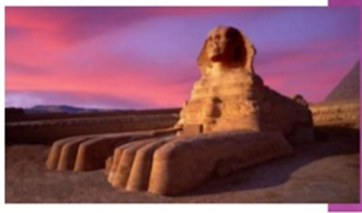

Relief Sculptures
- Relief sculptures follow the Canon of proportion
- When carved outdoors they are done Sunken Relief to dramatically create shadows and make the work visible
- When carved indoors reliefs are done either bas Relief or Mezzo Relievo

- Narmer Palette, 3000-2929 BC Relief sculpture depicting King Narmer uniting upper and lower Egypt
- The Narmer palette is the earliest artifact depicting an Egyptian King wearing the crowns of both upper and Lower Egypt. It commemorates king Narmer’s victory over Lower Egypt and the subsequent union of upper and lower Egypt
- Hieroglyphics explain and adding meaning to the Narrative
- A palette is used to prepare make-up
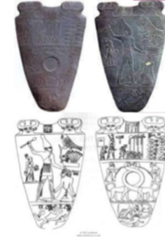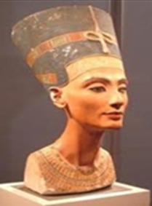
- Size of the figure signifies rank
- Statues made of granite and diorite
- Nefertiti (Queen of Egypt)
- Located at Berlin’s Egyptian museum
Hieroglyphics
- Holy Carvings
- Displayed on pyramids and tombs of the royalty.
- Pictures they used to represent words came to represent sounds
The Rosetta Stone
Contain three types of text:
- Hieroglyphics: Used for important and religious documents
- Egyptian writing (demotic): Used by most people in Egypt at that time
- Greek writing: Used by the rulers

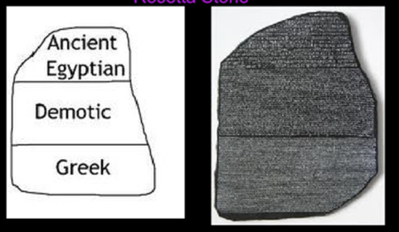

- Papyrus, from which we get the modern word paper, is a writing material made from the papyrus plant, a reed which grows in the marshy areas around the Nile River.
- In ancient Egypt, the wild plant was used for a variety of uses, and specially cultivated papyrus, grown on plantations, was used to make the writing material. The inside of the triangular stalk was cut or peeled into long strips
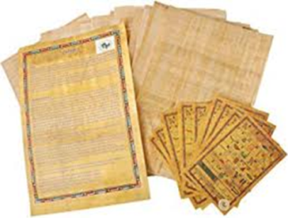
Mummy Cases
- Carefully carved
- Colorfully decorated
- Hieroglyphics
- Pictures of Gods
- Even insides were decorated
- Made in Layers
- Once complete the body was placed in a Sarcophagus (coffin)
- King Tutankhamen’s tomb is the only one in near original condition.
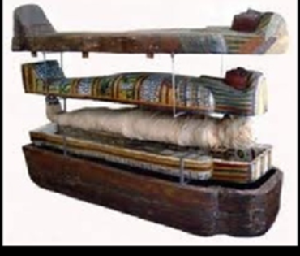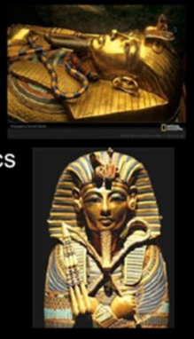
Painting
- Most Egyptian Art is a picture of contentment and stability that shows successful man and woman in a calm and rational manner
- Made use of a canon of proportion ( a precise measurement of a body) that allows little individuality
- Shoulders are seen frontally, while the rest of the body, except the eye, is turned profile. Often heads face one direction while legs face another.
- Red, the color of power symbolized life and victory as wel as anger and fire.
- Green, symbolized new life, growth and fertility
- Blue, symbolized creation of rebirth
- Yellow, symbolized the eternal, such as the qualities of the sun and gold
- White was the color of purity, symbolized all things sacred, and was typically used in religious objects and tool used by the priests
- Black was the color of death and represented the underworld and the night
Men are painted ruddy brown or red; Women painted lighter with yellowish tinge and Shading is rare
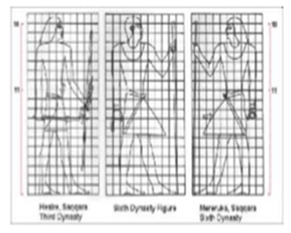
Judgement before Osiris(1290-1280 BC), papyrus
- Illustration of the Book of the Dead, an Egyptian book of spell and charm
- Anubis, god of embalming
- Thoth, god who invented hieroglyphics
- Osiris, god of the underworld seated on the throne

