Art History
Ancient Greek Art
The aim of Greek art was to express true ideals. To do this, the Greeks used balance, harmony, and symmetry in their art. A major branch of Greek art was sculpture. Greek sculptors did not create realistic works, but instead made statues that reflected what they considered ideal beauty.

The art of ancient Greece is usually divided stylistically into four periods: the Geometric and Oriental, Archaic, Classical, and Hellenistic. The Geometric age is usually dated from about 1000 BC, although in reality little is known about art in Greece during the preceding 200 years, traditionally known as the Greek Dark Ages.

Major Three Periods of Ancient Greek Art:
The Archaic, the Classical, and the Hellenistic

Geometric period:
Geometric art is a phase of Greek art, characterized largely by geometric motifs in vase painting, which flourished towards the end of the Greek Dark Ages, circa 900 BC – 700 BC. Its center was in Athens, and from there the style spread among the trading cities of the Aegean.
- Characterized by geometric motifs in vase painting
- Centered in Athens
- 900 to 700 BC
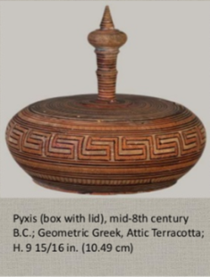

Features:
- Several horizontal bands
- In between: zigzag, triangle, meander, swastika
- Funerary objects
- Amphora, grave markers for the aristocrats
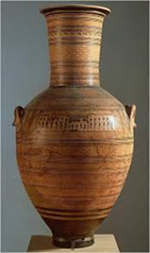 (Dypilon amphora, 760-750BC,figure in mourning gestures)

Orientalizing period:
- 700 to 600 BC
- Trade with foreign cultures: Asia Minor, Egypt, Ancient Near East
- New artistic conventions
- Combines Near Eastern and Egyptian motifs

Features:
- Black figure painting
- Inclusion of exotic and mythical animals
- Lions, griffins, sphinxes
- Human figures were rare
(Pitcher featuring exotic animals)
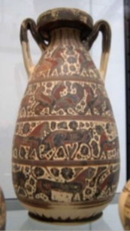 (Corinthian black figure jug with animal frieze, 580 BC)

- Daedalic sculpture
- From Daedalus, the creator of King Minos labyrinth
- Rigidity
- Pharaonic portraiture
- Near Eastern texture(hair)
(Lady of Auxxere)
Archaic Period
- 600-480 BC
- Expansion of Greek culture
- Rise in population
- Colonies along the Mediterranean and Black Sea
- Major powers: Athens, Corinth, Sparta, Thebes
Features:
- First stone temples
- Ideal temple design: naos, pronaos, peripteral colonnade
- Doric order: oldest Greek type of architecture
- Columns and frieze
(Temple of Hera II and Temple of Hera I, Paestum, Italy.
460and 550 BC)

- Dedicatory male kouroi figures (based on Egyptian statues)
- Sculptures become more naturalistic
- Female korai – draped which is the ideal, modest and clothed
- Archaic smile
- Pedimental sculpture
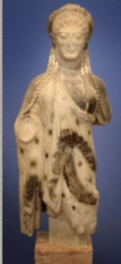 (Kore, wearing chiton, hamation Marble, Athens, 520-510 BC)

- Reconstruction of the paint on peplos kore
- Peplos: ancient Greek garment made of tubular piece of cloth
- As memorials, votive offerings, or grave markers replacing amphora and kraters

