Lab:Electronic Circuit Design
Week 1
Experiment :- Practical analysis of precision half wave rectifier using multisim software
Software used:-Multisim 11.0
Procedure:-Half wave rectifier is a device that converts AC signal in to half wave pulsating DC signal. During positive half cycle diode act as a short circuit because positive terminal of voltage is connected with anode of diode. During negative half cycle diode acts like an open circuit because negative terminal of source is connected with anode of a diode. The output is observed in oscilloscope.
Steps:-
(1)Right click on the breadboard and select place components. Then select all groups.
(2)Select Op-amp and in Op-amp section select 741.
(3)Click on place components and then select sources and in sources section select ground.
(4)For resistors select basics and then select resistor and give desired value.
(5)Select function generator for source and drag it on breadboard.
(6)The positive pin of the operational amplifier should be connected with function generator.
(7)Connect the oscilloscope with the circuit and check the desired output.

After performing this experiment on multisim software students will be able to understand the basic concept of half wave rectifier. They will understand that any positive voltage at the op-amp positive terminal is now sufficient to turn on the diode.

LAB NO: 11
“Practical analysis of precision half wave rectifier”

Objective:
________________________________________________________________________________________________________
Apparatus:
- OP-Amp UA 741CP
- Resistors
- DC Power supplies
- Function generator
- Oscilloscope
- Breadboard
- Diode
Theory:
Half wave rectifier is device that convert A.C signal into half wave pulsating D.C signal. During positive half cycle, Diode acts like a short circuit because positive terminal of voltage is connected with anode of diode. So output will be equal to input voltage. During negative half cycle, Diode acts like an open circuit because negative terminal of source is connected with anode of diode. So output will be equal to zero. The basic idea behind the super diode is to use the high gain of op-amp to mask the finite turn-on voltage of the diode. Any positive voltage at the op-amp positive terminal is now sufficient to turn on the diode.
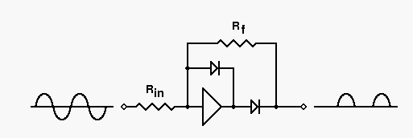

Circuit Diagram:
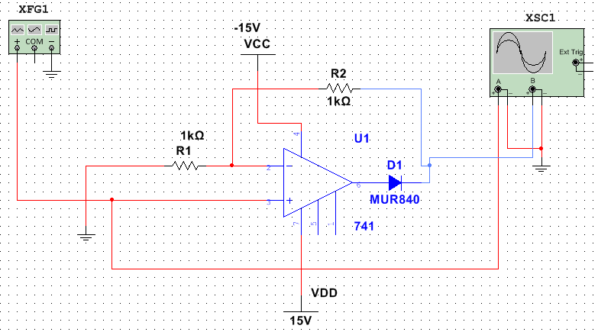
Procedure:
________________________________________________________________________________________________________________________________________________________________________________________________________________________________________________________________________________________________________________________________________________________________________________________________________________________________________________________________________________________________________________________________________

