Department of Electrical Engineering
Final-Assignment
Date: 23/06/2020
Course Details

Course Title: | Antennas & Wave Propagation | Module:
Instructor: |  | Total Marks: | 50

Student Details
Name: |  | Student ID:

Q1. | (a) | 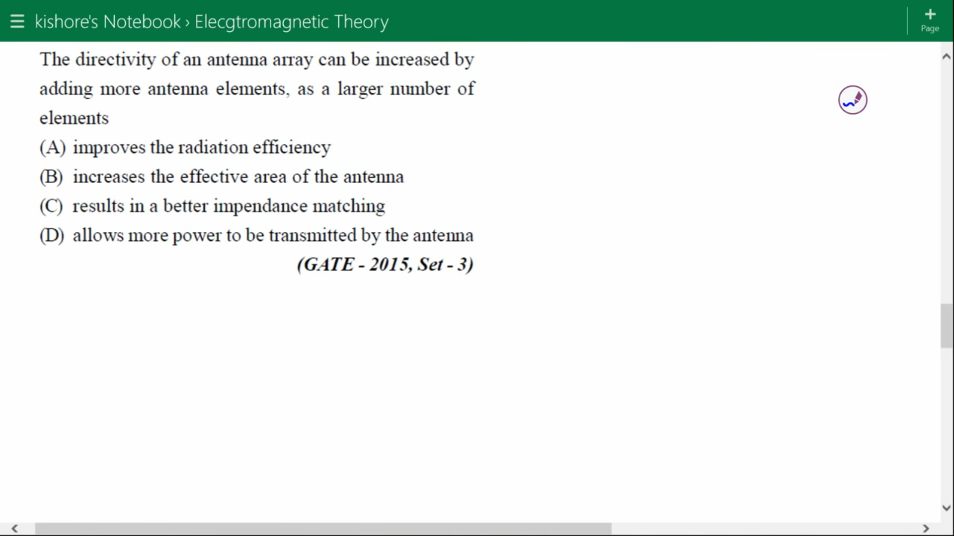 | Marks 5
 |  |  | CLO 2
 | (b) | Radiation resistance of an antenna is 90 ohms & loss resistance is 30 ohms. calculate antenna radiation efficiency? | Marks 5
 |  |  | CLO 1
Q2. | (a) | An antenna has a loss resistance of 40 ohms, power gain of 60, and directivity 13. Calculate the radiation resistance | Marks 4
 |  |  | CLO 3
 | (b) | Explain Scattering Parameter and VSWR? | Marks 6
 |  |  | CLO 2
Q3. | (a) | Briefly explain Ground wave propagation, sky wave propagation & space wave propagation? | Marks 4
 |  |  | CLO 1
 | (b) | What is Effective aperture, Reciprocity and FNBW? | Marks 6
 |  |  | CLO 2
Q4. |  | Explain the design and working principle of MPA (Micro strip patch Antenna) and discuss four feeding methods of MPA | Marks 15  CLO 3
Q5. |  | 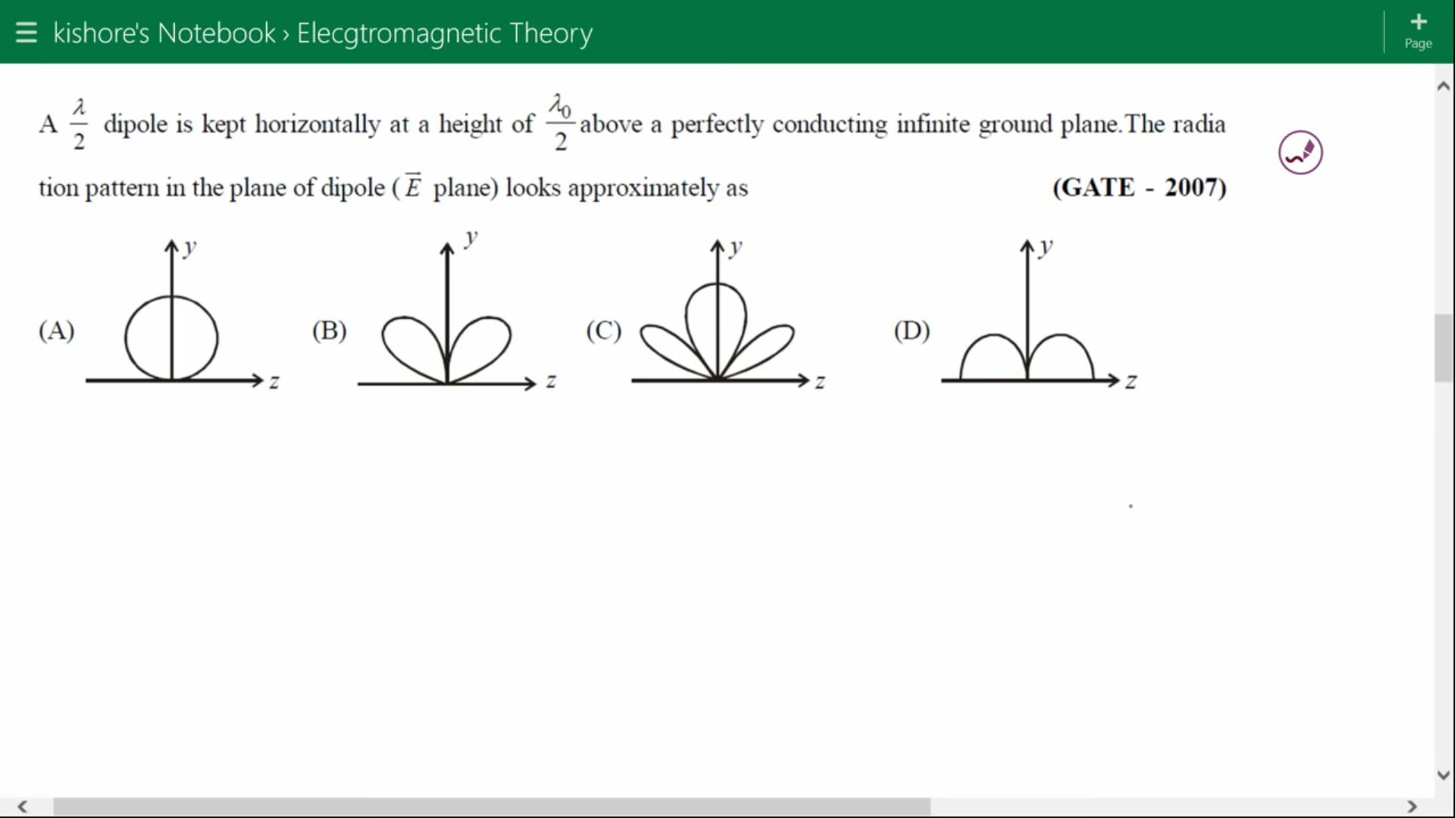 | Marks 05  CLO 2

