**Instructor: Rashid Aleem**

**Paper: Electrical Network Analysis**

**Time : 4 Hours**

**Note:**

1. **Attempt all questions.**
2. **Assume missing details if required.**
3. **Draw neat diagrams where required.**

**Q1:** **Find the current in R in following fig .using the superposition theorem. Assume the internal impedence source zero**. **(10)**



**Q2:** **Determine Vth for the circuit external to RL in Figure . The beige area identifies the portion of the circuit to be thevenized.. (10)**



**Q3:** **The circuit to the left of terminals A and B in Figure provides power to the load ZL. This can be viewed as simulating a power amplifier delivering power to a complex load. It is the Thevenin equivalent of a more complex circuit. Calculate and plot a graph of the power delivered to the load for each of the following frequencies:10 kHz, 30 kHz, 50 kHz, 80 kHz, and 100 kHz.?(10)** 

**Q4: Using Thevenin’s and Norton’s theorem, find the currents in 8 Ω resistor in the figure Shown below.** **(10)**

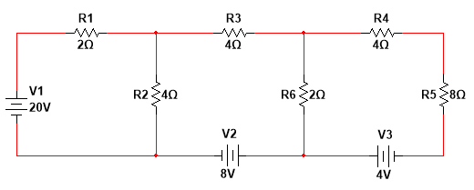

**Q5) Solve the following example by nodal analaysis.Write all the general steps?(10)**

