Assignment/Quiz (June/2020)
Subject: Construction Management Instructor: Dr .engr. Muhammad Zeeshan Ahad
Pages: 1 Duration: 6hours

- You have a team of project managers reporting to you. Recently a new manager relatively inexperienced has joined your team. Considering his level of experience you assign him to a small project. Considering low complexity and few stakeholders involved - you envision the project to have no surprises or hiccups. You have identified the number of communication channels to be only 6.However with increase in scope of work 2 additional stakeholders who need to be communicated with join the team. You ask the manager to identify the number of communication channels now?

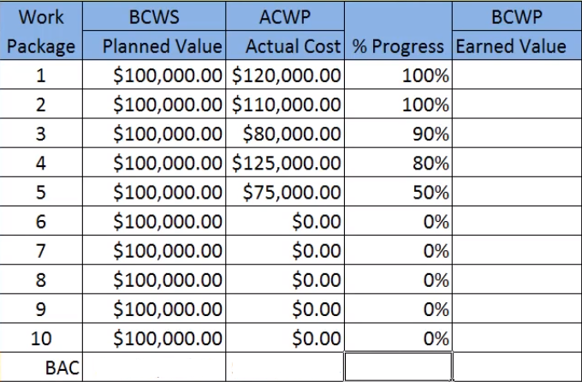
- If you have a project of 10 packages for each package planned value, Actual cost and percentage of completion is given. Calculate the earned value, cost variance, schedule variance, cost performance index and schedule performance index? (Comment if the project is ahead/behind schedule or over/under budget).

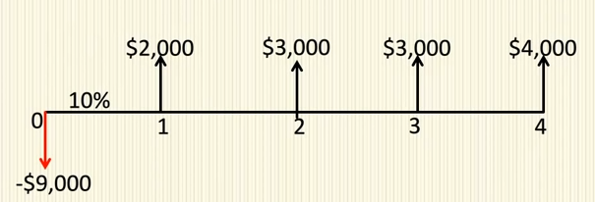
- A Company is planning to invest 9000$ in a project today. The project is expected to have life of four years. The expected cash flow for next four years is shown and the discount rate is 10%. Calculate Net present value (NPV) and comment on the result?

- Being a Project Manager, how would you identify the stake holders by power/interest Matrix?

- For a project of residential house what are the different stages to be considered in the risk management checklist?

