Studio Techniques 1

Coiling/ Quilling Technique
- First select image for this technique (Landscapes, still life painting , portrait)
- Materials you need for this assignment is scholar sheet or sketch book paper A3 size, use colored papers or sheets, glue, tool for making coil.
- In coiling technique cut stripes from colored sheets or paper (stripe width half cm and length of stripe is dependent on size of a coil you make.
- Size of coil is depending on area of your image (if area is narrow then make thin coil or if area is broad then make thick size of coil).
- To create values in image use light and dark color tones of colored sheets of same color to show 3D effect in your image.
Example:
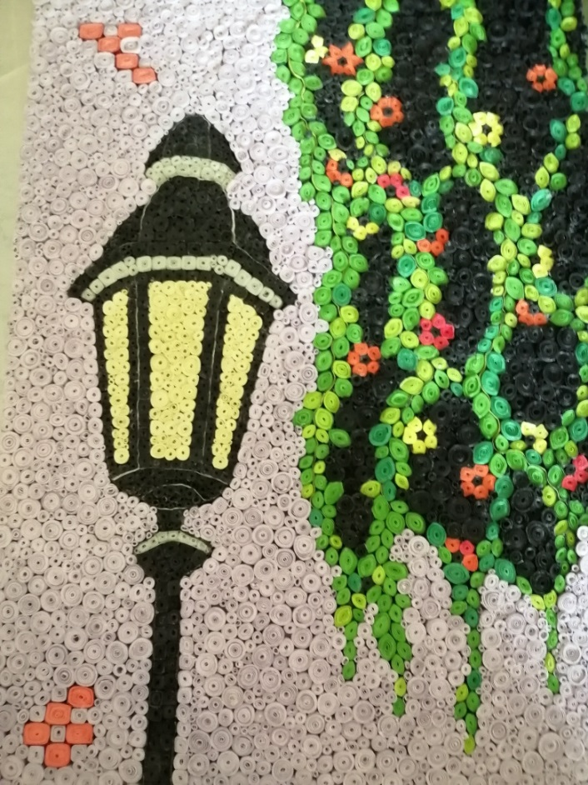

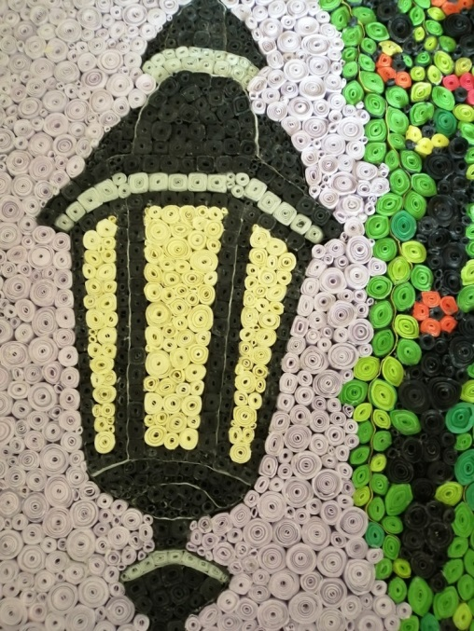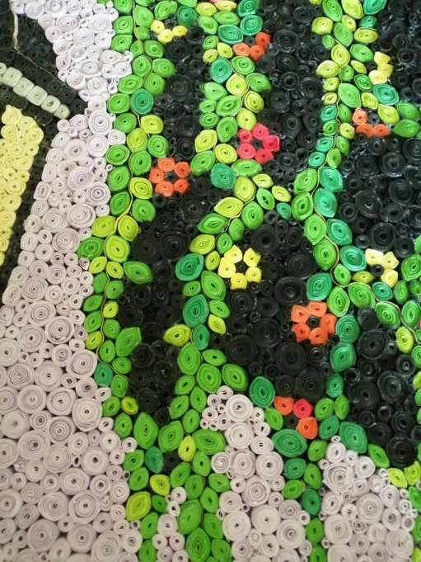

- See different images on net which are done through in this technique so it will be easy for you to get an idea.
- Kindly work on this task with proper concentration.

