Balance Sheet
The balance sheet, also called the statement of financial position, prepared during the accounting cycle. It reports a company's assets, liabilities, and equity at a single moment in time. You can think of it like a snapshot of what the business looked like on that day in time.
The balance sheet is essentially a picture a company's recourses, debts, and ownership on a given day.
The balance sheet is basically a report version of the accounting equation also called the balance sheet equation where assets always equation liabilities plus shareholder's equity.

Format
This statement can be reported in two different formats: account form and report form. The account form consists of two columns displaying assets on the left column of the report and liabilities and equity on the right column.
The report form, on the other hand, only has one column. This form is more of a traditional report that is issued by companies. Assets are always present first followed by liabilities and equity.
In both formats, assets are categorized into current and long-term assets. Current assets consist of resources that will be used in the current year, while long-term assets are resources lasting longer than one year.
Liabilities are also separated into current and long-term categories.
Let's look at each of the balance sheet accounts and how they are reported.

Asset Section
Similar to the accounting equation, assets are always listed first. The asset section is organized from current to non-current and broken down into two or three subcategories. This structure helps investors and creditors see what assets the company is investing in, being sold, and remain unchanged. It also helps with financial ratio analysis.
The first subcategory lists the current assets in order of their liquidity. Here’s a list of the most common accounts in the current section:
- Current
- Cash
- Accounts Receivable
- Prepaid Expenses
- Inventory
- Due from Affiliates

The second subcategory lists the long-term assets. This section is slightly different than the current section because many long-term assets are depreciated over time. Thus, the assets are typically listed with a total accumulated depreciation amount subtracted from them. Here’s a list of the most common long-term accounts in this section:
- Long-term
- Equipment
- Leasehold Improvements
- Buildings
- Vehicles
- Long-term Notes Receivable

Many times there will be a third subcategory for investments, intangible assets, and or property that doesn’t fit into the first two. Here are some examples of these balance sheet items:
- Other
- Investments
- Goodwill
- Trademarks
- Mineral Rights

Liabilities Section
Liabilities are also reported in multiple subcategories. There are typically two or three different liability subcategories in the liabilities section: current, long-term, and owner debt.
The current liabilities section is always reported first and includes debt and other obligations that will become due in the current period. This usually includes trade debt and short-term loans, but it can also include the portion of long-term loans that are due in the current period. The current debts are always listed by due dates starting with accounts payable. Here’s a list of the most common current liabilities in order of how they appear:
- Current Liabilities
- Accounts Payable
- Accrued Expenses
- Unearned Revenue
- Lines of Credit
- Current Portion of Long-term Debt

The second liabilities section lists the obligations that will become due in more than one year. Often times all of the long-term debt is simply grouped into one general listing, but it can be listed in detail. Here are some examples:
- Long-term Liabilities
- Mortgage Payable
- Notes Payable
- Loans Payable

Equity Section
Unlike the asset and liability sections, the equity section changes depending on the type of entity. For example, corporations list the common stock, preferred stock, retained earnings, and treasury stock. Partnerships list the members’ capital and sole proprietorships list the owner’s capital.
Like all financial statements, the balance sheet has a heading that display's the company name, title of the statement and the time period of the report. For example,
- Paul's Guitar Shop, Inc.
- Balance Sheet
- December 31, 2015

Example
Here is an example of how to prepare the balance sheet from our unadjusted trial balance and financial statements used in the accounting cycle examples for Paul's Guitar Shop.

Account Format Balance Sheet

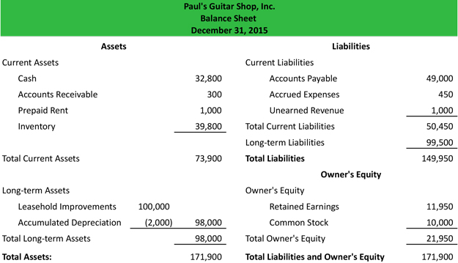

Report Format Balance Sheet

