Department of Electrical Engineering
Mid – Term Assignment Spring 2020
Date: 20/04/2020
Course Details

Course Title: | Advance Computer Networks | Module:
Instructor: |  | Total Marks: | 30

Student Details
Name: |  | Student ID:

Q1. | (a) | - A color image uses 16 bits to represent a pixel. What is the maximum number of different colors that can be represented?  - Assume six devices are arranged in a mesh topology. How many cables are needed? How many ports are needed for each device?  - For each of the following four networks, discuss the consequences if a connection fails.  a. Five devices arranged in a mesh topology  b. Five devices arranged in a star topology (not counting the hub)  c. Five devices arranged in a bus topology  d. Five devices arranged in a ring topology  - Performance is inversely related to delay. When you use the Internet, which of the following applications are more sensitive to delay?  a. Sending an e-mail  b. Copying a file  c. Surfing the Internet  - Match the following to one or more layers of the OSI model:  a. Route determination  b. Flow control  c. Interface to transmission media  d. Provides access for the end user | Marks 15
Q2. | (a) | In the following Figure, computer A sends a message to computer D via LANl, router Rl, and LAN2. Show the contents of the packets and frames at the network and data link layer for each hop interface.  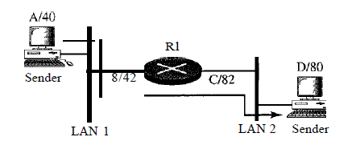 | Marks 05
 | (b) | In the above Figure, assume that the communication is between a process running at computer A with port address i and a process running at computer D with port address j. Show the contents of packets and frames at the network, data link, and transport layer for each hop. | Marks 05
Q3. | (a) | Dialog control and synchronization are two responsibilities of the session layer in the OSI model. Which layer do you think is responsible for these duties in the Internet model? Explain your answer. | Marks 05

