EXPERIMENT

1. Objective 2. Apparatus Used 3. Theory 4. Specifications 5. Procedure 6. Observation & Calculations
_____________________________________________________________________________________

1. Objective

To determine modulus of rigidity of given material by digital torsion testing machine.

2. Apparatus Used

Digital torsion testing machine, desired chucks, shafts of different materials.

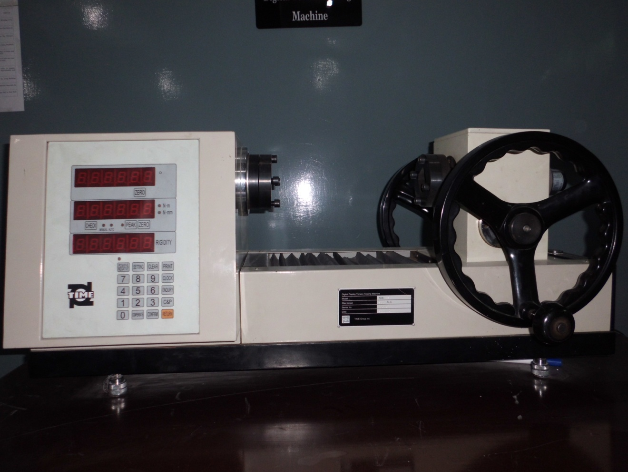

3. Theory

Torsion is the shear produced by rotation or by a torque. In this type of shear,one layer of a material is made to rotate on an adjection layer. This type of shear is present in rotating shafts when transmitting power.In torsion test, equal and opposing moments are applied at opposing ends of a suitable specimen in planes perpendicular to its longitudinal axis. Observation of applied torque and corresponding twist or rotation is used to determine modulus of rupture, modulus of rigidity and angle of twist of given material.
Torsion formula is used for determining Modulus of Rigidity of given material.
T / J = G Ө/ L = = τ /r
T = Torsion lb.-in
J = Polar moment of inertia in4
τ = Shear stress .Psi.
G = Modulus of rigidity. Psi.
Ө = Angle of twist. Rad.
L = Length of shaft in..
r = Radius of shaft in..
The assumptions that are made for the formulation of torsion formula are as under :
- The shaft is straight & of uniform cross section.
- The torque is constant along the length of shaft.
- Cross sections which are plane before twisting remain plane during twisting.
- Induced stresses don’t exceed limit proportionality.
Modulus of Rigidity is defined as, “The relationship between shearing stress & shearing strain.”

4. Specifications Of Mechanical Torsion Testing Machines

The mechanical torsion Tester has following specifications:
Deflection measuring apparatus
Diameter of specimen 4.5 mm
Torque Application disk

5. Procedure

- Insert Bar of diameter D in bar holder of the machine.
- Make the specimen surface free from dust and dirt.
- Note the diameter of disc and also measure the diameter of specimen (bar).
- Gradually apply and increase the load.
- Note the deflection in degree shown by the apparatus.
- Repeat the entire operation at least three times.
6. Observations & Calculations

Sr.# | Applied Force  F (N) | Torque  T=F x R  (N- mm²) | Angle of twist  Ѳ | Shear Stress  $$q=\frac{16T}{∏d^{3}}$$ | Shear Modulus  $$G=\frac{57.3⨉T⨉L}{J⨉Ѳ}$$  Wher : $J=\frac{πD^{4}}{32}$

NOTE:
Draw a Graph Between
- Force vs Shear stress
- Force vs Angle of twist
Force vs Shear modulus

