Subnetting
The process in which we borrow bits from Host Portion and Add it to the Network Portion is called Subnetting.
OR
It is the process of dividing a single Network into multiple Networks.
Converting Host bits into Network bits.
I.E:- Converting 0’s into 1’s

Types of Subnetting:-
There are two types of Subnetting.
- FLSM (Fixed Length Subnet Masking)
- VLSM (Variable length Subnet Masking)

- In FLSM the requirement is fixed. IP addresses are wasted in this.
- In VLSM the requirement is not fixed but Varies. IP addresses are not wasted in this type. Efficient utilization of IP addresses occurs.
- Industry use VLSM.
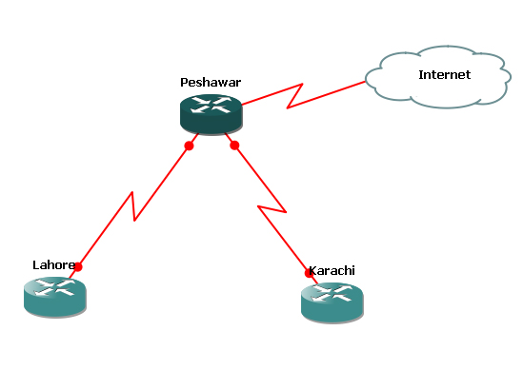

In this above diagram Peshawar is the Head office. It has two branches/ Subnets Lahore and Karachi. To connect Lahore Branch office Router and Karachi Branch Office Router with the Head office Peshawar Router, we need IP Addresses Now what we will do for this.
The Company Technical person will purchase Network –Id From the IANA (Name Assigning Authority).
Suppose they gives Network-ID of Class C
E.G. 193.168.1.0
Where /24 represent that 24 bits are for Network Portion
Steps for Subnetting:-
- Write down the Network-ID.
E.G. 193.168.1.0/24
- Write down the class. In this case it is class C.
- Write down the Subnet Mask for this Network-Id.
255.255.255.0

Note:- there are two type of Subnet Mask:
- Default Subnet Mask (Before Subnetting).
- Customize Subnet Mask (After Subnetting).

- Write down the Network bits and Host bits in the given IP Address.
Network-Bits = 24
Host-Bits = 8
- Write down the no of bits to be borrowed from the Host Portion. In this case.
0000000
0
193.168.1
.
Network Portion
Host portion
Borrowed Bit

We will borrow one bit because Peshawar Router has 2 subnets. So we will perform 1 bit Subnetting. Taking no of bits from Host portion depends upon how many subnets (Branches) Do you have. In the previous diagram we have two subnets, so we will perform one bit Subnetting.

No. Bits to be borrowed | Required no of Subnets
2¹ (one bit Subnetting) | 2 subnets
2² (two bits Subnetting) | 4 Subnets
2³ (Three bits Subnetting) | 8 Subnets
2⁴ (4 bits Subnetting) | 16 Subnets
2⁵ (5 bits Subnetting) | 32 Subnets
2⁶ (6 bits Subnetting) | 64 Subnets

Note:- In class C you can borrow Maximum of 6 bits from Host Portion.
- Write down the No of Hosts Per Subnets.
- Write down the customized Subnet Mask.
- After performing Subnetting the Subnet Mask we achieved is called Customized Subnet Mask.
Once again have a close look on this diagram

(Head Office)
(Branch Office)
(Branch Office)
S0/0
S0/0
S0/1
S0/1

FLSM Example:-
- Network-ID = 193.168.1.0/25
- Class C
- Default Subnet Mask = 255.255.255.0
- No of Host Bits to be borrowed = 1
- No of Host Bits left = 7
- If we perform one bit Subnetting than we will get two subnets.
193.168.1.0/25 ------- Subnet No 1
193.168.1.128/25 ------- Subnet No 2
- How /25 Comes
This is class C Network address
Default Network bits are = 24 when we borrow one mote bit from Host Bits than
Total No of bits we have = 24+1=25
- Total No of Hosts / Subnet will be
2⁷ = 128 Hosts on each Subnet.
- The Customized subnet Mask will be
255.255.255.128

Write down this in Binary:
1 1 1 1 1 1 1 1
.
.
128
255
255
255
. 1 0 0 0 0 0 0 0
. 1 1 1 1 1 1 1 1
. 128 64 32 16 8 4 2 1
. 128 64 32 16 8 4 2 1
. 128 64 32 16 8 4 2 1
128 64 32 16 8 4 2 1
. 1 1 1 1 1 1 1 1

FLSM Example 2:-

Requirement = 4 Subnets
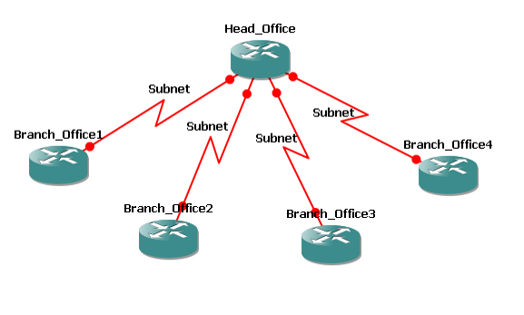
No of Hosts in each Subnet = 55

The Company XYZ Corporation has four Branch Offices in different cities. We need four different network-ids to connect with the Head Office. Two solutions for this,
- Either purchases four different Network-Ids from IANA. This is not good solution. (Company Budget is wasting).
- Perform Subnetting.(This is good solution. It will save your company budget).
- Only purchase one Network-Id from IANA and perform Subnetting.

Network-ID = 200.100.50.0/24
Class = C
Requirement Subnets = 4
No of Hosts (IPs) Per Subnet = 55
No of Bits to borrowed from Host = 2 (2² =4 Subnets)
Note:- You will see here how many subnets do you have according to your subnets requirement you will take bits from Host portion.

Default Subnet Mask for this Network = 255.255.255.0
200.100.50. 00 000000
Subnet Bits
Host Bits
Network Bits

Here we will left first 2 bits from the last octet.
In binary. The two bits combination will be as:

- 0 ----- Subnet 1
- 1 ----- Subnet 2
- 0 ----- Subnet 3
- 1 ------- Subnet 4

200.100.50.0/26
200.100.50.64/26
Required 4 Subnets
200.100.50.128/26
200.100.50.192/26

Customized Subnet Mask for all 4 subnets is 255.255.255.192

Subnet 1:-
Subnet- ID
Valid Host-Ids (IP Addresses)
Broadcast-ID
200.100.50.0
200.100.50.1
.
.
.
.
.
.

200.100.50.62
200.100.50.63

Subnet 2:-
2nd Subnet- ID
Valid Host-Ids (IP Addresses)
2nd Broadcast-ID
200.100.50.64
200.100.50.65
.
.
.
.
.
.

200.100.50.126
200.100.50.127

Subnet 3:-
3rd Subnet- ID
Valid Host-Ids (IP Addresses)
3rd Broadcast-ID
200.100.50.128
200.100.50.129
.
.
.
.
.
.

200.100.50.190
200.100.50.191

Subnet 4:-
4th Subnet- ID
Valid Host-Ids (IP Addresses)
4th Broadcast-ID
200.100.50.192
200.100.50.193
.
.
.
.
.
.

200.100.50.254
200.100.50.255
Note:- In each subnet we have total No of IPs = 64
Becouse 2⁶ = 64
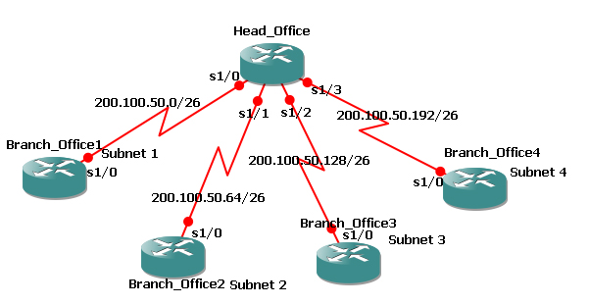
The 1st address and the last address of each subnet is never used. We can’t assign it to computer router. So the valid IP Addresses in each subnet are 2⁶ - 2 = 64 – 2 = 62

FLSM Example 3:-
Requirement = 500 Hosts Using Class B Network-ID
Network-ID = 172.16.0.0/16
172.16. 0000000 0.00000000
Host Bits
Network Bits
Borrowed Bits

Hosts Bits required (h) = 9
Borrowed Network Bits (h) = 7
Total Network Bits = 16+7 = /23
Total No of Hosts per Subnet = 512
Total No of Subnets = 2^{h} = 2⁷ = 128
Customized Subnet Mask = (/23) = 255.255.254.0

Range of Subnet-Ids:-
Subnet-Id Valid Host-Ids (IPs) Broadcast-Id
172.16.0.0/23 172.16.0.1—172.16.1.254 172.16.1.255/23
172.16.2.0/23 172.16.2.1—172.16.3.254 172.16.3.255/23
172.16.4.0/23 172.16.4.1—172.16.5.254 172.16.5.255/23
172.16.6.0/23 172.16.6.1—172.16.7.254 172.16.7.255/23
.
.
.
.
.
.
.
.
.
.
.
.
.
.
.
.
.
.
.
.
.
.
.
.

172.16.254.0/23 172.16.254.1—172.16.255.254 172.16.255.255/23

FLSM Example 4:-
Requirement = 2000 Hosts Using Class A Network-ID
Network-ID = 10.0.0.0/8
10 . 00000000.00000 000.00000000
Network Bits
Host Bits
Borrowed Bits

No of Bits to be borrowed = 13
No of Host Bits required = 11
Total Network Bits = 8+13 = /21
Total No of Hosts per Subnet = 2048
Total No of Subnets = 2^{h} = 2¹³ = 8192
Customized Subnet Mask = (/21) = 255.255.248.0
Range of Subnet-Ids:-
Subnet-Id Valid Host-Ids (IPs) Broadcast-Id
10.0.0.0/21 10.0.0.1—10.0.7.254 10.0.7.255/21
10.0.8.0/21 10.0.8.1—10.0.15.254 10.0.15.255/21
10.0.16.0/21 10.0.16.1—10.0.23.254 10.0.23.255/21
.
.
.
.
.
.
.
.
.
.
.
.
.
.
.
.
.
.
.
.
.
.
.
.

10.0.248.0/21 10.0.248.1—10.0.255.254 10.0.255.255/21
10.1.0.0/21 10.1.0.1—10.1.7.254 10.1.7.255/21
10.1.8.0/21 10.1.8.1—10.1.15.254 10.1.15.255/21
10.1.16.0/21 10.1.16.1—10.1.23.254 10.1.23.255/21
.
.
.
.
.
.
.
.
.
.
.
.
.
.
.
.
.
.
.
.
.
.
.
.

10.1.248.0/21 10.1.248.1—10.1.255.254 10.1.255.255/21
10.2.0.0/21 10.2.0.1—10.2.7.254 10.2.7.255/21
10.2.8.0/21 10.2.8.1—10.2.15.254 10.2.15.255/21
10.2.16.0/21 10.2.16.1—10.2.23.254 10.2.23.255/21
.
.
.
.
.
.
.
.
.
.
.
.
.
.
.
.
.
.
.
.
.
.
.
.

10.2.248.0/21 10.2.248.1—10.2.255.254 10.2.255.255/21
.
.
.
.
.
.
.
.
.
.
.
.
.
.
.
.
.
.
.
.
.
.
.
.

10.255.0.0/21 10.255.0.1—10.255.7.254 10.255.7.255/21
10.255.8.0/21 10.255.8.1—10.255.15.254 10.255.15.255/21
10.255.16.0/21 10.255.16.1—10.255.23.254 10.255.23.255/21
.
.
.
.
.
.
.
.
.
.
.
.
.
.
.
.
.
.
.
.
.
.
.
.

10.255.248.0/21 10.255.248.1—10.255.255.254 10.255.255.255/21
Variable Length Subnet Mask (VLSM):-

- VLSM is used for proper implementation of IP addresses which allows more then one subnet mask for a given network. According to the individual needs.
- Subnetting within subnetting is called VLSM. One Subnet can be subnetted for multiple times for efficient use.
- It requires Classless Routing Protocol.

Advantages:-
- With the help of VLSM we can implement efficient use of IP addresses. IP Address are not wasted in VLSM.

Example of VLSM Networks:-
Example 1 :- 200.100.50.0/24
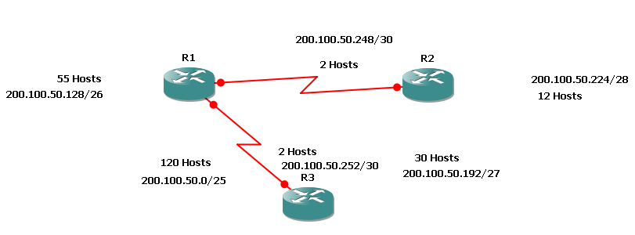
200.100.50.240/29
4 Hosts

Example of VLSM Networks:-
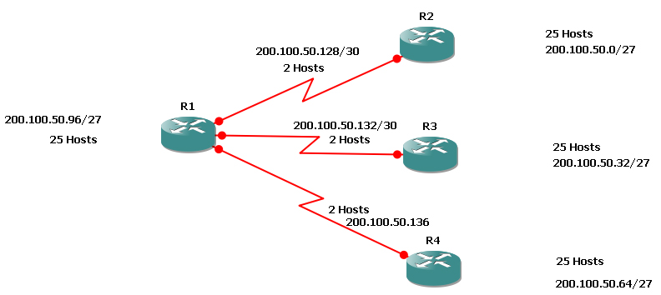Example 2 :- 200.100.50.0/24
Supernetting / CIDR:-

- Supernetting is also called route summarization.
- It is opposite of Subnetting.
- In Supernetting you are decreasing the Network portion and increasing the Host Portion.
- Supernetting is implemented in Core Routers.
- ISP implement this.
- It decreases the router routing table.
- It also reduces the load on the link.

