Studio Techniques

Paper Collage Technique
- Select image for this technique (Landscapes, still life painting , portrait )
- Materials you need for this assignment is scholar sheet or sketch book paper A3 size, use glue, magazine, newspapers or any paper material which is available use it for your selected image
- Tear paper in small bits of pieces and stick it with glue in an overlapping method
- Select colored paper according to your selected image from resources available to you
- See different images on net which are done through in this technique so it will be easy for you to get an idea
- Kindly work on this task at home and don’t take it for granted it will be checked later.

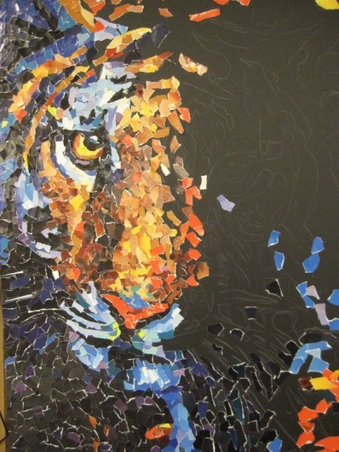

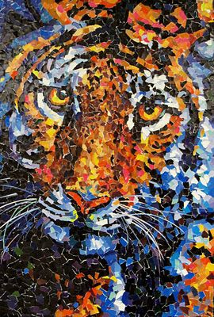

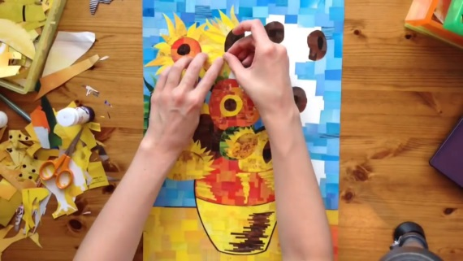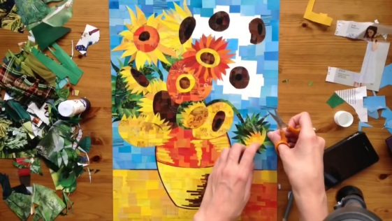

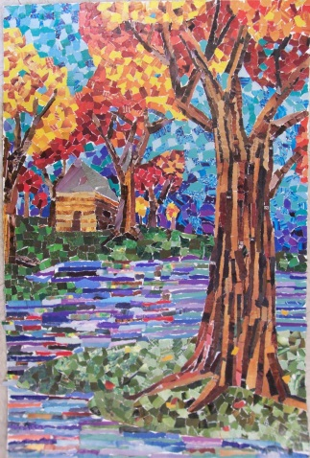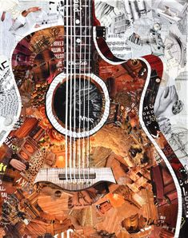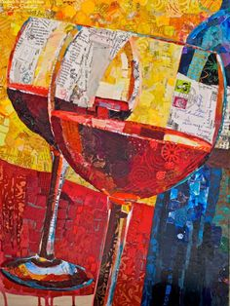

(Note: These are few images which help you out to get an idea)

