Studio Techniques 1
Final Sessional Assignment
- This assignment will be considered as Final exam task.

Typography Technique
- First select image for this technique (Landscapes, still life painting , portrait )
- Materials you need for this assignment is scholar sheet or sketch book paper A3 size, use pointer pen, marker for typography technique on your selected image.
- Keep it black and white so for that you have to create values (light and darks) in your selected images
- In typography technique you have to use alphabets to create an image.
- To create light values in image use fine and thin styles of letters and for darker values use bold letters through this way you can achieve 3D effect in your image.
- Each and every part of image should be created with use of letters or alphabets.
Examples:

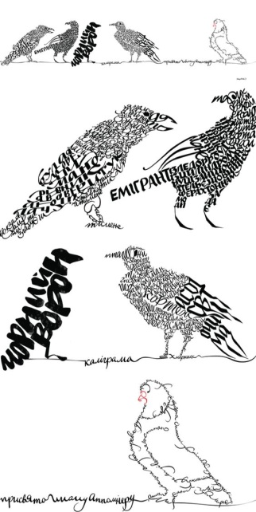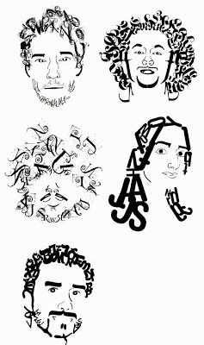

- See different images on net which are done through in this technique so it will be easy for you to get an idea.
- Kindly work on this task with proper concentration.

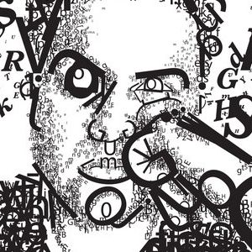

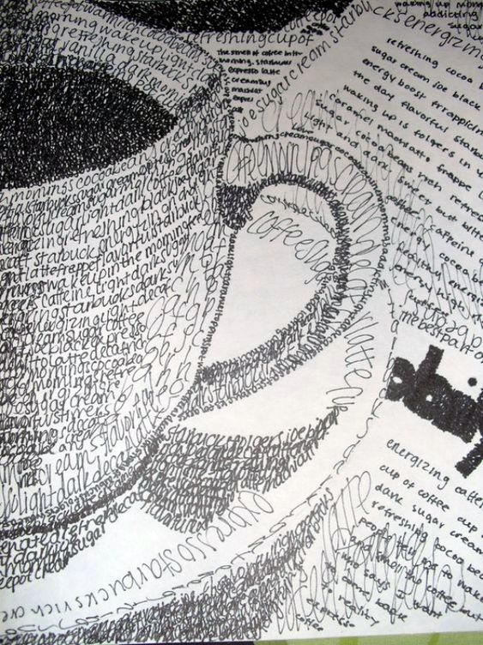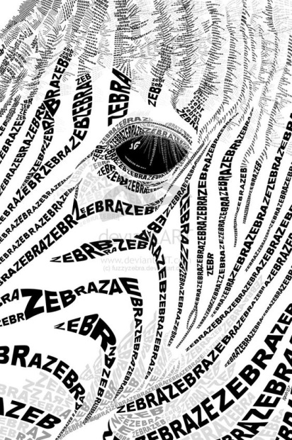

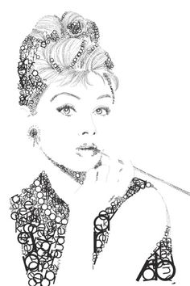

(Note: These images will help you out to get an idea about typograghy technique)

