Mid Term Examination (Summer Semester 2020)
Subject: Structural Analysis-II (CE-311)
Lecturer: Engr. Adeed Khan Total Marks: 30
Note: Attempt all questions. Assume any missing data.
Q No 1: CLO-02 (C-04/PLO-02) (10)
Analyze the given beam shown in FIG-1 by flexibility method. EI is constant.

Q No 2: CLO-02 (C-04/PLO-02) (10)
Differentiate between force method and displacement method and suggest which method is more suitable for structure analysis of matrix approach.

Q No 3: CLO-02 (C-04/PLO-02) (10)
Analyze the rigid-joint frame shown in FIG-2 by flexibility method. Assume EI is constant for all members.

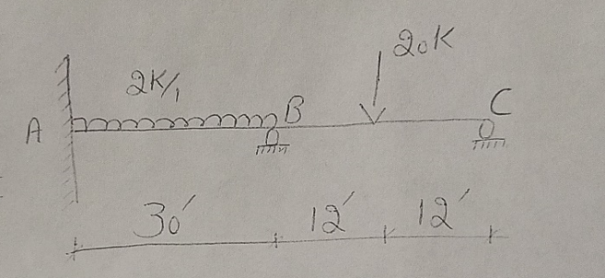
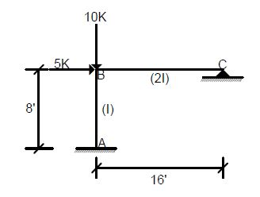
FIG-1

FIG-2

