Art History
Roman Civilization
The Roman Empire was one of the greatest and most influential civilizations in world history. It began in the city of Rome in 753 BC and lasted for well over 1000 years. During that time Rome grew to rule much of Europe, Western Asia, and Northern Africa.

The term Ancient Rome refers to the city of Rome, which was located in central Italy; and also to the empire it came to rule, which covered the entire Mediterranean basin and much of Western Europe.
The lands controlled by the Romans, which included parts of Europe (including Gaul (France), Greece and Spain), parts of North Africa and parts of the Middle East.

Roman founding in 625 BC to its fall in AD 476, the Roman Empire conquered and integrated dozens of cultures. The history of the Roman Empire can be divided into three distinct periods:
- The Period of Kings (625-510 BC),
- Republican Rome (510-31 BC),
- Imperial Rome (31 BC –AD 476)

Rome Beginning:
Roman legend claimed that brothers, Romulus and Remus founded Rome after they were raised by a she-wolf.

Platinum hill:
The original settlement on which Rome was founded, and; thus, Roman kingdom began by Romulus in 625 BC
- Rome was founded around 625 BC in the areas of ancient Italy known as Etruria and Latium.
- The city- state of Rome was initially formed by Latium villagers joining together with settlers from the surrounding hills in response to an Etruscan invasion.
- The first settlers of Rome were the Latins. They chose this spot because of the mild climate, good farmland, and strategic location.
- The settlers farmed in the fertile plain at the base of the hills and built their homes on the hilltops. They built atop the hills so they would be able to defend themselves against an enemy attack.
- Around 600 B.C., the Etruscans invaded the Latins’ little town of Rome and took over.
- The Etruscans drained the marshes near Rome to give them more land on which to build, thus under Etruscan rule, Rome grew into a city.
- Close to Mediterranean Sea on several ancient trade routes.
- Located next to the Tiber River
- Contained large plains making it easy to farm
- Location in the Italian Peninsula made it easy for Roman ships to reach other lands around the sea.
- This position made it easier for Rome to conquer other lands and gain new territory.
- The Alps and the Apennines Mountain Ranges helped to protect Rome

Roman civilization importance:
Governing the Empire. In order to control their large empire, the Romans developed important ideas about law and government. They developed the best army in the world at that time, and ruled by force. They had fine engineering, and built roads, cities, and outstanding buildings.

Two groups of citizens:
- Patricians- rich and powerful
- Plebeians- all other people, 90% of the people

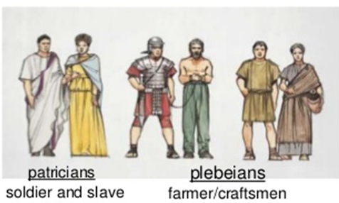
Roman Society:
- Most early Romans worked small plots of land growing wheat, barley, fruits, beans, and vegetables.
- They also raised livestock; such as pigs, sheep, goats, and chickens. They used oxen to pull their carts.
- Members of a Roman farm family worked very hard, as they only had simple tools available and usually had to travel to get water.
- Only landowners were able to join the army. This was because it was thought that they would fight harder to defend their land and the city.
- The head of the Roman family was the father. Although his power was limited by public opinion, he had control over other members of the family and owned all the property.
- Roman women were expected to run the household and take care of the children.
- Women were able to inherit property and run the family business when their husbands were away.
- Roman women had little power outside the home and could not vote.
Language:
Latin and Greek were the official languages of the Roman Empire, but other languages were important regionally. Latin was the original language of the Romans and remained the language of imperial administration, legislation, and the military throughout the classical period
Currency:
During the reign of Augustus, a common coin called a denarius was used throughout the empire.
Having a common form of money made trade between different parts of the empire much easier. This way, traders did not have to change their money into another currency when they bought and sold goods.
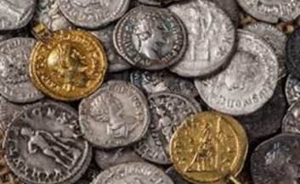
Famous Emperors of Rome:
Julis Caesar
- Rome’s most famous citizen
- Roman politician and general
- Conquered the vast territory of the Gauls to the north of his province
in France
- In the year 49 BC crossed the river between his province and Italy, called the river Rubicon, and conquered Rome itself which he then ruled as a dictator.
- His life was ended as he was infamously murdered in the senate in Rome.
- His military campaigns took him to Egypt where he met the famous Cleopatra.

Caesar Augustus
- Roman Empire (27 BC – 476 AD) The Roman Empire was founded when Augustus Caesar proclaimed himself the first emperor of Rome in 31BC and came to an end with the fall of Constantinople in 1453CE
- Augustus was a wise ruler. He secured the borders of the empire and built roads.

Religion:
- The 12 gods were Jupiter and Juno, Neptune and Minerva, Mars and Venus, Apollo and Diana, Vulcan and Vesta, Mercury and Ceres
- Temples honoring the gods would be built throughout the empire; however, these temples were considered the “home” of the god; worship occurred outside the temple. While this fusion of Roman and Greek deities influenced Rome in many ways.
- Later on Christianity spread through the Roman Empire and eventually it received legal status in 313 CE. This was an important development because it meant that Christians could openly practice their religion

Roman Economy:
- Rome had a strong economy. This is partly due to their agriculture and trade.
- Farming was always an important aspect in the Roman economy. Industry also grew in Rome.
- Romans manufactured goods such as pottery, metal goods, glass, wine, olive oil, and other food products.
- The Roman Empire fostered economic growth through the use of trade routes.
- By trading, Rome received valuable goods that were not available to them at home including: grain, ivory, silk, spices, gold, silver, and even wild animals.
- Successful trading relied on a few things: the quality of the Roman roads, the access to the sea, and the security provided by the Roman military.

Senate:
- The Roman Senate was a governing and advisory assembly in ancient Rome. It was one of the most enduring institutions in Roman history.

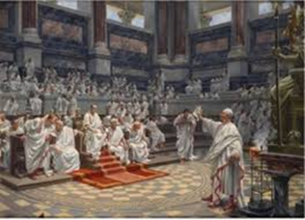
Circus Maximus:
- There was always something to do in this exciting city. One of the most popular events was to attend a horse race at a place called Circus Maximus.
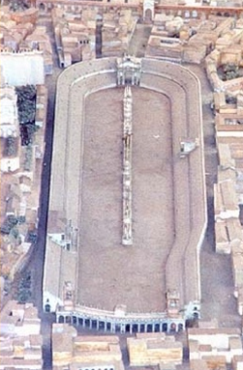
Public Baths:
- Rome had more than 100 public baths. The baths were open to the rich and poor. People could also exercise, relax, eat, read, or walk through gardens at the baths
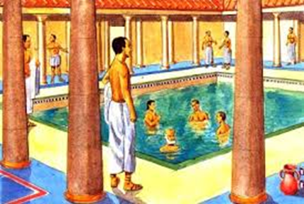
Forum:
- At the forum in Rome, people would talk, hear the latest news, shop, and eat. There were entertainers who would sing, dance, and even charm snakes in the Forum
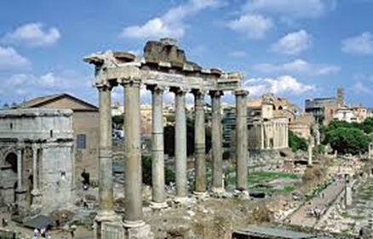
The Colosseum (70 BC, concrete)
- The Romans’ favorite entertainment was a trip to watch the gladiators.
- In Rome, the best fights took place in a 50,000-seat amphitheater called the Colosseum.
- The floor of the arena was covered in sand to soak up all the blood.
- The emperor sat in a special box just above the stage where he controlled the entertainment.
- He declared whether a gladiator would live or die with a thumbs-up or a thumbs-down gesture.
- The Colosseum was 160 ft. tall and had four stories of windows, columns, and arches.
- The arena could be flooded so there could be battles between real boats.
- Spectators sat according to social class in the arena.
- Women and the poor sat on the top tier.

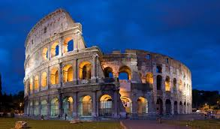
Gladiators
- Gladiators were prisoners or slaves who were trained to fight, and they would fight to the death.
- Gladiators would fight each other, and also against fierce wild beasts such as lions, tigers, or bears
- Some gladiators were equipped with only fishing net and a long fork called a trident. Others wore armor and carried swords or daggers.
- A gladiator who survived several fights might be given his freedom.

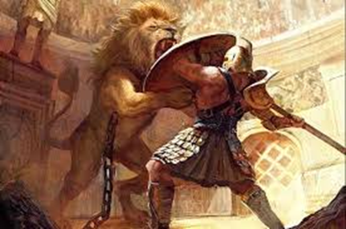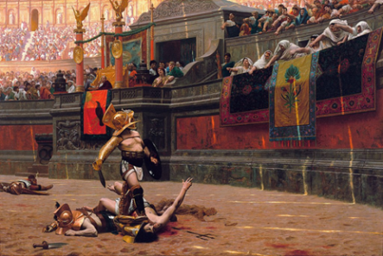
Defeat of Roman Empire:
Between AD 406 and 419 the Romans lost a great deal of their empire to different German tribes. The Franks conquered northern Gaul, the Burgundians took eastern Gaul, while the Vandals replaced the Romans in Hispania. The Romans were also having difficulty stopping the Saxons, Angles and Jutes overrunning Britain.
Odoacer
In 476 C.E. Romulus, the last of the Roman emperors in the west, was overthrown by the Germanic leader Odoacer, who became the first Barbarian to rule in Rome. The order that the Roman Empire had brought to Western Europe for 1000 years was no more.

Romans Writing Tools:
The Romans used a variety of tools for writing. Everyday writing could be done on wax tablets or thin leaves of wood. Documents, like legal contracts, were usually written in pen and ink on papyrus. Books were also written in pen and ink on papyrus or sometimes on parchment.
Roman Dress:
- Clothes needed to be simple
- Only one type of material: Wool, linen was available at times

