Art History

Sculpture:
- Realistic depictions of Roman leaders. Influenced by wax death masks used for memorializing the deceased
- Designed to be seen in public places all over the empire
- New coins made every time a new emperor was appointed and spread around the empire
- Roman sculpture is less idealized than Greek sculpture (not as obsessed with perfect beauty)
- Showed the true looks of their subject- including their imperfections

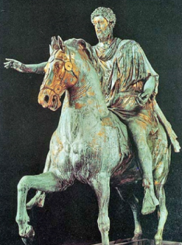 Marcus Aurelius (160- 180 BC, bronze)

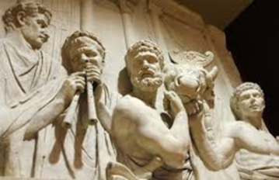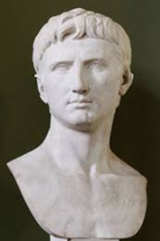

Roman Relief Sculptures:
- Shallow, 3 dimensional carvings on flat surfaces (like a coin)
- Showed off the skill of the artists with many intricate carvings and figures
- Most reliefs are on architectural works and have subject matters of battles or hunts
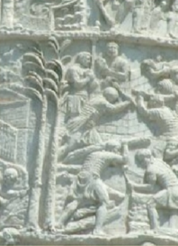

Trajan’s Column, Rome (113 AD, Marble)
- Made to commemorate Trajan’s battle victories. Height of the column and relief sculptures symbolize the height of success and accomplishment of the emperor Trajan

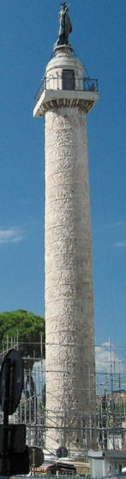
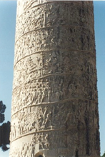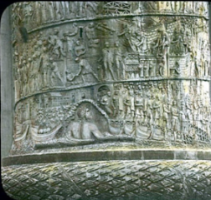

Roman Painting:
Roman houses were very dark and didn't even have windows. Romans used wall paintings as a way to open up and lighten their space. More specifically, they used frescoes
There are four main styles of Roman wall painting that have been found:
- Incrustation
- Architectural
- Ornamental
- Illusionist
Each style is unique

- Mau called the First Style the "Incrustation Style" and believed that its origins lay in the Hellenistic period—in the 3rd century B.C.E. in Alexandria. The First Style is characterized by colorful, patchwork walls of brightly painted faux-marble.
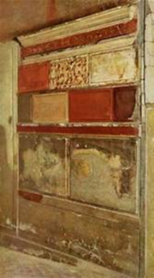

- Architectural imitates architectures, including perspective in 1st century BC (Cesar’s times). Frequent the depiction of windows from where buildings can be seen and tends to dissolve the wall.
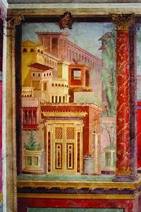
- Ornamental styles in mid-1st century AD. It is a mix of the former two styles (light ornamental elements, fantastic buildings, animals, stylized vegetables, mythological scenes) It is full of intense colors.
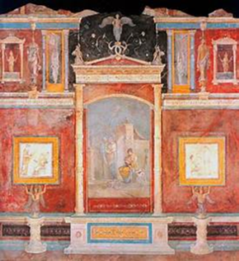
- Illusionist or stenographic took elements from second and third styles, it is more complicate, with mythological and historical scenes. Curtains are common and landscape is depicted
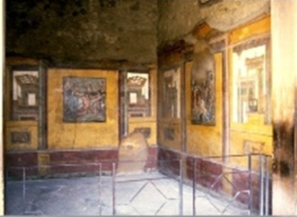
Easel painting:
- Subjects
History, landscape, daily life, Animals, portrait
The best examples are the funerary portraits of E1 Fayum

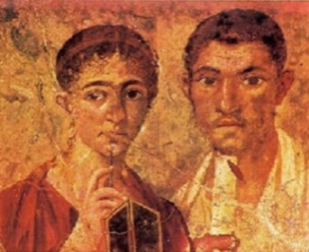
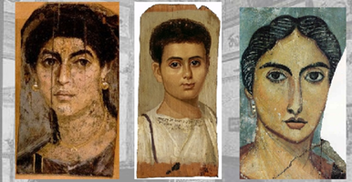

Mosaics Work:

Mosaics became a very popular art form during the time of the Roman Empire, although they were used in Italy both before and after this period. Roman mosaics appeared on floors in houses as early as the 2nd century BCE. Romans used mosaics to decorate floors and walls in homes and temples
- The technique consisted of combining small pieces of glass or stones called tesella
- There were others in which bigger and irregular pieces of stone were used
- Motives are varied, the same as in painting and they normally depict scenes related to the room they were made for.
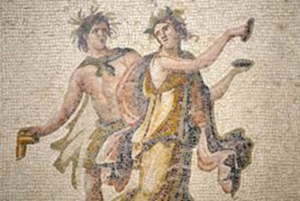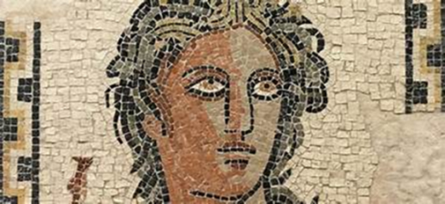

Painters used primarily black, red, yellow, brown, blue, and green pigments. ... Paints were made by using the ground pigment with gums or animal glue, which made them workable and fixed them to the surface being decorated. The encaustic painting technique was used widely in Greece and Rome for easel pictures.

Roman Fresco:
Fresco is a technique of mural painting executed upon freshly laid, or wet lime plaster.

