Art History
Roman Art
- Ancient Roman Art. Centered in the city of Rome, the civilization of Ancient Rome ruled much of Europe for over 1000 years. The arts flourished during this time and were often used by the wealthy and powerful to memorialize their deeds and heritage. The Romans admired the Greek culture and arts

- Roman art refers to the visual arts made in Ancient Rome and in the territories of the Roman Empire. Roman art includes architecture, painting, sculpture and mosaic work. Sculpture was perhaps considered as the highest form of art by Romans, but figure painting was also very highly regarded.

- The elements of Greek sculpture - realism, idealism, harmony of form - held a great appeal to the Romans. The Romans may also have borrowed inspiration from the Etruscans, who had an artistic tradition all their own, including sculptures and murals.

- Roman Art and Architecture. The Romans originated in central Italy, influenced by other local Italian cultures, notably those of Etruria, but from the 5th century they came into contact with the Greeks and from then onwards, the Roman republic absorbed many aspects of first Classical and then Hellenistic art.

The Romans sculpted statues of Gods, heroes, and real people in their culture. (their celebrities) They also painted and made a lot of pottery for the households, for cooking, and cleaning
Many types of art practiced by the Romans - including,
- Sculpture (bronze and marble statuary, sarcophagi)
- Fine art painting (murals, portraiture, vase-painting)
- Decorative art (including metalwork, mosaics, jewelry, ivory carving) had already been fully mastered by Ancient Greek artists
Architecture:
Ancient Roman concrete was a mixture of lime mortar, aggregate, pozzolana, water, and stones, and was stronger than previously-used concretes for architectures. The ancient builders placed these ingredients in wooden frames where they hardened and bonded to a facing of stones or (more frequently) bricks.
- Massive public buildings like courts, stadiums, palaces to proclaim the power and riches of the Roman Empire
- Other types of architecture: baths, aqueducts, bridges
- Spread these buildings and their architectural style through the empire
- Romans incorporated Greek pediments and columns into their architecture
- Also popularized the use of the arch, dome and vault

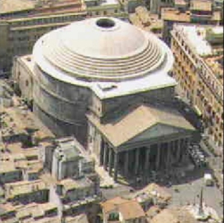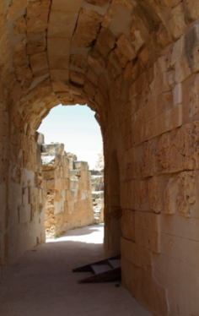
- The Romans built bridges called aqueducts to carry drinking water into their cities.
- To take the weight of all the water flowing along them, aqueducts were supported on rows of strong arches.
- The Romans also used the aqueducts to get fresh water for their baths.
- Many aqueducts still exist today, even though they are 2,000 years old

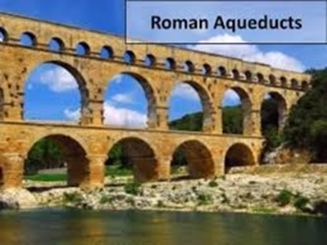

Important Roman Landmarks:
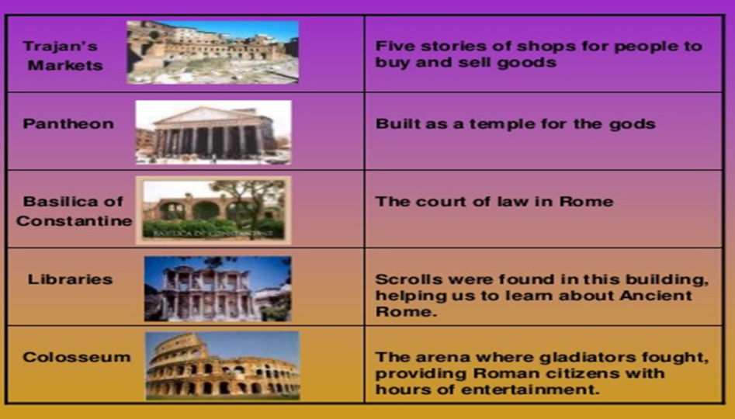
Roman Pottery:
Roman pottery was initially influenced by Etruscan and Greek style but later on established its own separate identity. Unlike Greek pottery in which decorations were painted on the pottery, Romans preferred to engrave them. Roman pottery can be divided in two main categories, namely fine ware and coarse ware.

• Terra sigillata ware, bright-red, polished pottery used throughout the Roman Empire from the 1st century BC to the 3rd century AD. The term means literally ware made of clay impressed with designs.

• Fine wares were the more formal and exquisite pottery that was used by Romans for formal occasions and was used to serve food on the table.

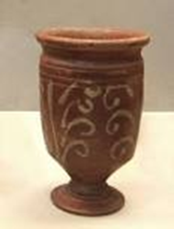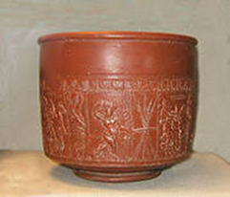
- Coarse ware, as the name suggests was coarsely made and was used for different purposes like cooking, carrying liquids and eating (for poor people).
