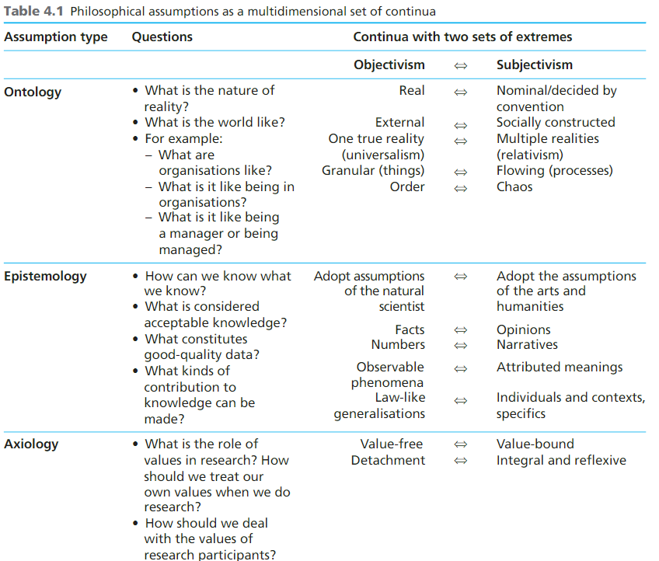
You will only deal with ontology and epistemology. First read the question these are questions which is answered and then in objectivism how it deals and same in subjectivism. The image is to know what you are dealing with so you will know about the school of thought.

Analysis of Saunders Research Onion
2 Comments / By Noko Emmanuel, J / June 29, 2019
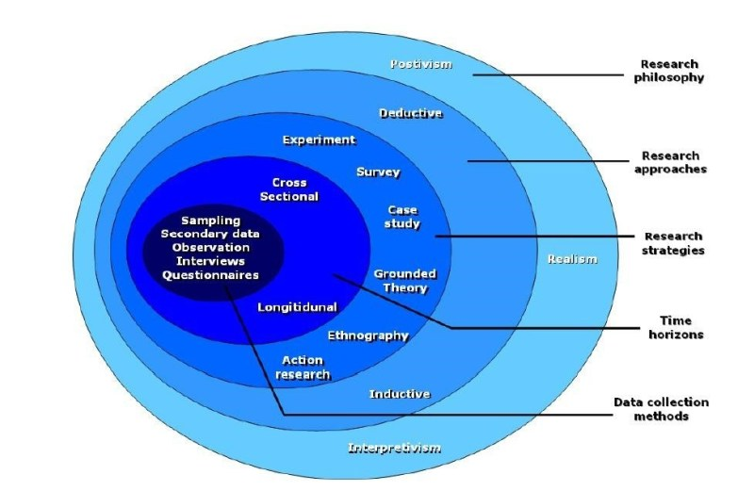

1.0 Introduction to Saunders research onions
The Saunders Research onion illustrates the stages involved in the development of a research work and was developed by Saunders et al, (2007). In other words, the onion layers give a more detailed description of the stages of a research process. It provides an effective progression through which a research methodology can be designed. Its usefulness lies in its adaptability for almost any type of research methodology and can be used in a variety of contexts (Bryman, 2012). Saunders et al (2012) noted that while using research onion one has to go from the outer layer to the inner layer. When viewed from the outside, each layer of the onion describes a more detailed stage of the research process (Saunders et al., 2007). Saunders et al sees research process as unwrapping of an onion layer by layer, for the inner layer to be seen the outer layer must be unwrapped first. For a goal to be achieved the right steps must be taken accordingly, this applies in research, cover one step first before proceeding to another.

1.1 The Layers of the Saunders research onions
The approach taken in using the research onion framework is to go from the outer layer to the inner layer of the research onion.
The outermost layer is the research philosophy which sets the stage for the research process and defines the method which is adopted as the research approach in the second step. In the third step, the research strategy is adopted, and the fourth layer identifies the time horizon.
The fifth step represents the stage at which the data collection methodology is identified. The benefits of the research onion are thus that it creates a series of stages under which the different methods of data collection can be understood, and illustrates the steps by which a methodological study can be described.
The Saunders research onion stages include:
- Research philosophy
- Research Approach
- Research strategies
- Research Choice
- Research time horizon

1.2 Philosophy to Saunders research onions

A research philosophy refers to the set of beliefs concerning the nature of the reality being investigated (Bryman, 2012). It is the underlying definition of the nature of knowledge. Also, Research philosophies can differ on the goals of research and on the best way that might be used to achieve these goals (Goddard & Melville, 2004). These are not necessarily different, but the choice of research philosophy is defined by the type of knowledge being investigated in the research project (May, 2011).
There are three main philosophies that are significant in the research process.
Ontology – ontology is more or less the study of reality. It describes the nature of reality; what comes to mind when conducting the research and what relational impact does it possess on the society and surroundings. Ontology clears the difference between reality and how you perceive reality. Furthermore, it makes you learn how it influences the behavior of the people. Mainly, three philosophical positions come under the ontological worldview. Those are objectivism, constructivism and pragmatism. Goddard & Melville (2004) noted that it helps one to know how reality actually is and the effect it has on our environment and people living in the environment. Ontology differentiates the actually reality and how one sees reality. Ontology includes; objectivism, constructivism and pragmatism. Objectivism makes you know a social event and the different meaning that different people attach to it. It differentiates the impact of social phenomena of different people. Constructivism proposes that it is people that create social phenomena; it is the opposite of objectivism. Pragmatism uses theories to identify a solution of a given issue. When compared with others it is relatively new, it is an alternative to others
Epistemology – Epistemology is mostly used in scientific research and it is like that because it helps you in finding the information that you can prove without a doubt; in other words, it tries to find the common acceptable knowledge and address the facts accordingly. Here, you have to define the acceptable knowledge about the field of your research and give information on results after rigorous testing. Positivism, critical realism and interpretivism are the philosophical positions under the epistemology worldview.
Bryman (2012) noted that epistemology includes; positivism, realism and interpretivism. Positivism uses research question that can be tested. It helps you find explanation by using the generally accepted knowledge of the people. Realism allows one to use new methods of research. For you to know reality you have to carry out research first. It is similar to positivism, the difference is that realism does not support scientific method while positivism does. Interpretivism assists you to interpret how people see their action and others’ own. It helps to understand people’s culture and their participation in social life.
Axiology – Axiology helps you learn how valuables and opinions impact the collection and analysis of your research. Silverman (2013) noted that it make one understand the impact that peoples opinion have on collecting and analysing of research. It helps you to understand that people’s opinion maters a lot while carrying out a research.

1.2.1 Objectivism, Constructivism and Positivism
Objectivism makes you aware of a social phenomenon and their different meanings and influences these phenomena have on their actors. On the other hand, constructivism rather defers that social actors are responsible in creating a phenomenon. Conversely, constructivism suggests that the inherent meaning of social phenomena is created by each observer or group (Ã–stlund et al, 2011). In this philosophy, one can never presume that what is observed is interpreted in the same way between participants and the key approach is to examine differences and nuances in the respondents understanding.
Positivism comes up with research questions and hypothesis that can be evaluated and analyzed. Common knowledge of the world can be measured and explained using Positivism. An example of it is the law of gravity.
Despite the inherent differences between these philosophical practices, one philosophy is not inherently better than the other, although researchers may favor one over the other (Podsakoffet al., 2012). The philosophy simply provides the justification for the research methodology. The methodology should be informed by the nature of the phenomena being observed.

1.3 Approach to Saunders research onions

Deductive and inductive are the two terms that the second layer of the research onion includes. Here, the previous layer of the onion has an effect on this one so it is important to know the research aim and its limitations.

1.3.1 The Deductive Approach
The deductive approach develops the hypothesis or hypotheses upon a pre-existing theory and then formulates the research approach to test it (Silverman, 2013). The deductive approach can be considered particularly suited to the positivist approach, which permits the formulation of hypotheses and the statistical testing of expected results to an accepted level of probability (Snieder & Larner, 2009). It is characterized as the development from general to particular: the general theory and knowledge base is first established and the specific knowledge gained from the research process is then tested against it (Kothari, 2004). However, a deductive approach may also be used with qualitative research techniques, though in such cases the expectations formed by pre-existing research would be formulated differently than through hypothesis testing (Saunders et al., 2007). Deductive approach uses questionnaire to create understanding of observation which allows you to compare different understanding of the people through empirical data. The data gathered helps to confirm or reject the question, the process can be repeated.

1.3.2 The Inductive
The inductive approach allows for you to create a theory rather than adopt a pre-existing one as in the deductive. This clearly outlines the difference in the two approaches. The inductive approach is characterized as a move from the specific to the general (Bryman & Bell, 2011). In this approach, there is no framework that initially informs the data collection and the research focus can thus be formed after the data has been collected (Flick, 2011). Although this may be seen as the point at which new theories are generated, it is also true that as the data is analyzed that it may be found to fit into an existing theory (Bryman & Bell, 2011). This method is commonly used for qualitative research. Interviews are carried out concerning specific phenomena and then the data may be examined for patterns between respondents (Flick, 2011). However, this approach may also be used effectively within positivist methodologies, where the data is analyzed first and significant patterns are used to inform the generation of results.

1.4 Strategies to Saunders research onions

The research strategy describes how the researcher intends to carry out the work (Saunders et al., 2007). The strategy can include a number of different approaches, such as experimental research, action research, case study research, interviews, surveys, or a systematic literature review.

1.4.1 experimental
Experimental research refers to the strategy of creating a research process that examines the results of an experiment against the expected results. It can be used in all areas of research, and usually involves the consideration of a relatively limited number of factors (Saunders et al., 2007).

1.4.2 Survey
Survey strategy of the research onion is often linked with the deductive approach. It is one of the finest and economical research strategy. You can collect rich and reliable data through this method. Surveys tend to be used in quantitative research projects, and involve sampling a representative proportion of the population (Bryman & Bell, 2011). The Survey strategy is mostly used to observe contributing variables among different data. It permits the collection of vast data that will be used to answer the research question.
1.4.3 Case Study
This strategy is focused on a one or more people or a single area. It can offer an insight into the specific nature of any example, and can establish the importance of culture and context in differences between cases (Silverman, 2013). This strategy is more useful in financial research. Case study research is the assessment of a single unit in order to establish its key features and draw generalizations (Bryman, 2012). This form of research is effective in financial research, such as comparing the experiences of two companies, or comparing the effect of investment in difference contexts.
1.4.4 Action research; This form of research is common in professions such as teaching or nursing, where the practitioner can assess ways in which they can improve their professional approach and understanding (Wiles et al., 2011). This strategy is used mainly to find the solution that can be used to solve a certain problem.

1.5 Choice to Saunders research onions
This is the fourth layer of the research onion, it is also known as research choice. This layer helps you to know whether it is fine to combine both quantitative and qualitative methodology or to use only one methodology. According to Saunders et al (2007), there are three outlined choices in the research onion that includes the Mono, Mixed and Multi method research choice or approach.
Mono method; when using this method you are required to gather one type of information; that is using either quantitative or qualitative methodology. You cannot combine the two.
Mixed method; this method permits one to combine quantitative and qualitative methodology in a research to create a precise set of data. According to (Flick, 2011), the mixed method combines methods to create a single dataset while the multi method is used where the research is divided into segments; with each producing a specific data set.
Multi-method; this method is similar with the mixed method because the two combines quantitative and qualitative methodology in a study. Although they are similar but still have their differences. While mixed method combines methodology to establish particular set of data, multi-method does not.

1.6 Time Horizon to Saunders research onions

The time horizon describes the required time for the completion of the project work. wo types of time horizons are specified within the research onion: the cross sectional and the longitudinal (Bryman, 2012).
1.6.1 Cross Sectional
The cross sectional time horizon is the one already established, whereby the data must be collected. This is used when the investigation is concerned with the study of a particular phenomenon at a specific time.
1.6.2 Longitudinal
A longitudinal time horizon for data collection refers to the collection of data repeatedly over an extended period, and is used where an important factor for the research is examining change over time (Goddard & Melville, 2004).
1.7 Analysis and Data collection
This is the sixth and last layer of the research onion; it is the innermost layer of Saunders research onion. The process used at this stage of the research contributes significantly to the study overall reliability and validity (Saunders et al., 2007). Data collection and analysis is dependent on the methodological approach used (Bryman, 2012). This layer explains how the data used in the research are collected and analysed. It also explains the source of data, the research design, the sample, the sample size, sample ethics, sample limitations, the research reliability and validity. The data collected could be primary data or secondary data. Primary data is a direct data, it is obtained directly from the source. Secondary data is the opposite of primary data, secondary data is indirect data.
1.7.1 Primary Data is defined as data collected from the source or first hand. This can be done via the use of several instruments questionnaires, oral or written interviews, etc
1.7.2 Secondary Data is derived from the work or opinions of other researchers (Newman, 1998).

