Art History
Renaissance Era
The Renaissance was a period in European history marking the transition from the Middle Ages to Modernity and covering the 15th and 16th centuries. It occurred after the Crisis of the Late Middle Ages and was associated with great social change.
The Renaissance was a fervent period of European cultural, artistic, political and economic “rebirth” following the Middle Ages that lasted from the 1300-1500s. Generally described as taking place from the 14th century to the 17th century, the Renaissance promoted the rediscovery of classical philosophy, literature and art. The start of the “modern world”. Changes in thought process about art, religion, literature, education.
The three fundamental periods of the Renaissance in Art:
- Early Renaissance.
- High Renaissance.
- Late Renaissance.

The Renaissance is a period in the history of Europe beginning in about 1400, and following the Medieval period. "Renaissance" is a French word meaning "rebirth". A person who is clever at a great number of things is sometimes called a "Renaissance man".

Although the Renaissance saw revolutions in many intellectual pursuits, as well as social and political upheaval, it is perhaps best known for its artistic developments and the contributions of such polymaths as Leonardo da Vinci and Michelangelo, who inspired the term "Renaissance man".
There was a renewed interest in learning about the achievements of the ancient Greeks and Romans.

Renaissance begun in Italy during the 14th century, after the end of the Middle Ages , and reached its height in the 15th century. The Renaissance spread to the rest of Europe in the 16th and 17th centuries. Later spread north to Germany and England.
Italians cities such as Florence and Venice became rich through trade and industry. These cities became the center for many artists and sculptors.
The most prevalent societal change during the Renaissance was the fall of feudalism and the rise of a capitalist market economy. Increased trade and the labor shortage caused by the Black Death gave rise to something of a middle class.

Renaissance art, painting, sculpture, architecture, music, and literature produced during the 14th, 15th, and 16th centuries in Europe under the combined influences of an increased awareness of nature, a revival of classical learning, and a more individualistic view of man.

Humanism
- Emphasized the abilities and accomplishments of human beings.
- Humanists believed people were capable of great things and placed a great value on education.
- As a result, artists, architects, leaders, writers, scientists and other talented individuals were greatly admired.
- Scholars encouraged a new way of thinking and learning.
- Humanities included history, poetry, and grammar.
- Idea started in the Renaissance that people have value, worth.
- Liberal arts education.
- Humans can do good.

The Italian Renaissance
- They were interested in human achievement (instead of religious or spiritual achievement)
- The figures in their artwork looked like Greek or Roman gods, i.e. perfect
The Northern Renaissance
- They were interested in the early Christian period.
- The figures in their artwork were more realistic.
Both Northern & Italian Renaissance
- Interested in Greek & Roman culture (“the classics”)
- Use of perspective in paintings
- Believed in humanism
- Used critical method of study

Science & Technology
- Some of the ancient Greek and Roman works rediscovered during the
Renaissance dealt with science.
- For the 1st time, Europeans could read about early Greek and Roman
Scientific advances.
- These discoveries inspired Europeans to study math, astronomy, and science.
- Johannes Gutenberg invented the first real printing press in Germany.
- Gutenberg’s first printed book was the bible.
- For the first time in history, the average person had access to printed materials.

Navigation and Exploration
- Advances in technology helped to make exploration of the world possible.
- The introduction of latitude lines on maps made it easier for navigators to find their way.
- Discovery of new ocean currents.
- New instruments allowed sailors to locate their positions.
- New ships could carry enough food and water for longer voyages.
- Larger ships with new sails and better steering devices made longer voyages possible.
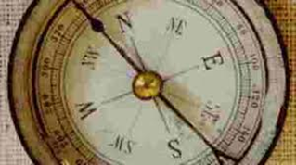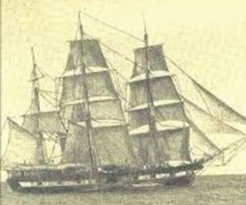
Renaissance Literature
- William Shakespeare is probably the most famous Renaissance writer.
- He is most famous for his plays, but also wrote poetry.
- His writing shows a deep understanding of human nature and expressed the thoughts and feelings of his characters.
- More people learned to read after the invention of the printing press.
Ideas were shared with others in distant areas.
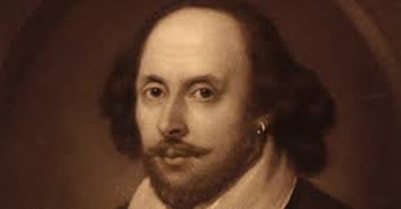 William Shakespeare (1564 -1616)

Reformation
- By the early 1300s many Europeans thought the church had become
too powerful and wealthy.
- Complaints and unhappiness with the church led to a religious reform
movement called the Reformation.
- The Reformation began in what is now Germany.
- People thought religious officials had lost sight of their religious duties.
The Protestant Reformation
- A German monk named Martin Luther disagreed with the teachings of the Catholic Church.
- In 1517, Luther nailed a list of complaints to a church door in Whittenberg, Germany.
- These complaints were called the 95 Theses.
- Luther’s protests angered church officials, who expelled him from the church.
- Other reformers followed Luther and created churches of their own.
- The Roman Catholic Church was no longer the only church in Western Europe.
The Catholic Reformation
- Also known as the counter-reformation.
- Many catholic officials wanted to reform the church as well.
- Church leaders began focusing more on spiritual concerns and less on political power.
- They worked to make the church’s teachings easier to understand.

Results of the Reformation
- Many different churches arose in Europe.
- In many areas, especially in the north, Protestants outnumbered Catholics.
- As the power of the church and the pope decreased, the power of monarchs (kings/queens) and national governments increased.
- Religious wars in parts of Europe led to long-lasting political and social change in Europe.
Renaissance Art
- Oil-based paints were used for the first time.
- Artists began to paint in perspective (3D) and use shading.
- Artists painted everyday life instead of religious scenes.
- Linear Perspective: Vanishing Point
- Influenced by Greco-Roman culture; its form and its themes(i.e. beauty of the human body)
- Frescos painting technique
- Sculpture in the Round/ in Relief
- The importance of religion in art

Artists gained prestige and became celebrities.
Patrons (mecenas), financed & protected artists. Patrons commissioned artwork and decided the themes
- Kings & Popes
- Medici Family in Florence were the most famous and wealthy patrons of the Renaissance.

Characteristics of Renaissance Art
- Classicism
- Emphasis on human figures
- Realism & expression
- Perspective
- Light & shade
Classicism
Artists, architects and sculptors studied the art of Ancient Greece and Rome and incorporated elements of these civilizations:
- Mythological themes
- Idealized beauty (proportion)
- Classical architectural elements (columns, semicircular arches) & techniques (symmetry, proportion, simplicity). Abandon of complex aspects of Gothic Art.

Emphasis on Human Figure
- The human figure became very important. Artist rediscovered the beauty of nature & the human body, expressing the optimism of this new age.
- As in classical art, beauty is achieved by proportion & symmetry.
- Less modest depiction of the human figure than during the church- dominated Medieval period
Realism & Expression
- One of the big changes in art was to paint and sculpt subjects realistically. This is called realism and involves a number of techniques that make the subjects and background look like they would in real life.
- This also meant giving the subjects more emotional qualities and more expression.
Perspective
- Perspective is drawing or painting a picture such that it looks like there are three dimensions.
- It gives the illusion that some objects in the painting are further away than others.
Light & Shade
- Renaissance painters used light and shades to:
- Add perspective & make it more realistic. Help viewers picture the shape of objects and to imagine what the objects feel like.
- Depict emotions (cheerfulness of a bright day, darkness of a sad day)
- Some artists used strong contrasts of light & shade. That technique is called “chiaroscuro”.
Architecture

- Brunelleschi
- Dome of Florence Cathedral

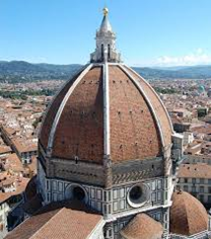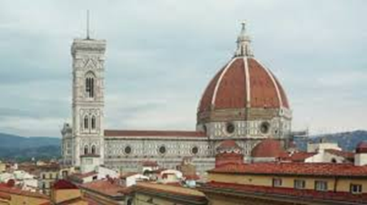

- Palazzo Pitti
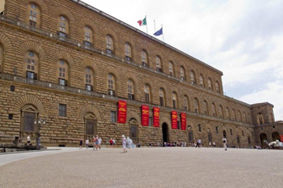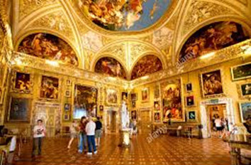
- Alberti
- Façade of Santa Maria Novella
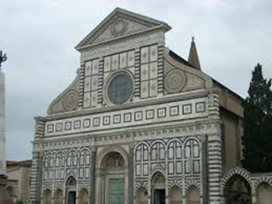
- Ghiberti
- Gates of Paradise (Florence Cathedral)
