Subject: Operations Research
Instructor: Saifullah Jan
___________________________ONLINE Assignment Spring 2019________________________
Note: Attempt this assignment on a paper clearing mentioning your Name, ID NO, Class timing (Monday / Wednesday) at the top of answer sheet. Once complete than take a picture of your answer sheet, convert pictures to pdf. (Make one pdf file) and upload it to sic.

Q 1: The ICARE Company has three plants located throughout a state with production capacity 50, 75 and 25 gallons. Each day the firm must furnish its four retail shops R1, R2, R3, & R4 with at least 20, 20, 50, and 60 gallons respectively. The transportation costs (in Rs.) are given below.
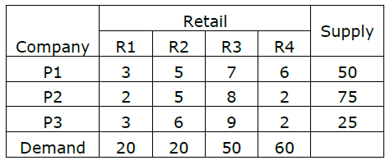
The economic problem is to distribute the available product to different retail shops in such a way so that the total transportation cost is minimum?
10 Marks

Q 2: A company makes two products (X and Y) using two machines (A and B). Each unit of X that is produced requires 50 minutes processing time on machine A and 30 minutes processing time on machine B. Each unit of Y that is produced requires 24 minutes processing time on machine A and 33 minutes processing time on machine B.
At the start of the current week there are 30 units of X and 90 units of Y in stock. Available processing time on machine A is forecast to be 40 hours and on machine B is forecast to be 35 hours.
The demand for X in the current week is forecast to be 75 units and for Y is forecast to be 95 units. Company policy is to maximize the combined sum of the units of X and the units of Y in stock at the end of the week.
Formulate the problem of deciding how much of each product to make in the current week as a linear program.
10 Marks
Q 3: Use Vogel’s Approximation Method to obtain the initial feasible solution of:
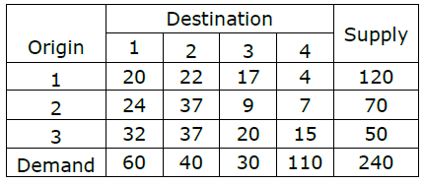 10 Marks

