Final Assignment
Program: BBA/MBA Final Assignment (Spring-2020)
Dated: 24th June, 2020 Time allowed: 06 Hours (05:00 PM to 11:00 PM)
Course Title: Project Management Instructor: Zaighum Abbas
Note: Attempt All Questions Total marks: 50
________________________________________________________________________________
Note: This Assignment should be attempted by word or PDF file. After making a word or PDF file upload this file through SIC portal in an assignment section. You have a limited time of 04 Hours which will automatically closed after the completion of timeline. No file will be accepted after the given time line. (Plagiarism from one source should not be more than 5% and overall should not be more than 19%)
Q1.
Please share ten key learning outcomes from this subject. What is the practical implementation of this subject?
(10 Marks)
Q2.
What are the components of project budget, sequence of these components and explain it with relevant example?
(10 Marks)
Q3.
What is the project quality, its purpose and project quality management processes?

(15 Marks)

Q4.
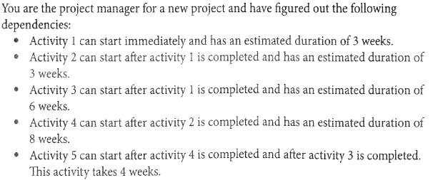
- Draw a Critical path diagram through critical path methods.
- What is the duration of critical path?
- What is the float of activity 3?
- What is the float of activity 2?
- What is the float of the path with the longest float?

Hint for this question
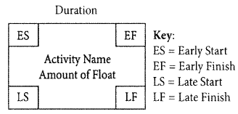
(15 Marks)

