Department of Media Studies and Mass Communication

Date: 24th June 2020
Time: 9am-3pm
Subject: Political Science
Semester: 1st, Fall 2019
Total Marks: 100
Mid-Term: 30
Assignments: 20
Final: 50
NOTE: Attempt all Questions. Write according to the marks mentioned (on the end of Each Question). No unnecessary material required. Plagiarism will be strictly checked. Kindly submit your paper online on SIC in the given time.
Q # 1. Write a note on the following
- Powers of President of Pakistan under the Constitution of 1973.
- Structure of National Assembly.
- Judiciary of Pakistan.
- Conditions of Democracy
- Powers of Election Commission
Marks: 10
Q # 2. View the cartoon carefully and answer the questions:
- Which problem is being highlighted in the picture
- Suggest any four reforms to curb mal practices during elections in Pakistan.
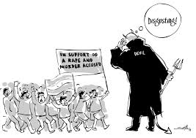
Marks: 10
Q # 3. List the names of speakers and deputy speakers of National Assembly from 1947-2020. Mention the dates of Election after which they are selected as the speaker and deputy speaker. Also describe their roles and responsibilities in National Assembly.
Marks: 15

Q # 4. Compare in your own words the process of evolution of the State from the primitive times to the modern Nation State.
Marks: 15

