Power Transmission and Distribution Lab Manual

Lab No. 14
Fault Analysis of Three-Phase Transmission Line

Objective

Analysis of fault on three-phase transmission system.

Electrical Faults:

Electrical fault is an abnormal condition, caused by equipment failures such as transformers and rotating machines, human errors and environmental conditions. Theses faults cause interruption to electric flows, equipment damages and even cause death of humans, birds and animals. There are mainly two types of faults in the electrical power system. Those are symmetrical and unsymmetrical faults.

Symmetrical faults
These are very severe faults and occur infrequently in the power systems. These are also called as balanced faults and are of two types namely line to line to line to ground (L-L-L-G) and line to line to line (L-L-L).
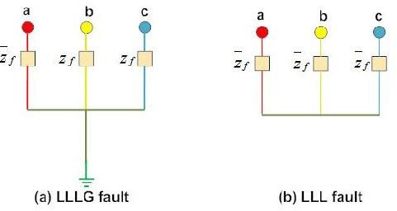

Only 2-5 percent of system faults are symmetrical faults. If these faults occur, system remains balanced but results in severe damage to the electrical power system equipments.

Unsymmetrical faults

These are very common and less severe than symmetrical faults. There are mainly three types namely line to ground (L-G), line to line (L-L) and double line to ground (LL-G) faults.

Power Transmission and Distribution Lab Manual

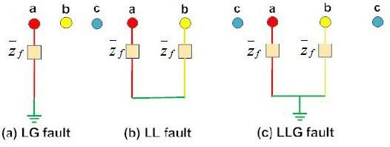

Line to ground fault (L-G) is most common fault and 65-70 percent of faults are of this type. It causes the conductor to make contact with earth or ground. 15 to 20 percent of faults are double line to ground and causes the two conductors to make contact with ground. Line to line faults occur when two conductors make contact with each other mainly while swinging of lines due to winds and 5- 10 percent of the faults are of this type.

These are also called unbalanced faults since their occurrence causes unbalance in the system. Unbalance of the system means that impedance values are different in each phase causing unbalance current to flow in the phases. These are more difficult to analyze and are carried by per phase basis similar to three phase balanced faults.

Steps:

First of all pick Three-phase source from Sim power system electrical sources.

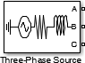

Change its parameters values by double clicking on this block. We are using 11KV phase angle will be zero. We are not changing this value and base value will be same as RMS voltages.

Power Transmission and Distribution Lab Manual

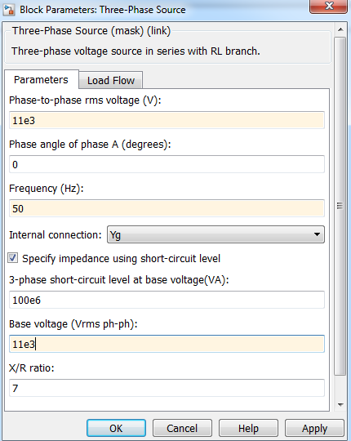

Next we are using the Three-phase circuit breaker. This block contains four input and three outputs. The three inputs are coming from the Three-phase source. The circuit breaker is actuated by some kind of external mechanism relay. So the fourth link is from that relay.
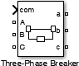

Now to see the breaker parameters double clicking on this block.
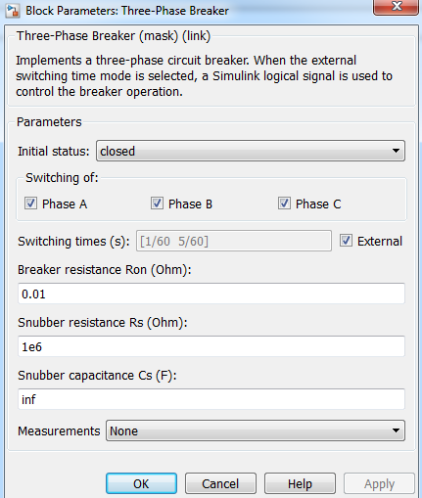
The initial status should be closed. It means circuit breaker is closed. The important thing is that switching time. So we will control it from external source. This is obviously a relay. Next step is

Power Transmission and Distribution Lab Manual

we are doing measurements that how much AC is passing through the system and then the faults occur. This block contains three inputs and three outputs because the inputs are going same to same to the load in the output. But we have to measure the V_{AB} voltage and I_{AB} current.

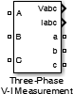

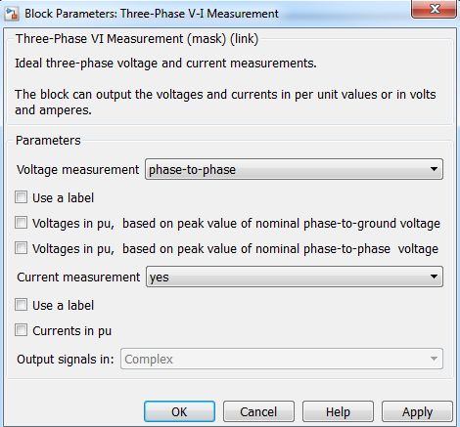
Change the voltage measurement to phase-to-phase and current measurement option to YES.

We are using here Demux with one input and three outputs. The numbers of output are changed as shown above. We are using three phase load so pick up from the Simulink library as shown below.
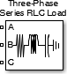

Now change the parameters as shown.

Power Transmission and Distribution Lab Manual

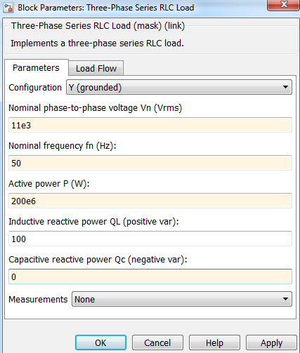

Click on the load flow option and change the load type to constant Z. Next important thing is the three-phase fault.

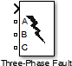

Which will be induced in this circuit and this fault will occurs when the step function actuates this fault mechanism.

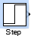

We will set the step time to 0.1. So at 0.1 a pulse will be generated and the fault will be occurred.
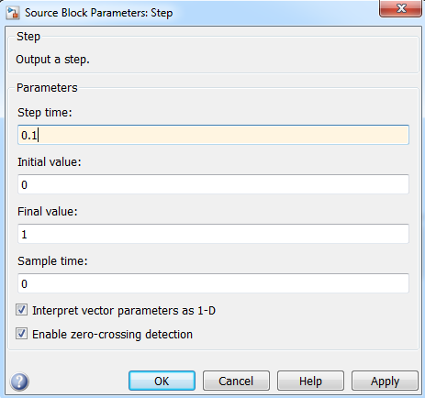

Power Transmission and Distribution Lab Manual

After that the important thing is the relay. This is a kind of subsystem including three inputs and one output. This will be not a practical but a theoretical form of relay because SR flip flops are not used in relay but they can be used in simulations. So here we are just trying to compare the input current and when it cross certain limits e.g. 30 x 10³Amp (i.e. 30KAMP). So this comparison is done to compare two values so we are using this relational operator block.
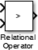

And change the relational operator to greater than sign ―>‖.
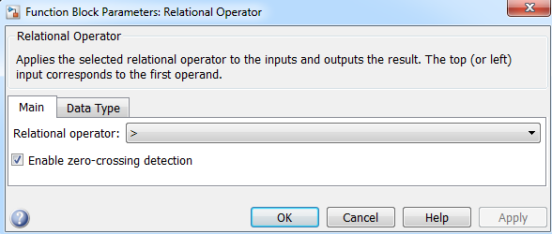
Take the data type to Boolean because we are taking data in terms of binary. After comparison we are giving this output to SR flip flops.
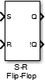

The S port is connected to the output of the relational operator comparison block while the R port is to be connected to the constant block. We are not using the Q port so connect it with a terminator.
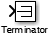

The !Q is just used and this should be connected to the AND logic gate. It is used here so that the when the output will be 1 of the S-R flip flop then the AND gate will be 1.

Power Transmission and Distribution Lab Manual

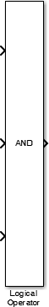

The output of the AND gate will be digital so we use Data type Conversion block.
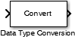

As the output of the AND gate will be digital so convert the output data type from digital to double.
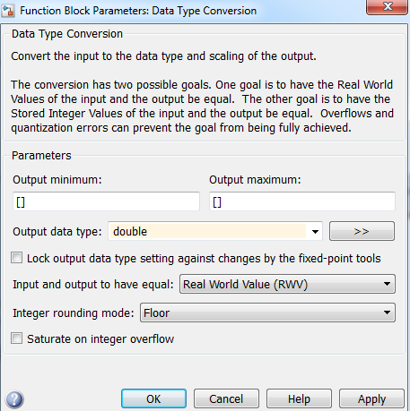
So finally the relay subsystem will look like that as shown below.

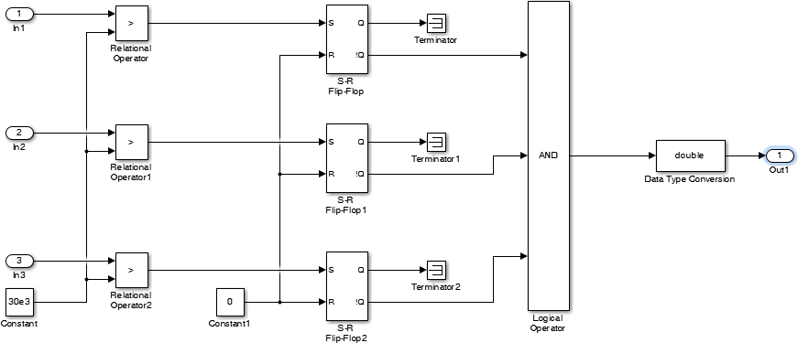

Power Transmission and Distribution Lab Manual

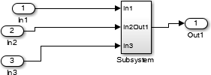

So the relay output will be going to the circuit breaker. As the fault occurs when the current is exceeding from the limit as mention above then the circuit actuates. Our final circuit will be like this as shown below.
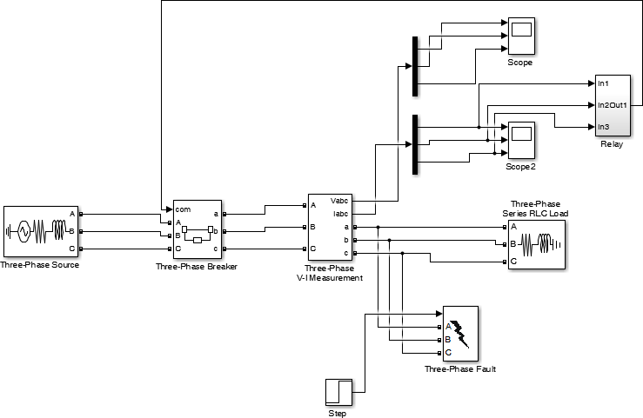

The next important thing is that we select the running simulation time to 0.3 seconds as the fault will occurs at 0.1 seconds. So now run the simulation.
Check the scope output we see current is flowing normally. As we select the step time to 0.1 seconds so you see that at 0.1 second a huge amount of current pass through the circuit which is round about 6x10⁴. This is more than the comparison value. So when this current exceed the relay operate and you can see the current is zero after this fault occurred and reaches up to 0.3 seconds. So the relay operates until unless the current became zero.
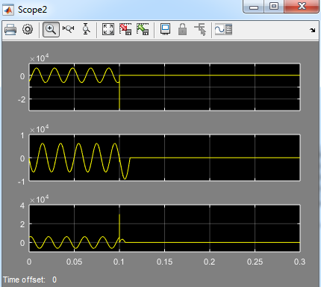

Power Transmission and Distribution Lab Manual

Now when you click on this scope you see the three phase voltage and when the fault occurs at
  - seconds when a short circuit happens and a lot of current is produced so it becomes to almost zero.
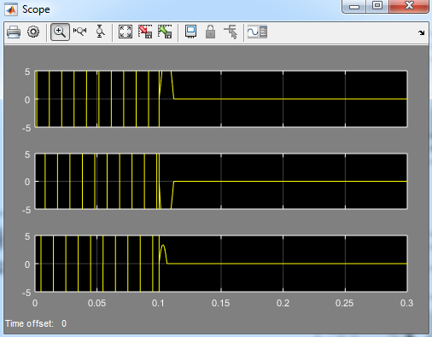

Power Transmission and Distribution Lab Manual

Lab Task:

    - What are the causes of electrical faults?

    - Explain the effects of electrical faults.

    - Explain some of the fault limiting devices.

    - Explain the subtypes of symmetrical and unsymmetrical faults.

Teacher remarks:

Obtained Marks: / 10

