Power Transmission and Distribution Lab Manual

Objective
Lab No. 07 Coupler panel connection

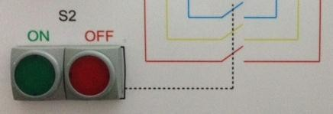
To determine and understand the coupler panel connection.

Theory
Coupler is a device which is used to couple one bus to the other without any interruption in power supply and without creating hazardous arcs. It is achieved with the help of circuit breaker and isolators.
Bus coupler is used also for segregation of buses. If there is continuous fault in any bus results to shutdown of all feeders if bus coupler is there faulty section will only get affected others remain healthy. This will improve the reliability of substation.

Experiments
Use three phase main supply to online coupler panel.

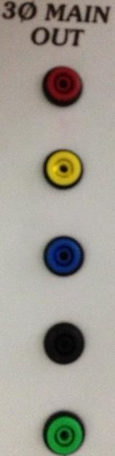
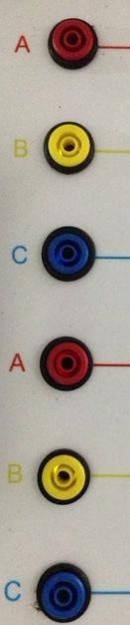
After connect three phase wire coupler panel then press ON (GREEN) the S1 switch to through the supply S2.

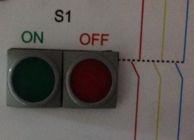
When press S1 switch so the supply stand on S2 switch, Then press ON (GREEN) button S2 and the supply through on S3.

Power Transmission and Distribution Lab Manual

Then press S3 ON (GREEN) button then supply through on the (A, B, C) connector of 2nd alternative supply output. Check voltage supply with digital multi meter (Caution high voltage).

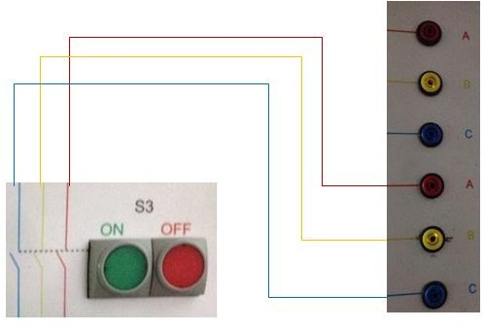

Power Transmission and Distribution Lab Manual

Lab Task:

Q1: Draw the schematic diagram of the power distribution in Industries.

Q2: Explain LT panel, sub-LT panel, SDB (sub-distribution board), PDB (power distribution board) and LDB (lighting distribution board).

Q3: Write your Observation and Conclusion about this lab.

Teacher remarks:

Obtained Marks: / 10

