Power Transmission and Distribution Lab Manual

Lab No. 01

Objective:
Electrical Safety & Precaution

To determine the basic electrical safeties for home and industry.

Theory:
Electrical Safety Principles
- When planning and performing work on electrical Home wiring systems and equipment, keep these principles in mind:
- Understand the procedure completely before starting the work.
- Use good quality footwear/shoes in order to provide maximum resistance.
- Never energize any circuit unless you are sure that no one is working on the circuit. Give electric supply to the wiring system only after thorough verification.
- Before replacing a blown fuse always remember to put the switch off.
- Do not touch switch boards, main switches, holder points etc. with wet hands. Do not use broken switches, sockets or plug.
- Use non-conductive tools whenever possible.
- Before putting the plug pins in socket put off the plug switch and disconnect the plug by pulling the plug pin and not by pulling cable.
- Take utmost care while handling lamps, lamp holders, switches etc. because these materials are brittle.
- Before beginning work, tie back long hair, and roll up loose sleeves.
- Know the location and how to operate shut-off switches and/or circuit breaker panels. Use these devices to shut off equipment in the event of a fire or electrocution.

Study of safety devices Important of safety devices:

  - The safety features are inbuilt with electric power distribution. The current is to flow through the path it is expected to pass and should not take another path through which it is not expected to pass. Conductors made of copper or aluminum are provided across the path for carrying the current and insulators like PVC, paper or rubber are provided across the path through which the current is not expected to flow.
  - Under abnormal condition there can be failure of insulations and current will flow through the undesired path which can cause damage to

Power Transmission and Distribution Lab Manual

equipments and more important the safety of the user. Sometimes the user may inadvertently touch a live conductor and cause electric shock. The circuit may also carry under short circuit condition much more than normal value of the current. The inbuilt safety features will isolate the faulty circuit from the rest of the supply.
  - The very high currents caused by short circuit situation can cause lots of damage to electrical installation. Protective devices are needed to break short-circuit and overload currents.
  - Circuit breakers and fuses are protective devices that control the power going to a particular route of wiring. In case of an overload or a short on that circuit, the breaker or fuse trips and automatically shuts off power to that circuit. Fuses are the commonly used protection devices to protect components like wires, transformers electronics circuit modules against overload. The general idea of the fuse is that it "burns fuse link" when current gets higher than its rating and thus stops the current flowing.

Types of safety devices

Fuse
Circuit breakers (MCB, MCCB & ELCB) Earthing

Basically two types of protections are provided in the power supply system of domestic consumers.

- Protection from over current.
- Protection from leakage current due to failure of insulation or inadvertent contact with live conductors by the user.

Over current and Short circuit

One type of situation that wiring needs to be protected against is over current. The electrical wiring is rated for certain maximum current. If you try to pull more current through it, the wiring will heat considerably. When the wiring heats too much, it will cause the melting of cable insulation, cause fire if there is something flammable near cable and even melt the copper conductors in the cable. So protection is needed to guarantee that in case of something tries to pull too much current through mains wiring, this cannot happen for any long time until the fuse blows and stops the current.
Many people are familiar with a "short circuit", which is a type of fault that occurs when two conductors of an electric circuit touch each other. The current flow caused by a short circuit is usually high and rapid and is quickly detected and halted by conventional circuit protective devices, such as fuses or circuit breakers.

Power Transmission and Distribution Lab Manual

Protection against over current

Every electrical circuit shall be protected against over current by suitable over current devices. These devices could be
- Miniature Circuit Breaker (MCB)
- Moulded Case Circuit Breaker
- Semi enclosed re-wirable fuses
- High Rupturing Capacity (HRC) fuses
Typical breaking capacities of protective devices are as follows: HRC fuses - 80 kA
MCB - 16 kA
Rewirable fuses - 1 to 4 kA

Protection against electrocution

The use of exposed, substandard, badly wired, wrongly connected or damaged equipment as well as frayed or badly repaired cables reduces the safety of an installation and increases the risk of person receiving an electric shock. Electrocution is a passage of current through human body, which is dangerous. The flow of current through human body effects vital functions.

- Breathing
- Heartbeat

A correctly chosen RCCB can detect small currents flowing to earth and reduces the risk of electrocution. Effect of electric current through human body has been well researched and following chart summarizes the results:

Human sensitivity to electricity
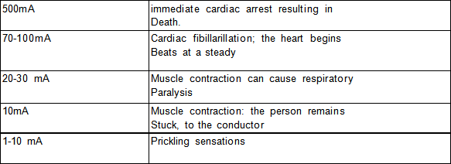

However, electrocution should not be viewed in terms of current alone but in terms of contact voltage. A person gets electrocuted by coming in contact with an object that

Power Transmission and Distribution Lab Manual

has a different potential from his/her own. The difference in potential causes the current to flow through the body.

The human body has known limits:
- Under normal dry conditions, voltage limit = 50V.
- In damp surroundings, voltage limit = 25V.

FUSES

Fuse is a wire of short length having low melting point which gives protection against excessive current. This excessive current may be due to over load or short circuit. Under normal working condition the current flowing through the circuit is within safe limit. But when some faults such as short circuit occurs the current exceeds the safe limit value, the fuse wire gets heated and melts. This will cause breaking of the circuit. After one fusing operation, fuse wire must be rewired with the same size wire.
This basic guide will help you decide which fuse to fit to ensure the safe use of your household appliances.

  - Appliances up to 700 Watts = 3 Amp fuse
  - Appliances between 700 and 1000 Watts= 5 Amp fuse
  - Appliances over 1000 Watts = 13 Amp fuse

COMMON FUSE TYPES

  - Rewirable Fuse
  - Cartridge Fuse
  - HRC Fuse

Rewirable Fuse:
This is the cheapest method for protecting a circuit from short circuit. Wires of different diameters made of lead and tin are used in the circuit. When large current flows these wires melts and disconnects the faulty circuit from the rest of the supply.
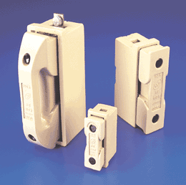
There are different types of fuses. The usual type is the rewirable type in which the fuse wire is carried in a removable fuse link (Fig. a). The fuse link is made of porcelain or other suitable insulating material. The fuse carrier is push-fitted to the fuse base to make the connection through. An advantage of this type is that the blown fuse wire can be replaced with negligible cost. But there is a chance of selecting a wrong size of fuse wire. Another disadvantage with rewirable fuse is that it may sometimes lead to fire hazards, when the fuse wire blows.
Fig: (a) Rewirable Fuse

Power Transmission and Distribution Lab Manual

The semi enclosed rewirable fuses has the following drawbacks:
  - It normally melts on 50 % to 100 % excessive overload. The melting current cannot be accurately predicted.
  - It takes time to rewire the fuse.
  - Standard fuse wire should be always made available. However it is the cheapest mode of protection from short circuit.

Cartridge Fuse
Cartridge fuse consists of a tube with metal end caps at both ends (Fig. b). The tube is usually made of glass with no filling material. The fuse wire is placed inside the tube, connected between the end caps. Since the tube is made of glass, the fuse element can be easily inspected for breakage. When the fuse is blown, the whole cartridge has to be replaced. The advantages of cartridge fuses are, quick and easy replacement and the fuse rating is marked on the end cap of the cartridge itself.
Cartridge fuses are mainly: used in various electrical and electronic equipment.
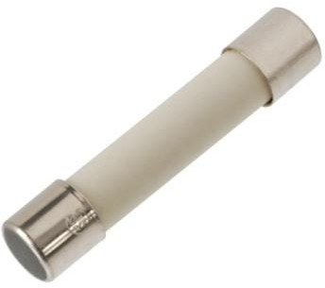
Fig: (b) Cartridge Fuse

High Rupturing Capacity Fuse (HRC):

This is a completely enclosed cartridge type of fuse. These fuses are screwed or linked in the circuit. Generally it is used in the high power circuits. High Rupturing Capacity (HRC) fuse consists of a porcelain tube, with metal end caps and fixing tags (Fig. c). The fuse element is held inside the tube between the end caps and the tube is filled with silica sand or granulated quartz. When the fuse element blows, the silica inside the tube prevent the formation of an arc, and thus avoids the possibility of fire hazards. HRC fuse links are available in a range of 10A to 800A.
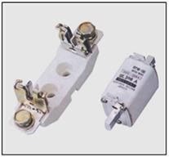
Fig: (c) High Rupturing Capacity (HRC) Fuse

Power Transmission and Distribution Lab Manual

The HRC fuse has the following advantages:
  - It is very reliable.
  - It has an enclosed fuse wire, therefore no chance of its arc doing any damage to the surroundings.
  - It has low temperature rise at rated load.
  - Maintenance free. The drawbacks are:
- It is costly.
- Take time to replace the fuse.

Circuit breakers MCB and ELCB
MCB is miniature circuit breaker. It is automatic in action. When excessive current passes through the circuit, handle of MCB will moves down and thus trips the circuit. After one such an operation we can manually reset the supply by solving the fault in that circuit.
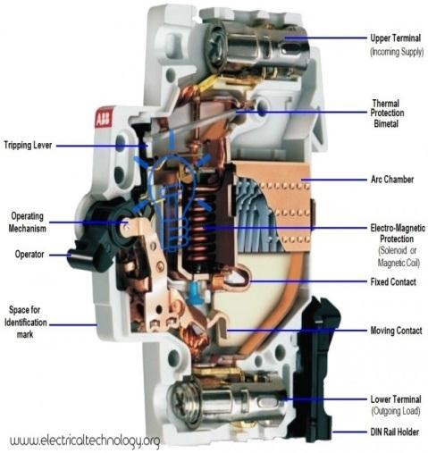
Fig: (d) Miniature Circuit Breaker

ELCB is earth leakage circuit breaker. It protects the circuit from any leakage of current. It protects the circuit from lightning and thunder.
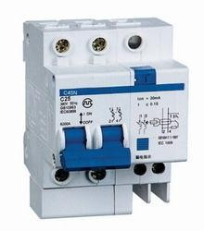
Fig: (e) Earth Leakage Circuit Breaker

Power Transmission and Distribution Lab Manual

Earthing

What is earthing /grounding?

Earthing or grounding is the term used for electrical connection. Equipment or a system is said to be 'earthed' when it is effectively connected to the ground with a conducting object. Earthing provides protection to personal and equipment by ensuring operation of the protective gear and isolation of faulty circuit during:

- Insulation failure
- Accidental contact
- Lightning strike

For large current to flow, earth resistance should be low. To achieve this, proper earthing has to be done.
Earthing is classified as:
- System earthing
- Equipment earthing

Some Definitions:

Earthing:
A tower/equipments connecting to the general mass of earth by means of an electrical conductor.

Earth Electrode: Connection to earth is achieved by electrically connecting a metal plate, rod or other conductors or an array of conductors to the general mass of earth. This metal plate or rod or conductor is called as "Earth electrode".

Earth lead: The conductor by which connection to earth is made.

Earth loop impedance: The total resistance of earth path including that of conductors, earth wire, earth leads and earth electrodes at consumer end and substation end.

Factors affecting the value of earth electrode resistance

- Electrode material.
- Electrode size.
- Material and size of earth wire.
- Moisture content of soil.
- Depth of electrode of underground.
- Quantity of dust and charcoal in earth pit.

Earth resistance consists of following components

- Resistance of metal electrode

Power Transmission and Distribution Lab Manual

- Contact resistance between electrode and soil
The resistance decreases with the presence of moisture and salt in soil. To increase the effectiveness of earth, the total earth resistance should be reduced. Efforts should be made to reduce the resistance contributed by each of above components.

Earth Electrodes

Earth electrodes can be following shapes

- Driven Rods or pipes
- Horizontal Wires
- Four Pointed Stars
- Conductive Plates
- Round Vertical plates
- Square Vertical Plates
- Buried Radial Wires
- Spheres made of metal
- Water Pipes

Effect of Soil Properties in Earthing

While it is not possible to change the fundamental nature /properties of soil at a given location, but local variations of soil conditions do occur even in a small area. When a location for making earthing pit has to be selected, preference should be given to location, which is likely to give minimum electrical resistance. In the list below, soils have been arranged in ascending order with regard to their electrical resistance.
- Wet marshy lands, or lands containing ashes (Avg Resistivity 2400 ohm cm)
- Clay, loamy soil, arable land clay
- Clay & loam mixed with varying proportion of gravel & sand (Avg Resistivity 15,800 ohm cm)
- Damp & wet sands
- Dry sand
- Gravel & Stones

Power Transmission and Distribution Lab Manual

Lab Task:

Q1: Briefly explain types of safety devices.

Q2: What do you know about short circuit and overvoltage?

Q3: What is the difference between earthing and grounding?

Q4: What is meant by neutral link??

Q5: Which components affect earth resistance?

Q6: Write your observation and opinion about this lab.

Teacher remarks:

Obtained Marks: / 10

