http://upload.wikimedia.org/wikipedia/commons/9/9c/Inu_peshawar_logo.gif**Department of Electrical Engineering**

**Final Examination Summer-20**

**Subject: Power System Analysis**

**Electrical Engineering**

**Engr. Shayan Tariq Jan Max Marks: 50**

**Time Allowed: 180 minutes 23rd Sep, 2020**

**ATTEMPT ALL QUESTIONS**

**Question No: 1**

1. A three-phase 765-kV, 60-Hz, 300-km, completely transposed line has impedance and admittance of ***z = 0.0165 + j0.3306 ohm/km*** andy = j4.674 x 10-6 S/km. Calculate the exact ABCD parameters of the line. (10)

**Question No: 2**

1. What is surge impedance of transmission lines and how can it be found (5)
2. What are the different reactive power compensation techniques used in transmission lines (5)

**Question No: 3**

1. Draw and explain the equivalent fault circuit diagram of the following three phase circuit, and then draw and explain the post fault condition of the circuit. (5)

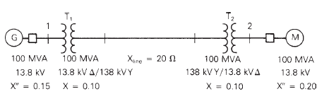

1. A fault occurs in the above system. The fault voltage is 1.05<0 kV. The load current is 3.984<-18.19 kA. Find the fault current and Generator current. (5)

**Question No: 4**

1. What are bus-bars and what are the type of bus bars used in transmission lines (4)
2. What is the effect of Voltage on the number of insulators, distance from ground and distance between phases of Transmission Lines (5)

**Question No: 5**

