Subject: Discrete Structure
Instructor: Saifullah Jan
___________ONLINE FINAL Assignment Spring 2019_______________
Note: Attempt this assignment on a paper clearing mentioning your Name, ID NO, Class timing (Monday / Wednesday) at the top of answer sheet. Once complete than take a picture of your answer sheet, convert pictures to pdf. (Make one pdf file) and upload it to sic.

Q 1: Determine whether the graphs are bipartite.
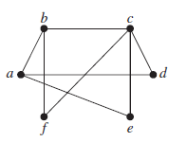
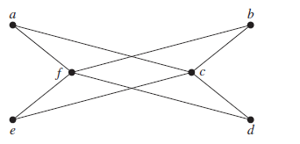
- (ii)

Q 2: Determine whether the given pair of graphs is isomorphic.

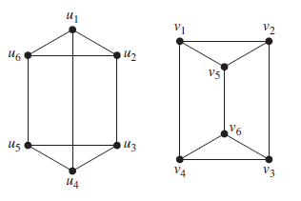

(i)
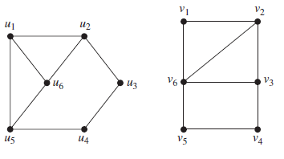
(ii)

Q 3: Are the simple graphs with the following adjacency matrices isomorphic?

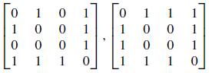
(i)
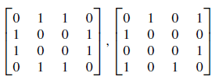
(ii)
Q 4: Determine whether the given graph has an Euler circuit. Construct such a circuit when one exists. If no Euler circuit exists, determine whether the graph has an Euler path and construct such a path if one exists.
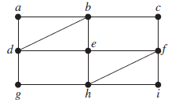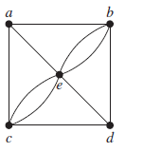
- (ii)
Q 5: Determine whether the given graph has a Hamilton circuit. If it does, find such a circuit. If it does not, give an argument to show why no such circuit exists.

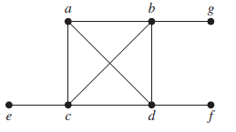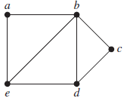
- (ii)

