Art History
Medieval Era
- In the history of Europe, the Middle Ages or Medieval Period lasted from the 5th to the 15th century. It began with the fall of the Western Roman Empire and merged into the Renaissance and the Age of Discovery.

- The 'Middle Ages' are called Medieval because it is the time between the fall of Imperial Rome and the beginning of the Early Modern Europe. ... The fall of the Roman Empire, and the invasions of barbarian tribes, devastated European towns and cities and their inhabitants

Middle Ages in Europe (400- 1400)
- The 1,000 years that followed the fall of the Western Roman Empire have been called the medieval period or the Middle Ages
- Because they came between the fall of the Roman Empire and the rebirth or Renaissance of Greco-Roman ideas in the 15th century

Medieval Art
- Art historians attempt to classify medieval art into major periods and styles, often with some difficulty
- A generally accepted scheme includes the later phases of Early Christian art, Migration period art, Byzantine Art, Romanesque Art and Gothic Art, as well as many other periods within these central styles.
- In addition each region, mostly during the period in the process of becoming nations or cultures, had its own distinct style, such as Anglo-Saxon Art or Norse Art.

Early Medieval Art
- Early Medieval art had three major influences: Christianity, the classical world of Rome and the pagan North. ... The cultures of the pagan North, including the Anglo-Saxons and the Celts, added their intricate patterns and designs to early Medieval art
- The art of the early Middle Ages took shape as Early Christian art absorbed a new influence: the art of the invaders.
- Many nomadic peoples traveled across the Eurasian grasslands, which extend from northwest China to central Europe.
- Their migration occurred over a long period that began in the 2nd millennium BC and lasted well into the Middle Ages.
- These “barbarians” were considered a constant threat and Hadrian’s Wall + Great Wall of China were both built to keep them out.
- The meeting of decorative nomadic style with Christianity can be seen most clearly in the illustrated holy books created in Ireland

The Irish
- The Irish had never been part of the Roman Empire, and in the 5th century they were Christianized without first becoming Romanized.
- During the chaotic centuries that followed the fall of Rome, Irish monasteries became the major centers of learning and the arts in Europe
- They produced numerous hand-lettered copies of religious manuscripts.

Book of Kells, Ireland, late 8th Century
Inks + Pigments on Vellum
- The initial letters in these manuscripts were increasingly embellished over time, moving first into the margin and then onto a separate page.
- The initial page is known as the “Chi-Rho monogram” because it is composed of the first two letters of Christ in Greek (XP) and is used to represent Christ or Christianity.
- Except for XP and two Latin words beginning the story of Christ’s birth, most of the page is filled with a rich complexity of spirals and tiny interlacing.
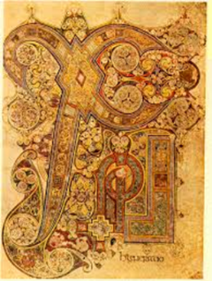

- The main purpose for drawing was to produce art mainly to glorify God and to teach religion.
- Painting and drawing merged in the illustration of Bibles and prayer books produced by monks, called Illuminated Manuscripts
- These beautifully decorated manuscripts were hand-lettered on vellum (calfskin), or later, on paper.
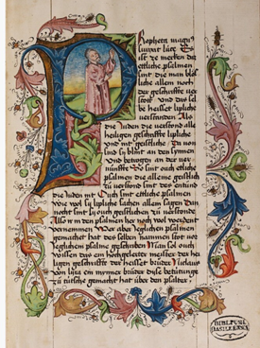
- The medieval art of the Western world covers a vast scope of time and place, over 1000 years of art in Europe, and at times the Middle East and North Africa.
- Medieval life was consumed by superstition, unsanitary conditions and an extreme form of Christianity.
- Medieval art in Europe grew out of the artistic heritage of the Roman Empire and the iconographic traditions of the early Christian church
- The rise and power of the Christian church consumed all of Medieval Western life.
- Daily life was under the eye of the God and the teachings of the Church

Medieval and the Body
- Medical knowledge in the Middle Ages must have appeared to have stood still.
- In Britain, as an example, most things linked to the Romans was destroyed –villas were covered up as the Ancient Britons believed that they contained ghosts and evil spirits
- Medicine became steeped in superstition and the Roman Catholic Church effectively dominated what direction the medical world took.
- Any views different from the established Roman Catholic Church view could veer towards heresy with the punishments that entailed.
- Therefore, when the Roman Catholic Church stated that illnesses were punishments from God and that those who were ill were so because they were sinners, few argued otherwise.
- As a result, very little was known about the body and how it functioned. Little was known about diseases and many medical schools were closed.
- In many parts of the medieval Europe, operations and dissection were illegal.

Characteristics of Medieval Paintings
- Vivid use of color
- Lack of perspective/ space
- Lack of accurate scale and proportion
- Most works created for the church
- Thus most works are religious (mostly saints and the Holy Family)
- Human bodies are thus subjected to Catholic ideologies
- Medieval paintings were also called illuminations since there were no portrait paintings during this time.
- The term illumination was inspired by the gleaming effect of a gold leaf, which was often applied to the pages of the manuscript together with ink and paint
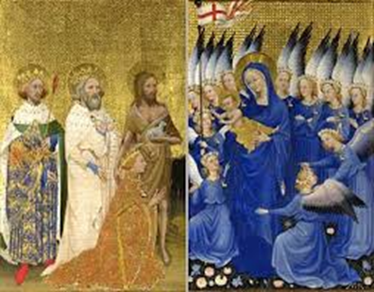
- Unlike paganism, Christianity required no images of naked divinities, and new attitudes cast doubt and opprobrium on nude athletics, public bathing, and the very value of the human body.
- The early Christian emphasis on chastity and celibacy further discounted depictions of nakedness.
- In this climate, there was little motive to study the nude, and unclothed figures are thus rare in medieval art.
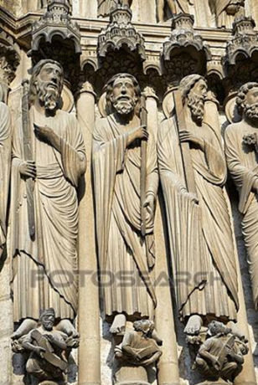

The Head in the Middle Ages
- The head was the chief symbolic part of the body for Western culture in the Middle Ages
- Since antiquity it signified not only the intellect, the center of power, but was also regarded as the seat of the soul.
- The face is not only central to identity, but is also the primary vehicle for human expression, emotion, and character.
- Depiction of the head becomes a true test of the quality of the artist and a telling indicator of style.
- Thus, the head becomes the only true sense of reality in the Medieval period.
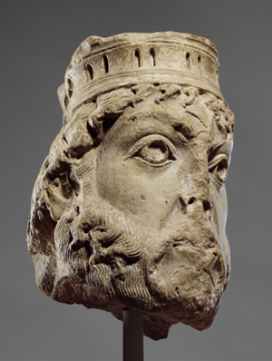 (Head of King David
Date: ca. 1145 Paris, France)

ARENA CHAPEL PADUA, ITALY 1305

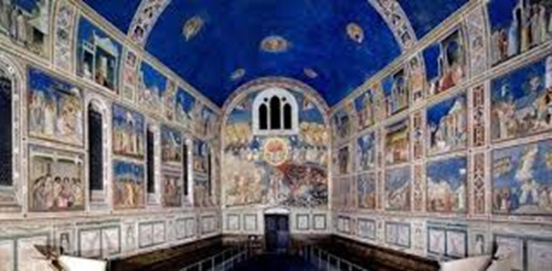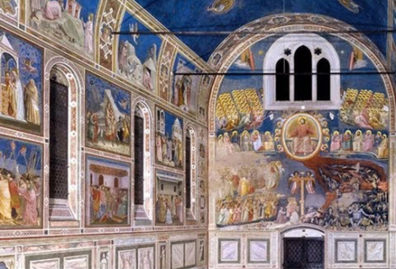

Giotto
Lamentation of Christ
Arena Chapel Padua, Italy 1305

- Giotto and his team covered all the internal surfaces of chapel with frescos, including the walls and the ceiling.
- The largest element is extensive cycles showing the Life of Christ and the Life of the Virgin
- Lamentation= After Jesus was crucified, his body was removed from the cross and his friends mourned over his body
- Space + foreground and background.
- Elongated body
- Emotion is back
