Shearing Stress

Forces parallel to the area resisting the force cause shearing stress. It differs to tensile and compressive stresses, which are caused by forces perpendicular to the area on which they act. Shearing stress is also known as tangential stress.

where V is the resultant shearing force which passes which passes through the centroid of the area A being sheared.
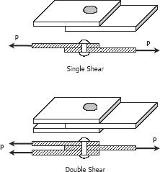

SOLVED PROBLEMS IN SHEARING STRESS

Problem 115

What force is required to punch a 20-mm-diameter hole in a plate that is 25 mm thick? The shear strength is 350 MN/m².

Solution 115
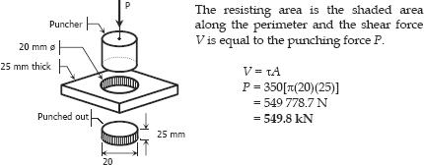

Problem 116

As in Fig. 1-11c, a hole is to be punched out of a plate having a shearing strength of 40 ksi. The compressive stress in the punch is limited to 50 ksi. (a) Compute the maximum thickness of plate in which a hole 2.5 inches in diameter can be punched. (b) If the plate is 0.25 inch thick, determine the diameter of the smallest hole that can be punched.

Solution 116
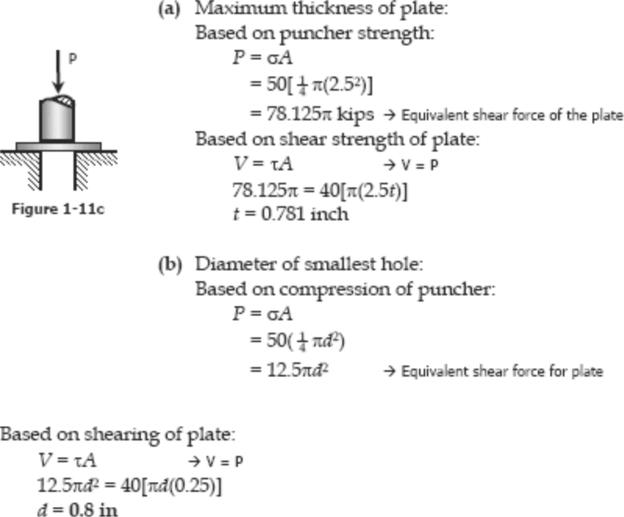

Problem 117

Find the smallest diameter bolt that can be used in the clevis shown in Fig. 1-11b if P = 400 kN. The shearing strength of the bolt is 300 MPa.

Solution 117
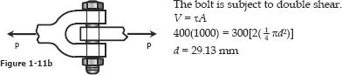

Problem 118

- 200-mm-diameter pulley is prevented from rotating relative to 60-mm-diameter shaft by a 70-mm-long key, as shown in Fig. P-118. If a torque T = 2.2 kN·m is applied to the shaft, determine the width b if the

allowable shearing stress in the key is 60 MPa.

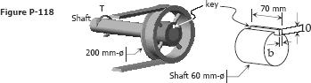

Solution 118
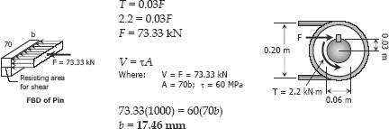

Problem 119

Compute the shearing stress in the pin at B for the member supported as

shown in Fig. P-119. The pin diameter is 20 mm.
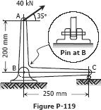

Solution 119
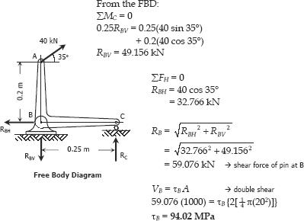

Problem 120

The members of the structure in Fig. P-120 weigh 200 lb/ft. Determine the smallest diameter pin that can be used at A if the shearing stress is limited to 5000 psi. Assume single shear.
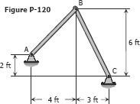

Solution 120
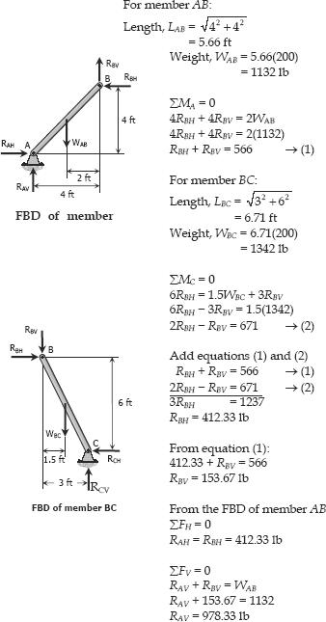

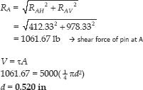

Problem 121

Referring to Fig. P-121, compute the maximum force P that can be applied by the machine operator, if the shearing stress in the pin at B and the axial stress in the control rod at C are limited to 4000 psi and 5000 psi, respectively. The diameters are 0.25 inch for the pin, and 0.5 inch for the control rod. Assume single shear for the pin at B.
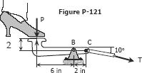

Solution 121
