Simple Stresses

Simple stresses are expressed as the ratio of the applied force divided by the resisting area or

- = Force / Area.

It is the expression of force per unit area to structural members that are subjected to external forces and/or induced forces. Stress is the lead to accurately describe and predict the elastic deformation of a body.

Simple stress can be classified as normal stress, shear stress, and bearing stress. Normal stress develops when a force is applied perpendicular to the cross-sectional area of the material. If the force is going to pull the material, the stress is said to be tensile stress and compressive stress develops when the material is being compressed by two opposing forces. Shear stress is developed if the applied force is parallel to the resisting area. Example is the bolt that holds the tension rod in its anchor. Another condition of shearing is when we twist a bar along its longitudinal axis. This type of shearing is called torsion and covered in Chapter 3. Another type of simple stress is the bearing stress, it is the contact pressure between two bodies.

Suspension bridges are good example of structures that carry these stresses. The weight of the vehicle is carried by the bridge deck and passes the force to the stringers (vertical cables), which in turn, supported by the main suspension cables. The suspension cables then transferred the force into bridge towers.
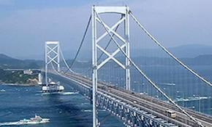

Normal Stress

Stress

Stress is the expression of force applied to a unit area of surface. It is measured in psi (English unit) or in MPa (SI unit). Another unit of stress which is not commonly used is the dynes (cgs unit). Stress is the ratio of force over area.

stress = force / area

Simple Stresses

There are three types of simple stress namely; normal stress, shearing stress, and bearing stress.

Normal Stress

The resisting area is perpendicular to the applied force, thus normal. There are two types of normal stresses; tensile stress and compressive stress. Tensile stress applied to bar tends the bar to elongate while compressive stress tend to shorten the bar.

where P is the applied normal load in Newton and A is the area in mm². The maximum stress in tension or compression occurs over a section normal to the load.
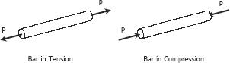

SOLVED PROBLEMS IN NORMAL STRESS

Problem 104

A hollow steel tube with an inside diameter of 100

- must carry a tensile load of 400 kN. Determine the outside diameter of the tube if the stress is limited to 120 MN/m².

Solution 104
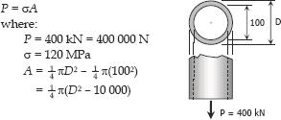
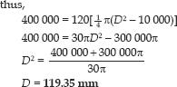

Problem 105

A homogeneous 800 kg bar AB is supported at either end by a cable as shown in Fig. P-105. Calculate the smallest area of each cable if the stress is not to exceed 90 MPa in bronze and 120 MPa in steel.

Figure P-105
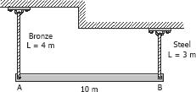

Solution 105
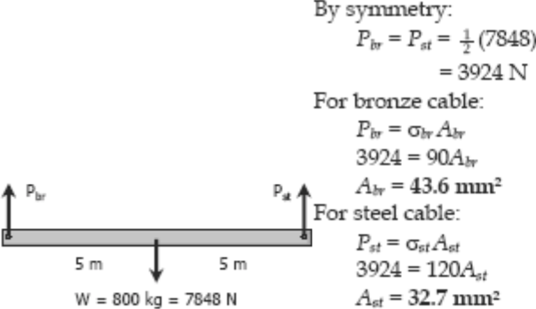

Problem 106

The homogeneous bar shown in Fig. P-106 is supported by a smooth pin at C and a cable that runs from A to B around the smooth peg at D. Find the stress in the cable if its diameter is 0.6 inch and the bar weighs 6000 lb.
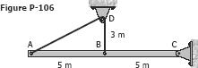

Solution 106
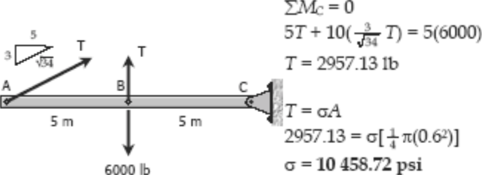

Problem 107

A rod is composed of an aluminum section rigidly attached between steel and bronze sections, as shown in Fig. P-107. Axial loads are applied at the positions indicated. If P = 3000 lb and the cross sectional area of the rod is 0.5 in², determine the stress in each section.
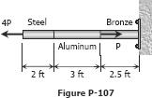

Solution 107
