Textile Analysis
(Week 12)

Textile Repeat:
The point where an identical design begins again on a textile is called a repeat. Textile designers use repeats because they can enable large pieces of fabrics to be printed without breaks or awkward gaps in a pattern.
A repeat on a textile is where an identical figure or pattern begins again. The term also means the distance or number of inches between the replicated figures. Repeats can be vertical or horizontal. ... And a random repeat places the figure across the fabric surface without using an underlying geometric pattern.

Mirror Repeat:
A mirror repeat can provide quite an interesting look if done right. Depending on the motif, you can sometimes end up with odd bits that have mirrored, creating a new object and now look a little out of place.
To create a mirror repeat, you duplicate your motif horizontally and then select the ‘mirror’ option in your design program.
You then duplicate both motifs across the same horizontal line.
Repeat this process vertically and you will have an all over mirrored repeat.
ASSIGNMENT:
- Firstly draw 10cm x 10cm block in sketch book and then draw design or pattern with use of curve lines in that square block.
- After finalizing your design then cut one piece of the scholar sheet in size of 10cm x 10cm and trace that curve line design on it.
- Now cut another piece of the scholar sheet in size of 20cm x 20cm and trace that same design on it in mirror repeat by flipping that 10 cm x 10cm design four times on it.
- When tracing of four blocks is complete on 20cm x 20cm piece then paint it with poster colors.
- Use 5 colors of your own choice in that design as a color combination.
- After completing your assignment paste it on a black chart and put it in your pocket file. (As you did it with your pervious assignments e.g. fibers & dye samples)
EXAMPLE:
Look into this example step by step properly and carefully to get an idea about mirror repeat, then after that you have to make your design, as all details and instructions are mentioned above for the assignment.

MIRROR REPEAT
Step 1:
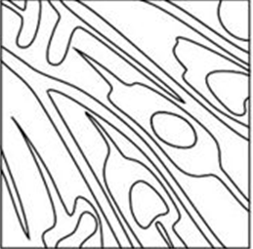 (Make 10cm x 10cm block)

Step 2:
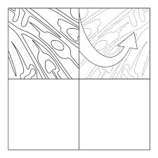 On 20cm x 20cm size, repeat that design in mirror
Repeat by flipping)
Step 3:
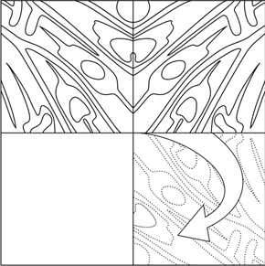
Step 4:
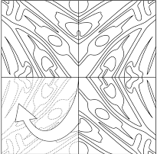

Step 5:
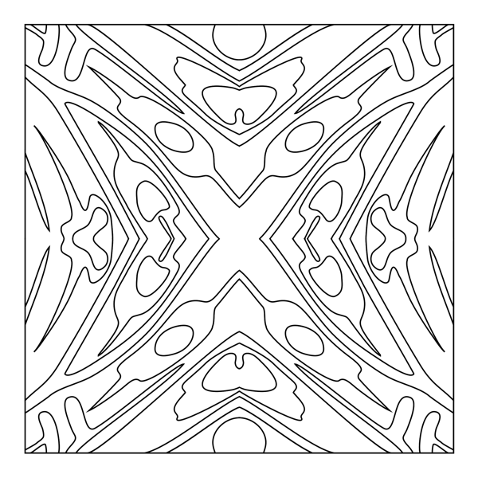
(Final design view of mirror repeat on 20cm x 20cm size)
Step 6:

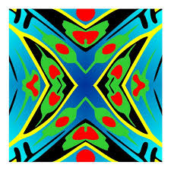(Paint your design in 5 colors)

Note:
Make sure while doing mirror repeat joining of your design will be set properly in central part of your 20cm x 20cm sheet.

Another sample view of mirror repeat for your further understanding & clarity regarding repeat setting:
