Operating System Deadlocks

What Is In This Chapter?

- What is a deadlock?

- Staying Safe: Preventing and Avoiding Deadlocks

- Living Dangerously: Let the deadlock happen, then detect it and recover from it.

DEADLOCKS

EXAMPLES:

- "It takes money to make money".

- You can't get a job without experience; you can't get experience without a job.

BACKGROUND:

The cause of deadlocks: Each process needing what another process has. This results from sharing resources such as memory, devices, and links.

Under normal operation, a resource allocations proceed like this:

- Request a resource (suspend until available if necessary).
- Use the resource.
- Release the resource.

Bridge Crossing Example:

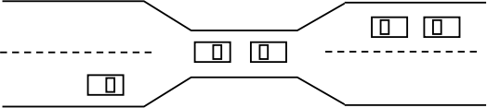

- Traffic only in one direction.
- Each section of a bridge can be viewed as a resource.
- If a deadlock occurs, it can be resolved if one car backs up (Preempt resources and rollback).
- Several cars may have to be backed up if a deadlock occurs.
- Starvation is possible.

NECESSARY CONDITIONS

ALL of these four must happen simultaneously for a deadlock to occur:

  - Mutual exclusion:

One or more than one resource must be held by a process in a non-sharable (Exclusive) mode.

  - Hold and Wait

A process holds a resource while waiting for another resource.

  - No Preemption

There is only voluntary release of a resource - nobody else can make a process give up a resource.

  - Circular Wait

Process A waits for Process B waits for Process C waits for Process A.

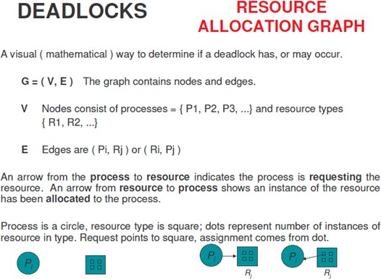

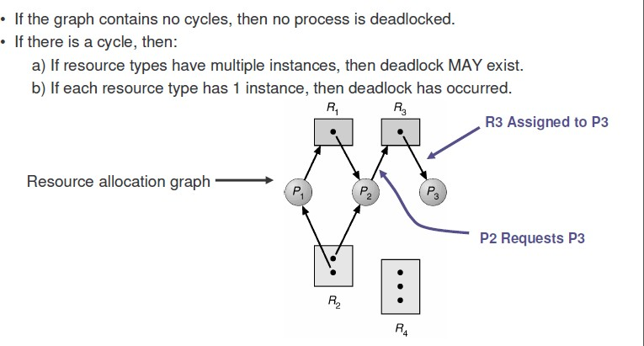

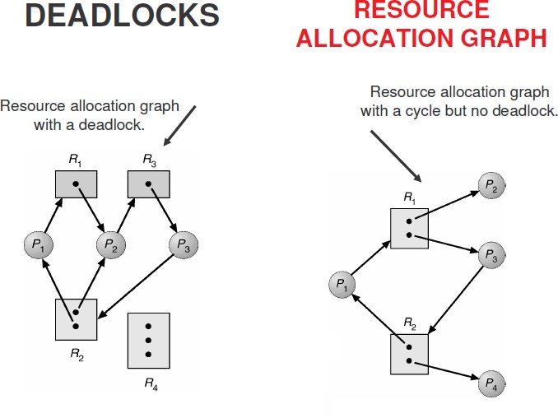

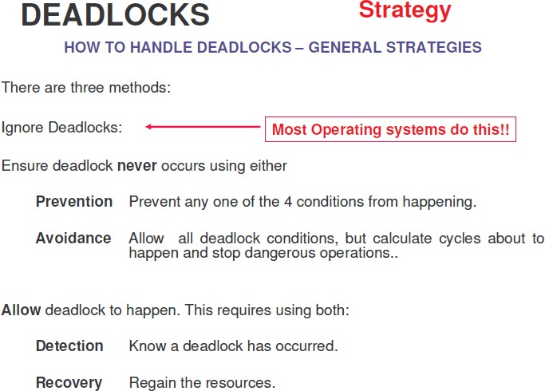

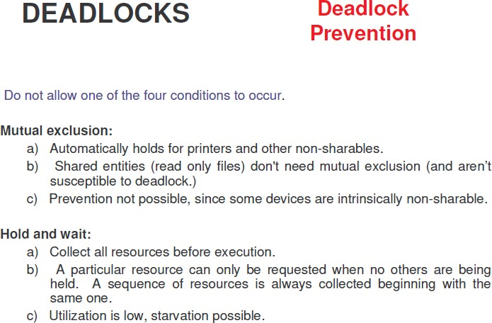

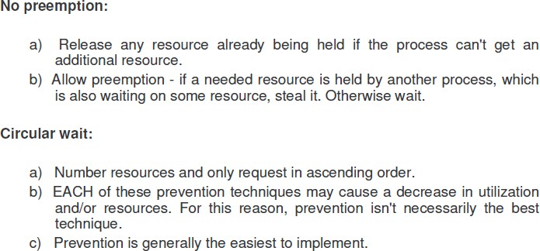

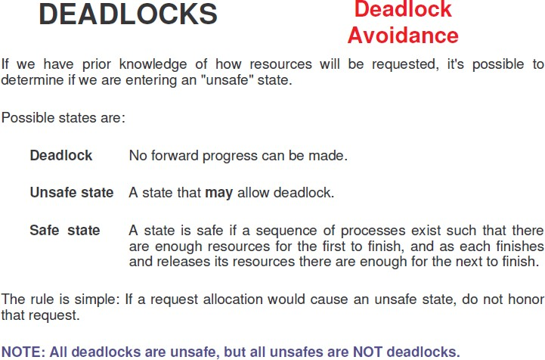

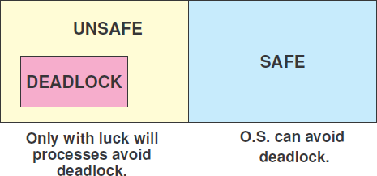

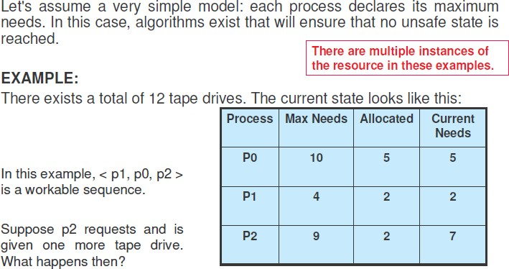

Follow the video link please

https://ocw.vu.edu.pk/Videos.aspx?cat=Computer+Science%2fInformation+Technology+&course=CS604

