Fashion Concepts

Fashion
New designs are constantly being created and consumers steadily replace their old clothes with new ones.

Who encourages fashion movement?
Everyone, from the original designer to the final consumer encourages fashion movement.

- In reality, fashion designers work hand-in-hand with what are known as fashion forecasters, people who predict future fashion trends based on data, statistics, and overall, consumer behavior. ... Essentially, popular culture determines these fashion trends and it is the general public that determines popular culture.

Fashion Market Segment
- Haute-Couture (hi-fashion)
- Pret -A- Porter (ready to wear)
- Mass Market

Haute Couture
- French for “high sewing” or high dressmaking” or “high fashion” refers to the creation of exclusive custom-fitted clothing. Haute couture is made to order for a specific customer’s or wearer’s measurements and body stance, and it is usually made from high-quality, expensive fabric and sewn with extreme attention to detail and finished by the most experienced and capable seamstresses, often using time- consuming hand-executed techniques.
- “Couture” means dressmaking, sewing, or needlework and “Haute” means elegant or high. Haute Couture is a protected name that can be used only by firms that meet certain well-defined standards.

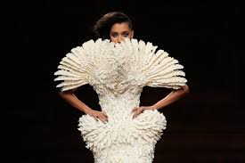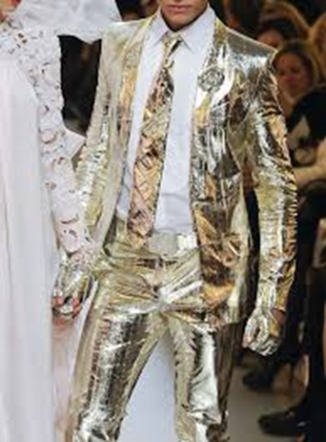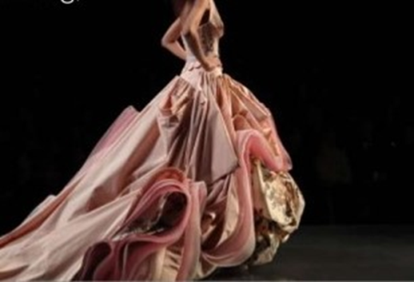
Pret (ready to wear)
- Pret –a-portor is the term for factory-made clothing, sold in finished condition, in standardized sizes. Designers produce ready-to-wear clothing intended to be worn without significant alteration, because clothing made to standard sizes fits most people. They use standard patterns, factory equipment, and faster construction techniques to keep costs low, compared to a custom-sewn version of the same item.

- In high-end fashion, ready-to-wear collections are usually presented by fashion houses each season during a period known as Fashion Week.
- The Fall/ Winter shows take place in February, and the Spring/ Summer collections are shown in September.

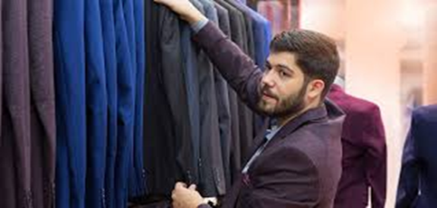

Mass Market
- Ready-to-wear garments in mass.
- Available in large quantities and standard measurements.
- Use cheap materials or fabrics, creatively used, to produce affordable fashion.
- Use simple production techniques therefore to sell at cheaper rates.
- Mass products are fashion, available both in brands and on streets.

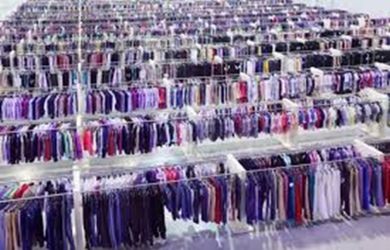

Design Development Process

- Research
- Theme/ mood board
- Inspiration board
- Illustration board
- Client board
- Accessory board
- Flat sketch board/ tech pack
- Trim and fabric board
- Muslin fits (toile)
- Actualizing the garment
- Costing
- Presentation

Research Work
- Type of collection
- Trend forecast
- Material availability
- Theme and inspiration
- Season
- Story line
- Clients profile
- Budgeting and costing

Theme/Mood & Inspiration Boards
- Occasions
- Seasons
- Activities
- Interests
- Social Interests
- Objects
- Nature
- Emotions

Client Profile
- Age group
- Social status
- Income
- Interests and hobbies
- Demography or geography
- Season or activity
- Marital status
- Character
- Attitude
- Role model

Accessory Board
Accessories can be categorized mainly into 3 types:
- Carried Accessories:
Canes, handbags, swords, hand fans, parasols, umbrella etc
- Worn Accessories:
Jackets, boots and shoes, cravats, ties, sunglasses, belts, gloves, muffs,
jewellery, watches, shawls, scarves, socks, stockings etc
- Detachable Accessories:
Aigrettes, lapels, pins and badges etc

Flat/ Technical Sketches
- the proportional drawing on construction of garment
- seam types and placements
- stitching and its types
- the blue print of making a garment
- trims and fabrics
- number of pieces to construct
- number of colors for the same design
- sizes

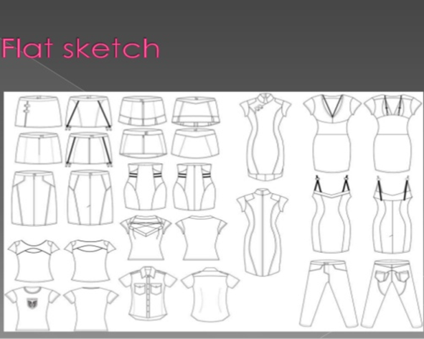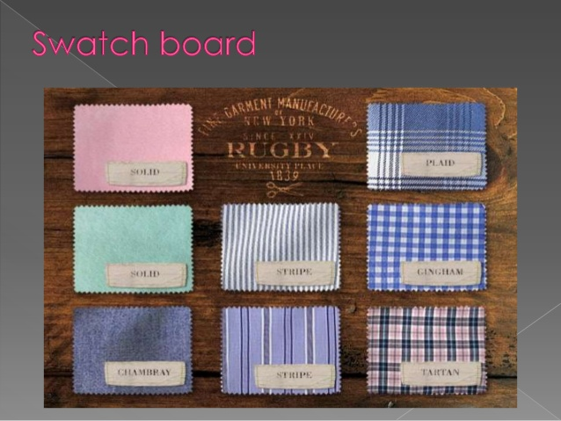

Muslin fit (toile)
- Are done by either using draping method or pattern making method.
- This is the process of test fit done before actualizing on real fabric.
- It helps in correcting any ill fit or flaws in the garment.
- Is done on cheaper fabrics.

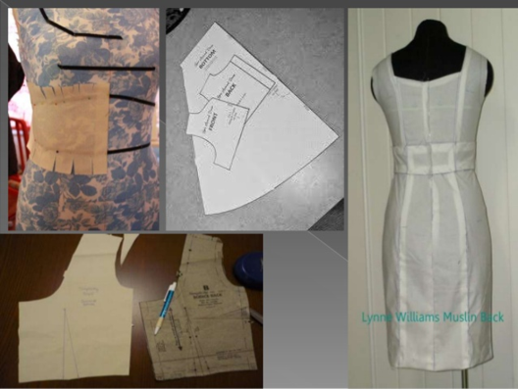

Actualizing
- Muslin fit or toile are transferred onto real fabrics after alteration or correction if any
- The transferring is done with the help of tracing wheel, scales and markers

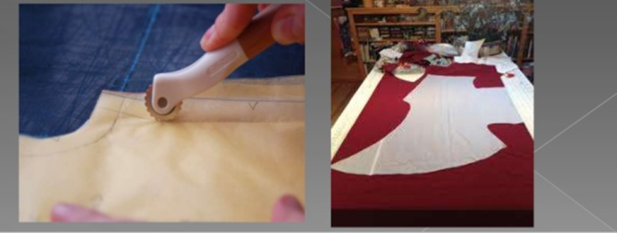

Costing
- Includes all expenses inherited during the development of every single garment piece.
- Later a price is put up on the basis such that all the expenses + profit are incurred back.
- Can hike any % of the total net expense to gain back any % of profit.

Presentation
- Collection launch at a fashion runway
- Retail store exhibition
- Exhibition to client
- E-store launch
- Presenting to the in house head designer

Conclusion
- Fashion keeps inviting and exploring new lands and base when every time a new design develops. Buy the concepts and process involved remains the same and design derivation are always fresh, crisp and edgy.
- Fashion will never fade its face in any era. Fashion in you showcases the outlook, who you are as a person.

