Deflection of simply supported beam and cantilever

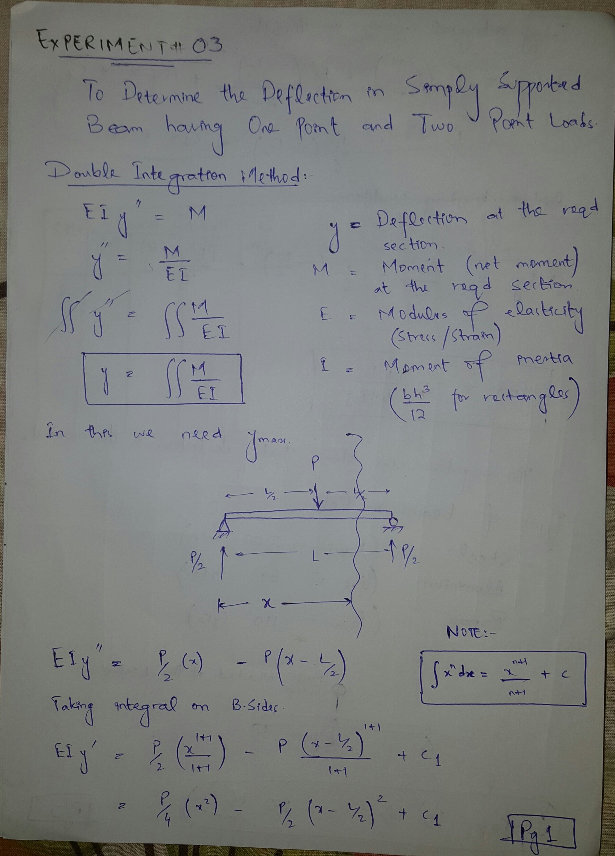
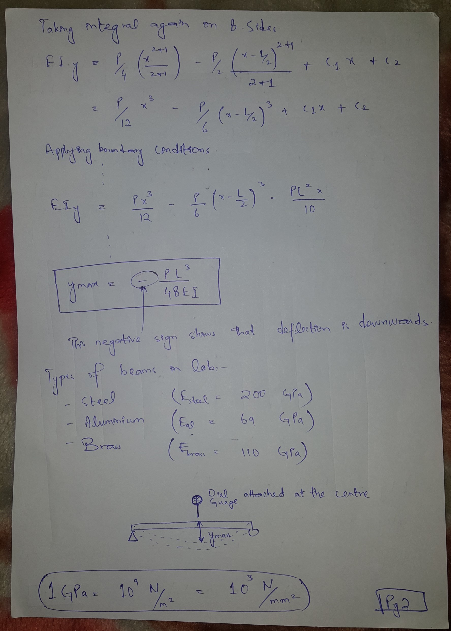
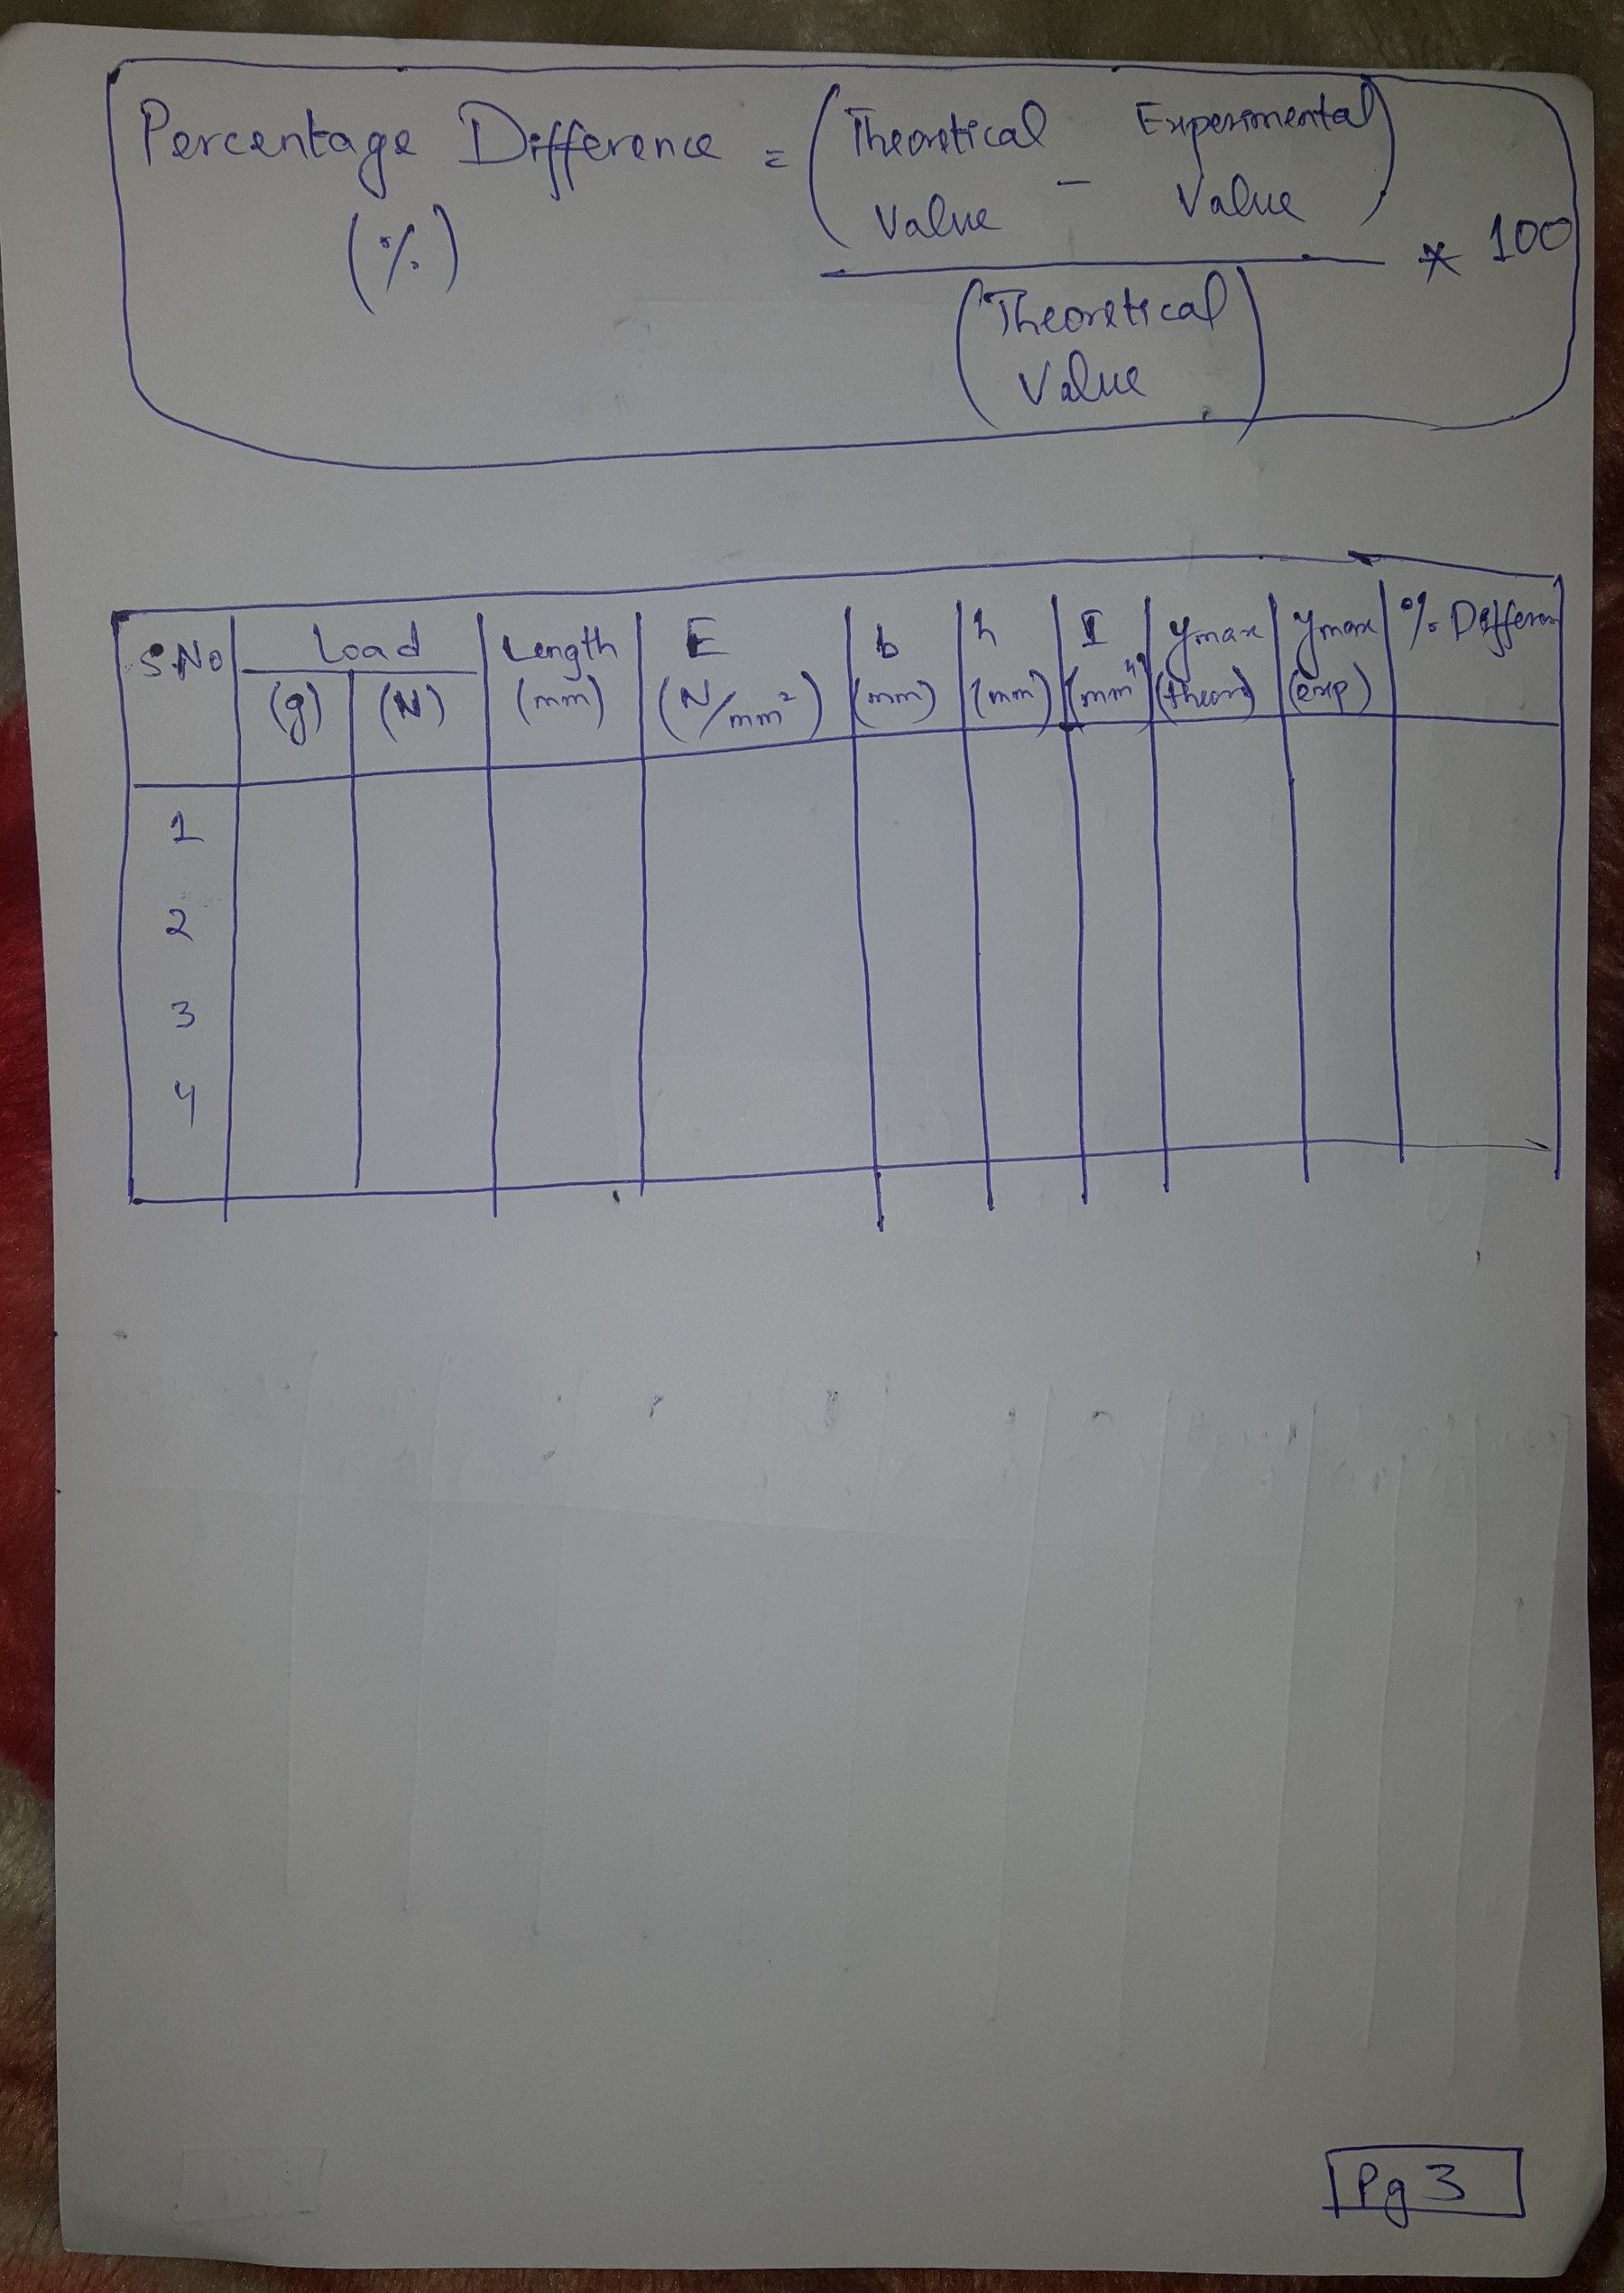
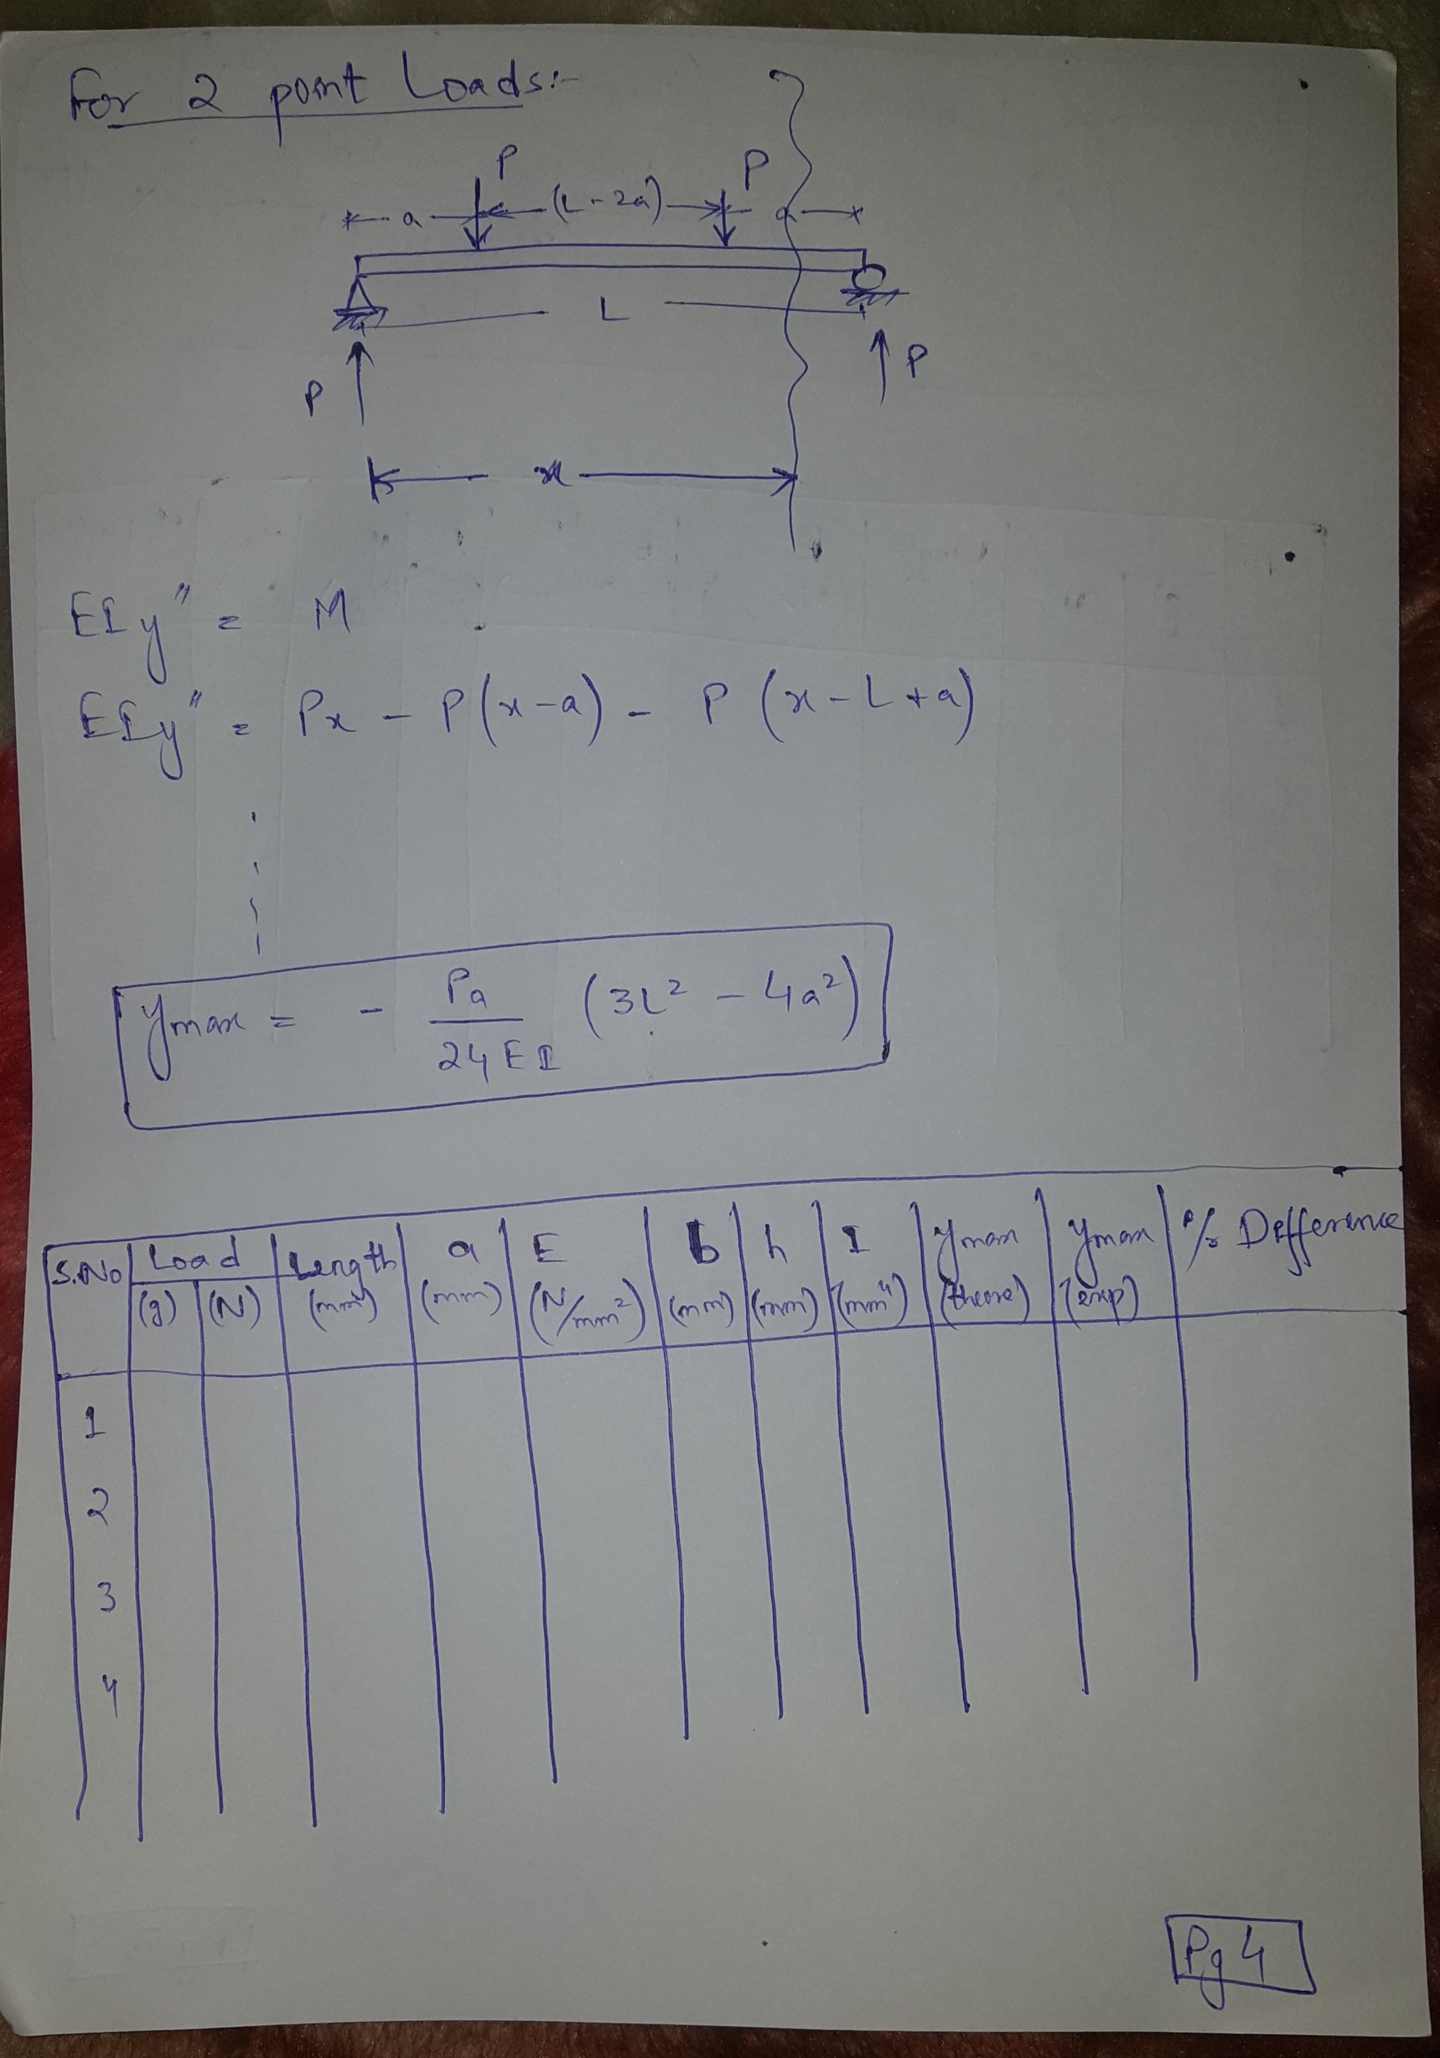

DOUBLE INTEGRATION METHOD

Problem 605
Determine the maximum deflection δ in a simply supported beam of length L carrying a concentrated load P at midspan.

Solution 605
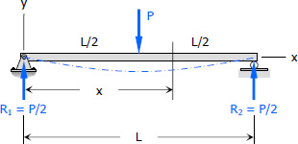

At x = 0, y = 0, therefore, C₂ = 0

At x = L, y = 0

Thus,

Maximum deflection will occur at x = ½ L (midspan)
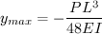

The negative sign indicates that the deflection is below the undeformed neutral axis.

Therefore,
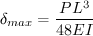 answer

Problem 607
Determine the maximum value of EIy for the cantilever beam loaded as shown in Fig. P-607. Take the origin at the wall.

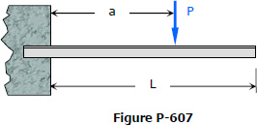

Solution 607

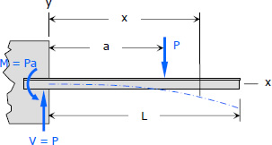

At x = 0, y' = 0, therefore C₁ = 0
At x = 0, y = 0, therefore C₂ = 0

Therefore,

The maximum value of EI y is at x = L (free end)
answer

Problem 609
As shown in Fig. P-609, a simply supported beam carries two symmetrically placed concentrated loads. Compute the maximum deflection δ. Check your answer by letting a = ½ L and comparing it with the answer to Problem 605.

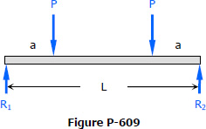

Solution 609
By symmetry

Experiment (A)
Aim: Deflection of simply supported beam with concentrated point load on the mid of beam
Apparatus: knife edge, load hanger, movable digital dial, test indicator, movable knife edge, clamp, hanger with mass, steel structure mild steel bar.
Theory:
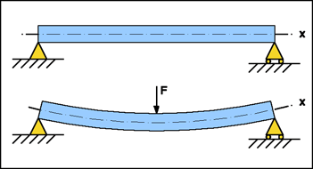
Fig: simply supported beam
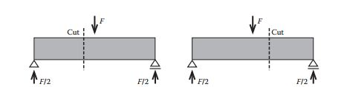
a)Cut to the left of the load b) Cut to the right of the load

M+F*($\frac{L}{2}-x$)- $\frac{F}{2}\left(L-x\right)=0$
Where clockwise moments are defined as being positive.
We shall evaluate the deflection of a simply supported beam. Dividing the bending-moment distribution by EI, we obtain the distribution of curvature.
$\frac{d^{2}v}{dx^{2}}=\frac{Fx}{2EI}$ for 0<x<$\frac{L}{2}$
Integrating this function,
$\frac{dv}{dx}=\frac{Fx^{2}}{4EI}$+ θ
Where θ is a constant of integration representing the slope at the left end. Because the slope should be zero at mid span, we have
$$θ=-\frac{FL^{2}}{16EI}$$
Integrating this equation with the boundary condition v = 0 at x = 0 leads to
$v=-\frac{Fx^{3}}{12EI}+θx$ for 0<x<$\frac{L}{2}$
$v=-\frac{Fx(4x^{2}-3L^{2})}{12EI}$
The deflection at mid span (x = L/2) is
$$v=-\frac{FL^{3}}{48EI}$$

Procedure:
(Load kept at center of simply supported beam is varying, but distance between applied load and fixed end is same)
A mid steel bar is clamped on steel structure with the help of knife edge bolts and movable clamped.
Using the load hanger mass is added at the center of beam.
The deflection of beam is noted using the digital dial.
Zero correction is noted using the digital dial before adding any weight.
Now load is increased as per the table and the deflection of beam is noted.
The process is repeated again and again for different weight.
Specification of beam:
Beam height = 3.3mm
Beam width = 18.5mm
$E_{steel}$ = 207GPa
I = 5.54$*{10}^{-11}m^{4}$

Calculation:
$△ = \frac{W*l^{3}}{48EI}= \frac{0.1*9.81*{0.4}^{3}}{48*207*{10}^{9}*5.54*{10}^{-11}}mm=0.114mm$
Observation table:
- Simply supported beam , length = 400mm
serial no. | mass (gm) | actual deflection (mm) | theoretical deflection (mm)
1 | 0 | 0 | 0
2 | 100 | 0.06 | 0.114
3 | 200 | 0.22 | 0.2281
4 | 300 | 0.37 | 0.3421
5 | 400 | 0.48 | 0.456
6 | 500 | 0.65 | 0.572

Graph:

Now repeat the some procedure by reducing the length of beam
Observation table
- Simply supported beam , length = 200mm
serial no. | mass (gm) | actual deflection (mm) | theoretical deflection (mm)
1 | 0 | 0 | 0
2 | 100 | 0.03 | 0.0142
3 | 200 | 0.06 | 0.0285
4 | 300 | 0.09 | 0.0427
5 | 400 | 0.13 | 0.057
6 | 500 | 0.17 | 0.0712

Graph:

Experiment (B)
Aim: To determine the deflection in a cantilever beam when a load is applied at the center.
Apparatus: knife edge, load hanger, movable digital dial, indicator, movable knife edge, clamp, hanger with mass, steel structure
Theory:
Fig: cantilever beam

We shall evaluate the deflection of a cantilever beam. Dividing the bending-moment distribution by EI, we obtain the distribution of curvature.
$$EI\frac{d^{2}v}{dx^{2}}=-M$$
Boundary condition $\frac{dy}{dx}=0$
Therefore, we obtain the solution as
$$EI\frac{dv}{dx}=-(P*L)x$$
Integrating this equation with the boundary condition v = 0 at x = 0 leads to
v= $\frac{-Px^{2}}{6EI}(3L-x)$

Now calculate deflection for x = $\frac{L}{2}$
v= $\frac{-PL^{3}}{3EI}$

Procedure:
- Load kept at center of cantilever is varying, but distance between applied load and fixed end is same.
Mild steel is clamped at one end and the other end left free.
At a distance of 200mm from the fixed end a load is applied .
The deflection at the point of application of load is noted.
The load is varied as per mention in table.
- Load at center of cantilever is kept constant i.e. 500gm, distance between dial indicator and clamped end is changing
Mild steel is clamped at one end and the other end left free.
Keep the dial indicator exactly at the fixed end of mild steel beam.
Make the reading of dial indicator ‘zero’.
Now put the load of 500gm initial at 200mm from fixed end and then shift the dial indicator by 50mm.
Continuously shift the dial indicator by keeping the constant difference of 50mm and note down the deflection.
Specification of beam:
Beam height = 3.3mm
Beam width = 18.5mm
$E_{steel}$ = 207GPa
I = 5.54$*{10}^{-11}m^{4}$
Calculation: L = 200mm
$△ = \frac{W*l^{3}}{3*E*I}= \frac{0.1*9.81*{0.2}^{3}}{3*207*{10}^{9}*5.54*{10}^{-11}}mm=0.228mm$
Observation table(A):
- Load kept at center of cantilever is varying , but distance between applied load and fixed end is same
serial no. | mass(gm) | actual deflection(mm) | theoretical deflection(mm)
1 | 0 | 0 | 0
2 | 100 | 0.38 | 0.228
3 | 200 | 0.7 | 0.456
4 | 300 | 1.06 | 0.684
5 | 400 | 1.34 | 0.912
6 | 500 | 1.68 | 1.14

Graph(A):

Observation table (B) : L = 400mm
- load at center of cantilever is kept constant i.e. 500gm , distance between dial indicator and clamped end is changing
serial no | position from fixed end (mm) | actual deflection (mm)
1 | 0 | 0
2 | 50 | 0.597
3 | 100 | 1.66
4 | 150 | 3.04
5 | 200 | 4.51
6 | 250 | 5.79
7 | 300 | 6.56

Graph(B):

Conclusion:
- Linearity observed in both experiment between the mass and deflection, as increases the deflection of beam decreases.
- Linearity observed in second experiment between the position of dial indicator from the fixed end to the deflection , as the dial indicator shifted toward left side its deflection increases.

For video tutorial of hands on experiment, do check the following videos:

- Simply supported beam (https://www.youtube.com/watch?v=jpzHgRASjNU )
- Cantilever beam ( https://www.youtube.com/watch?v=P3rcO1UMxYw )

Thank you

