Lab No. 1

To Study the different sections of EME Unit analyze

11.0 Objectives:

11.1 Apparatus:

11.2 Procedure:
11.3 Characteristics of equipment:
The electrical machine equipment, EME, is formed by a cabinet in which several different modules are included. An easy scheme of this equipment can be seen in figure.

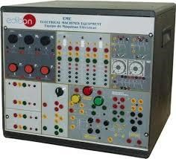
A box including different modules, just as it is represented in figure constitute the electric machine EME equipment of EDIBON.
- Terminal connection module.
- Activation module.
- Protection module.
- Synchronism and rectification module.
- Contactor module.
11.3.1 Module discription

i) Power supply
It is situated at right inferior part of the closet and it includes the connection terminals of the three phases: R, S and T and 380v supply. There are four terminals in each phase.
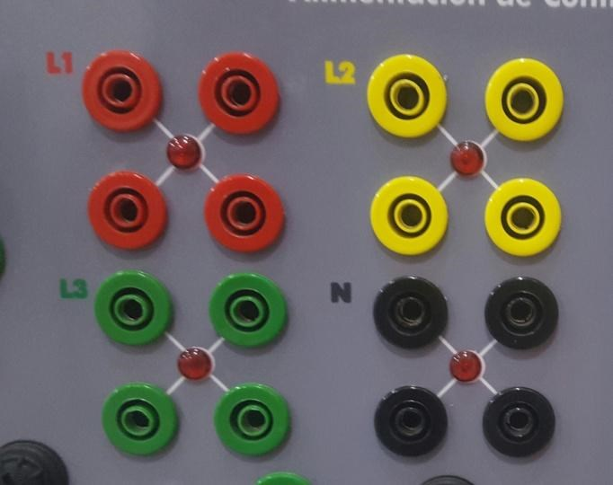

Power Supply
In the inferrior part of this module a signaloing lamp is provided, which will light up when the three-phase sequence is correct. If it does not light up, we will have to modify the inlet connections by changing the order of any two phases.
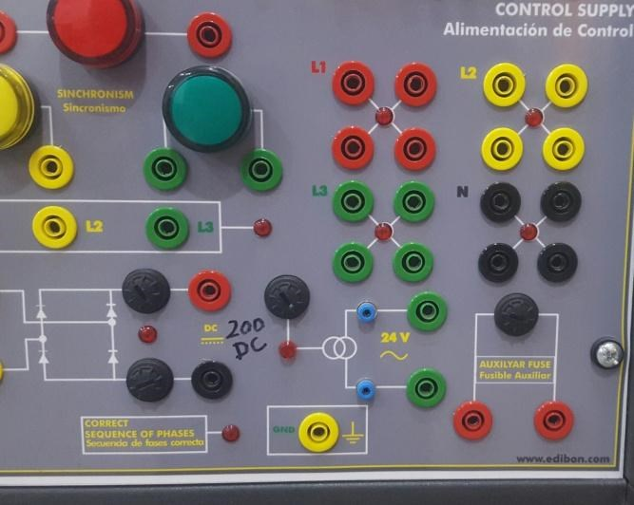

Signaling lamp
In control circuit, small cabels with small terminals i.e 24v and secuirity terminals in power circuit (380v) are used.
This module, which is situated in the right inferior part of the closet, has two different sections. The upper section corresponds to the synchronizing and it includes three 380v Lamps, as well as the inlet terminals for the three phases with a signaling neon for indicating its correct sequence.

ii) Rectification module
In the inferior part, there is a one-phase bridge rectifier, protected with two 3A fuses with there corresponding fusion lamps.this provides us the continous voltage of 200v dc needed for carrying out the practices.
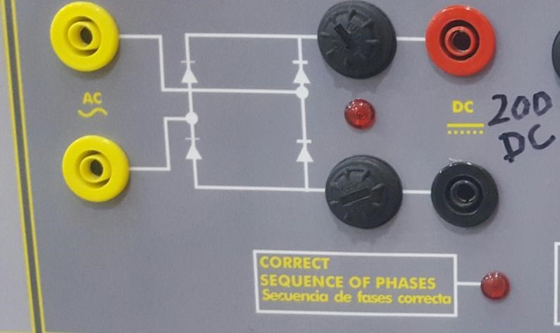
Rectification circuit
11.3.2 module 2: Operation module:

i) Switches Module
This module contain the devices needed for starting and using machines. In the left side, we can see three running switches , and , each one with a contact that is normally open (NA), and another one that is normally closed (NC), and three stop switches , and . Each one with a NC contact.
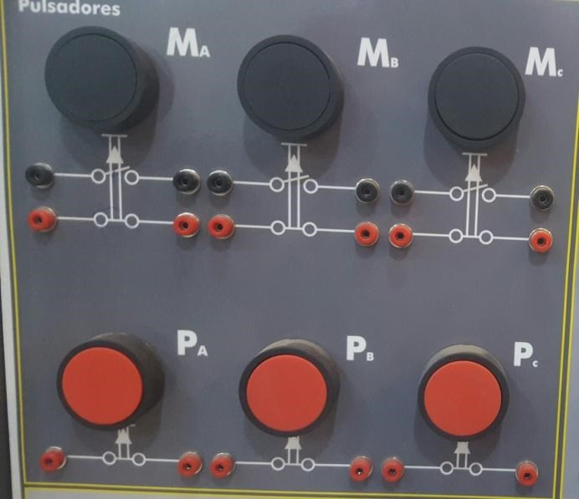

ii) Contactors
In the central part, the module includes three 9A three pole contactors power A, B and C, with control circuit in alternating current, 24Vac. A part from the coil terminals and the power terminals, each contactor has 2 NC auxiliary terminals and 3 NA auxiliary terminals. A small neon lamp is situated in the upper part and will light up when the contactor is started.
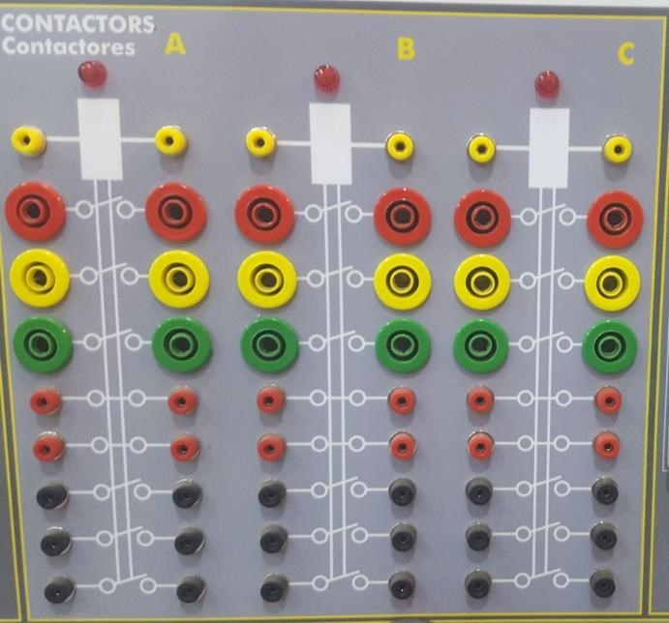

Contactors module

iii) Relay
In the right part of this module, there are two timing relays. The time adjustment (in the timing relays) and can be changed by using a small screwdriver.
In the inferior part of front panel, we can find another two wheels for selecting the scale and time units. The one on the right is used for selecting time scale, that is to say:
seconds, minutes, hours. While on the left, is used for changing the numerical values of time unit which has been selected.
Timing relays can operate, that are activated, using it in switch n top of each one (GATE), putting it in the on position.
It also has the ability to reset the relays using the RESET button located on top of each time relay.
In order to adjust the wanted time value, we will turn the round plastic cover for moving the red arrow and adjusting the value. The time will start from the moment when the control tension ( 24 Vac ) is supplied to relay.
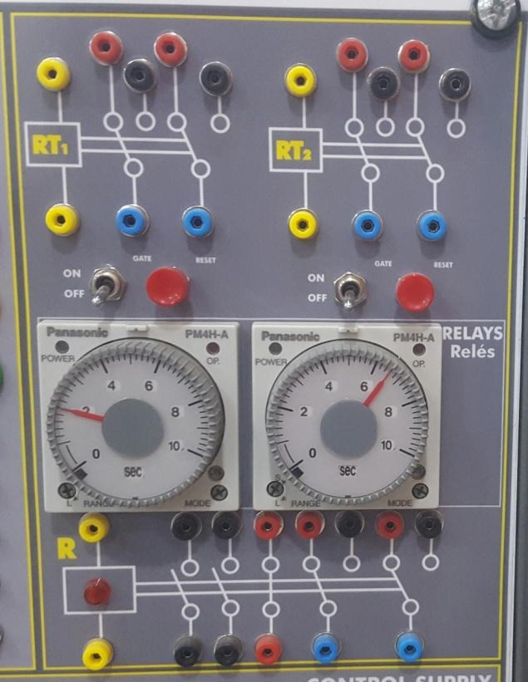

Relay module
Finally in the upper left part, a lamp (POWER) will indicate that the relay has been activated and a second lamp (OP) will light up when the scheduled time is over. Both relays have a NA terminal and a NC-NA terminal.
11.3.3 Module 3: Protection module
It is situated on the left side of the closet and it indicates the devices for protecting the machines that we are going to test: a magnetothermic disjuncture ( DMT ) and a thermal relay ( RMT ).
Both devices, apart from the three power contacts, have two auxiliary contacts for operating ( a NA and a NC).
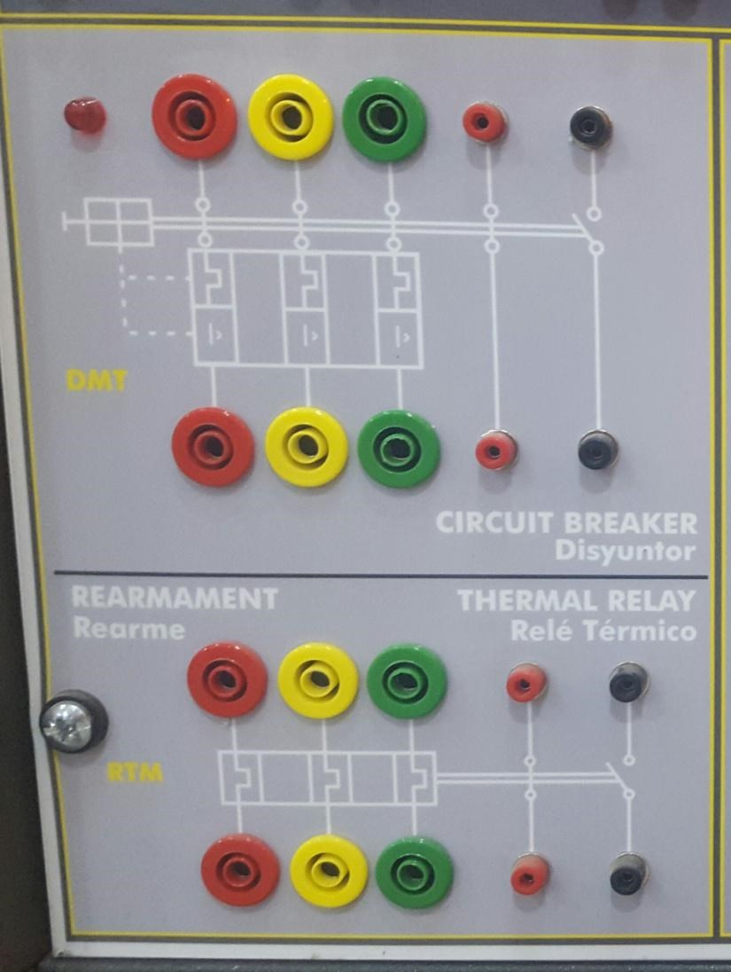

Protection relay
11.3.4 Module 4: Switch module
The switch module closes one of the contacts selected with the three position switch ( 1, 2 and 3). It has three power takeoffs ( red, green and yellow) and the selected position closes the corresponding contact in the three phases. That is to say, if we select position 2, the three contacts situated in the middle of each phase will be connected.
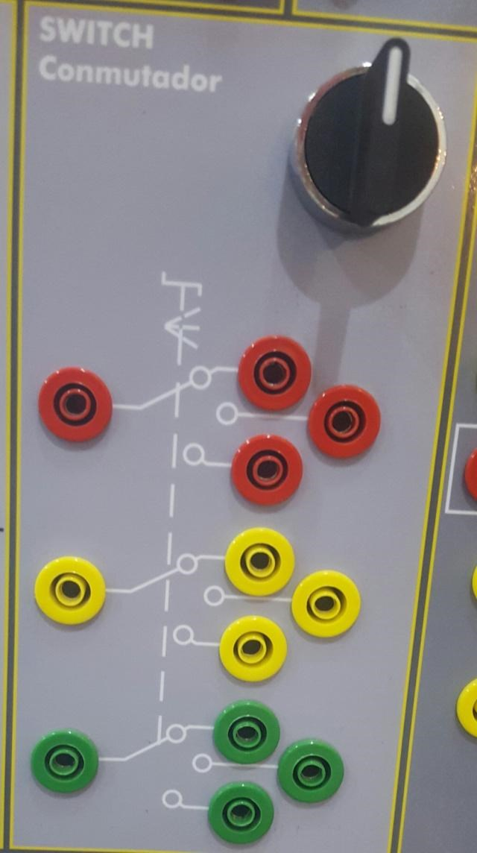

Switch module

11.5 Lab task
i) What are the two operation conditions of magnetic contactors?
__________________________________________________________________ __________________________________________________________________ ii) List down the types of power supplies provided in EME-unit?
__________________________________________________________________ __________________________________________________________________ __________________________________________________________________ iii) What is the purpose of rectifier circuit?
__________________________________________________________________
__________________________________________________________________
__________________________________________________________________

Obtained marks: _____ / 10.

