**Lab:Electrical Network Analysis**

**Week 5**

**Experiment :-** Frequency response analysis of high pass filter

**Software used:-**Electronic workbench

**Procedure:-**High pass filter is a filter that passes signals with a frequency higher than a certain cut off frequency and attenuates signals with frequency lower than a certain cutoff frequency. A 100 micro farad capacitor is connected to 10 Ohm resistor and AC source was attached to the circuit.

**Steps:-**

* Open the software and add new file.
* From the tool bar select the desired components. In this experiment resistor, inductor, ground and dc power supply is used.
* Connect all the components with the help of cursor. When the cursor select the terminal a black spot will appear. Hold it by clicking the left mouse button and join it with the required component.
* Now when the circuit is complete go to Circuit>Schematic option>show nodes. This will select the nodes and number it.
* Now go to Analysis>AC frequency>Add nodes and Accept it.
* Now again select Analysis>AC frequency and Simulate in dialog box.
* This will display the graph of frequency response on a screen. You can edit the title, axis and grid from graph dialog box.

.

After performing this experiment on electronic workbench software students will able to understand the basic concept of high pass filter.

**EXPERIMENT#9**

**FREQUENCY RESPONSE ANALYSIS OF HIGH PASS FILTER**

**OBJECTIVE:**

The basic purpose of this lab is to know about the fundamentals of high pass filter and its frequency response.

**THEORY:**

**FILTERS:**

**Filters** are circuits which are used to remove unwanted frequency components from the signal, to enhance wanted ones, or both. [Filters](https://en.wikipedia.org/wiki/Filter_%28signal_processing%29) can be [active](https://en.wikipedia.org/wiki/Active_filter), [high-pass](https://en.wikipedia.org/wiki/High-pass_filter), [low-pass](https://en.wikipedia.org/wiki/Low-pass_filter), [band-pass](https://en.wikipedia.org/wiki/Band-pass_filter), [band-stop](https://en.wikipedia.org/wiki/Band-stop_filter) etc.

**PASSSIVE FILTERS:**

Passive implementations of linear filters are based on combinations of [resistors](https://en.wikipedia.org/wiki/Resistor) (R), [inductors](https://en.wikipedia.org/wiki/Inductor) (L) and [capacitors](https://en.wikipedia.org/wiki/Capacitor) (C). These types are collectively known as *passive filters*, because they do not contain active components such as transistors.

Inductors block high-frequency signals and conduct low-frequency signals, while [capacitors](https://en.wikipedia.org/wiki/Capacitor) do the reverse. [Resistors](https://en.wikipedia.org/wiki/Resistor) on their own have no frequency-selective properties, but are added to inductors and capacitors to determine the *time-constants* of the circuit, and therefore the frequencies to which it responds.

**ACTIVE FILTERS:**

[Active filters](https://en.wikipedia.org/wiki/Active_filter) are implemented using a combination of passive and active (amplifying) components, and require an outside power source. [Operational amplifiers](https://en.wikipedia.org/wiki/Operational_amplifier) are frequently used in active filter designs.

**HIGH PASS FILTER:**

**High-pass filter** is an [electronic filter](https://en.wikipedia.org/wiki/Filter_%28signal_processing%29) that passes [signals](https://en.wikipedia.org/wiki/Signal_%28electrical_engineering%29) with a [frequency](https://en.wikipedia.org/wiki/Frequency) higher than a certain [cutoff frequency](https://en.wikipedia.org/wiki/Cutoff_frequency) and [attenuates](https://en.wikipedia.org/wiki/Attenuate) signals with frequencies lower than the cutoff frequency. The amount of [attenuation](https://en.wikipedia.org/wiki/Attenuation) for each frequency depends on the filter design.

The simple first-order electronic high-pass filter shown in Figure 1 is implemented by placing an input voltage across the series combination of a [capacitor](https://en.wikipedia.org/wiki/Capacitor) and a [resistor](https://en.wikipedia.org/wiki/Resistor) and using the voltage across the resistor as an output. The product of the resistance and capacitance (*R*×*C*) is the [time constant](https://en.wikipedia.org/wiki/Time_constant) (τ); it is inversely proportional to the cutoff frequency *fc*, that is,

f_\mathrm{c} = {1 \over 2 \pi \tau } = {1 \over 2 \pi R C}

Where *fc* is in [hertz](https://en.wikipedia.org/wiki/Hertz), *τ* is in [seconds](https://en.wikipedia.org/wiki/Second), *R* is in [ohms](https://en.wikipedia.org/wiki/Ohm_%28unit%29), and *C* is in [farads](https://en.wikipedia.org/wiki/Farad).

**CUTOFF FREQUENCY:**

Cutoff frequency applies to an edge in a low pass, high pass, band pass, or band-stop characteristic –A frequency characterizing a boundary between a pass band and a stop band.
\omega_\mathrm{c} = {1 \over \tau} = {1 \over R C}

\omega_\mathrm{c} = {1 \over \tau} = {1 \over R C}


**PROCEDURE:**

* Open the software and add new file.
* From the tool bar select the desired components. In this experiment resistor, inductor, ground and dc power supply is used.
* Connect all the components with the help of cursor. When the cursor select the terminal a black spot will appear. Hold it by clicking the left mouse button and join it with the required component.
* Now when the circuit is complete go to Circuit>Schematic option>show nodes. This will select the nodes and number it.
* Now go to Analysis>AC frequency>Add nodes and Accept it.
* Now again select Analysis>AC frequency and Simulate in dialog box.
* This will display the graph of frequency response on a screen. You can edit the title, axis and grid from graph dialog box.

**HIGH PASS FILTER:**

**SCHEMATIC DIAGRAM AND ANALYSIS GRAPH (1):**

**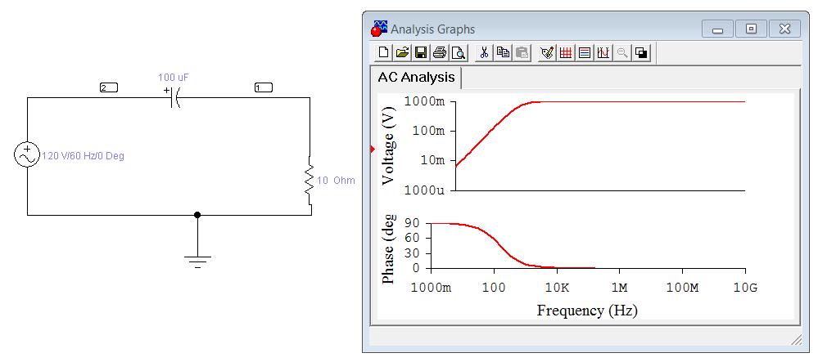**

**OBSERVATIONS AND CALCULATIONS:**

**CALCULATE:**

**FC1=**

**FC2=**

**CONCLUSIONS:**

**LAB TASK:**

* **Change the value of capacitor and resistor and repeat the whole procedure.**
* **Observe the effect of graph.**
* **Calculate the FC1 and FC2.**