Lab#09

Make a circuit of full-wave controlled rectifier using Resistive triggering
Objectives:
In this lab, we will examine the output waveform of a full-wave controlled rectifier deriving resistive load while using the resistive triggering method.

Equipment Required:
- SCR (BT-151)
- Power Diodes
- Function Generator
- Breadboard & connecting wires
- Digital multimeters
- Resistances
- Oscilloscope

Circuit Diagram:
Figure 9.1 Simplest form of a 1-phase controlled rectifier | Figure 9.2 Practical circuit for 1-phase half wave controlled rectifier using Resistive triggering

Conceptual Background:
Simplest form of a single phase full wave controlled rectifier is shown in figure 9.1. It can easily be observed that arrangement of the switches is same as full-wave bridge uncontrolled rectifier with the only difference that all the diodes have been replaced with SCRs (Silicon Controlled Rectifiers). To achieve the controlled output we need to controll the firing angles of all the SCRs which can be achieved by digital firing angle control techneque. In this lab we are intrested to use the resistive trigering mathod as shown in Fig. 9.2. At first AC input is simpally converted into uncontrolled full-wave pulsating DC. This pulsated DC is now easily controlled by using only one controlled switch (SCR) using the same resistive control techneque as it was used in lab no. 06. Hense by increasing the resistance we can increase the firing angle and output voltage is decreased cosequently. Just like half-wave controlled rectifier this scheme has the drawback that we can’t control the output after 90 degree.
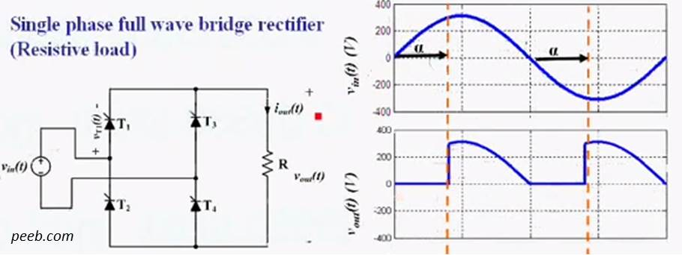
Figure 7.3: Input and output Voltage waveforms of Full-wave controlled rectifier

Procedure:
- Draw the connections to make the circuit shown in fig 9.2 on Multisim.
- Connect the voltmeter (20Vdc range) and ammeter (200mAdc range) to measure the output voltage and current.
- At start, set the variable resistance to its minimum value, the firing angle in this case will be minimum or approximately zero.
- Increase the firing angle by increasing the variable resistance in steps while monitoring the waveforms. Do this increase/decrease of resistance and record the data mentioned in step 4 and 5.
- Also record the current and voltage readings for different firing angles and record the results in table 9.1.

Data & Calculations:
Table 9.1
Sr. | α | V_{AC} |  | V_{DC(LOAD)} | I_{DC(LOAD)} | P_{DC(LOAD)}
 | R | Vrms | Vp | Measured | Measured | Measured
 |  | V | V | V | mA | W
1
2
3
4
5

P_{AC} = V_{rms} x I_{rms} =
Efficiency η ==

Waveforms & Plots:
Draw the voltages obtained on CRO on a common scale as shown in fig. 6.3 by properly labeling the time and voltages etc for the firing angles of 30 degree and 60 degree. ( Hint: see the figure 6.2 as you made in half-wave controlled rectifier for referance.)
Review Questions:

- How will you turn off a SCR if it is turned on using DC power sourse?
- What do you suggest to achieve control after 90 degrees?
- What is the importance of snubber circuit?
- Suppose you are required to design a controll mechanism for DC motor what will you preffer a) half-wave controlleed rectifier or b) full-wave controlled rectifier why?

The End

