Lab 9

Lists

Python offers a range of compound data types often referred to as sequences. List is one of the most frequently used and very versatile data types used in Python.
A list is a data type that allows you to store various types of data in it.
List is a compound data type which means you can have different-2 data types under a list, for example we can have integer, float and string items in a same list.

Create a list
In Python programming, a list is created by placing all the items (elements) inside square brackets [], separated by commas.
It can have any number of items and they may be of different types (integer, float, string etc.).
List-Name = [Element 1, Element 2…..]

Program 1
# empty list
my_list = []

# list of integers
my_list = [1, 2, 3]

# list with mixed data types
my_list = [1, "Hello", 3.4]
Output:

Access list elements
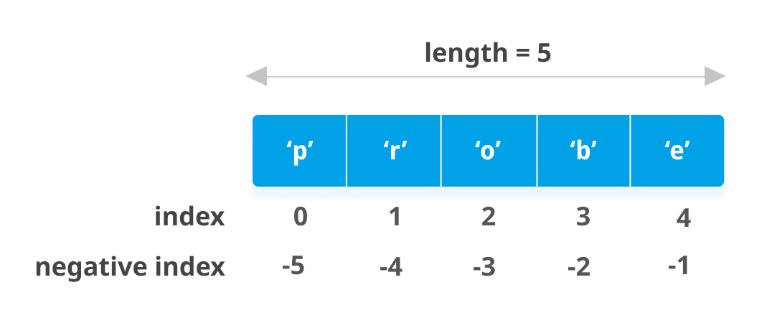

List Index

We can use the index operator [] to access an item in a list. In Python, indices start at 0. So, a list having 5 elements will have an index from 0 to 4.

Trying to access indexes other than these will raise an IndexError. The index must be an integer. We can't use float or other types, this will result in TypeError.

Nested lists are accessed using nested indexing.

Program 2

# List indexing

my_list = ['p', 'r', 'o', 'b', 'e']

# Output: p
print(my_list[0])

# Output: o
print(my_list[2])

# Output: e
print(my_list[4])

# Nested List
n_list = ["Happy", [2, 0, 1, 5]]

# Nested indexing
print(n_list[0][1])

print(n_list[1][3])

# Error! Only integer can be used for indexing
print(my_list[4.0])

Output:

Negative indexing
Python allows negative indexing for its sequences. The index of -1 refers to the last item, -2 to the second last item and so on.
Program 3
# Negative indexing in lists
my_list = ['p','r','o','b','e']
print(my_list[-1])
print(my_list[-5])

Output

Slice list
We can access a range of items in a list by using the slicing operator :(colon).

Program 4
my_list = ['p','r','o','g','r','a','m','i','z']

# elements 3rd to 5th
print(my_list[2:5])

# elements beginning to 4th
print(my_list[:-5])

# elements 6th to end
print(my_list[5:])

# elements beginning to end
print(my_list[:])

Output

change elements to a list
We can use the assignment operator (=) to change an item or a range of items.
Program 5
# Correcting mistake values in a list
odd = [2, 4, 6, 8]

# change the 1st item
odd[0] = 1

print(odd)

# change 2nd to 4th items
odd[1:4] = [3, 5, 7]

print(odd)

Output

Add Element to list
We can add one item to a list using the append() method or add several items using extend() method.
Furthermore, we can insert one item at a desired location by using the method insert() or insert multiple items by squeezing it into an empty slice of a list.
Program 6.a
# Appending and Extending lists in Python
odd = [1, 3, 5]

odd.append(7)

print(odd)

odd.extend([9, 11, 13])

print(odd)

Output

Program 6.b
# Demonstration of list insert() method
odd = [1, 9]
odd.insert(1,3)

print(odd)

odd[2:2] = [5, 7]

print(odd)

Output

combine two lists
We can also use + operator to combine two lists. This is also called concatenation. The * operator repeats a list for the given number of times.
Program 6

odd = [1, 3, 5]

print(odd + [9, 7, 5])

print(["re"] * 3)

Output

Delete elements from a list
We can delete one or more items from a list using the keyword del. It can even delete the list entirely.
Program 8
my_list = ['p', 'r', 'o', 'b', 'l', 'e', 'm']

# delete one item
del my_list[2]

print(my_list)

# delete multiple items
del my_list[1:5]

print(my_list)

# delete entire list
del my_list

# Error: List not defined
print(my_list)

Output

Remove elements from a list
We can use remove() method to remove the given item or pop() method to remove an item at the given index.
The pop() method removes and returns the last item if the index is not provided. This helps us implement lists as stacks (first in, last out data structure).
We can also use the clear() method to empty a list.
Program 9
my_list = ['p','r','o','b','l','e','m']
my_list.remove('p')

# Output: ['r', 'o', 'b', 'l', 'e', 'm']
print(my_list)

# Output: 'o'
print(my_list.pop(1))

# Output: ['r', 'b', 'l', 'e', 'm']
print(my_list)

# Output: 'm'
print(my_list.pop())

# Output: ['r', 'b', 'l', 'e']
print(my_list)

my_list.clear()

# Output: []
print(my_list)

Output

Lab Task
Create your own list of 10 elements and reapply all the operations in today’s lab on it.

Marks Obtained: ____________________
Instructor’s Signature: _________________

