Lab # 11
Creating a Network with Subnets

Objective:
__________________________________________________________________________________________________________________________________________________________________________________________________________________________________________Apparatus:

Procedure:
- Start OPNET Modeler 14.5 ⇒ Choose New from the File menu.

- Select Project and click OK ⇒Name the project <your initials>_Net Design, and the scenario Simple Network ⇒ Click OK.

- In the Startup Wizard: Initial Topology dialog box, make sure that Create Empty Scenario is selected ⇒ Click Next ⇒ Choose Campus from the Network Scale list ⇒ Click Next ⇒ Choose Miles from the Size drop-down menu and assign 1 for both X Span and Y Span ⇒ Click Next twice ⇒Click OK.

Initialize the Network:
- The Object Palette dialog box should be now on the top of your project space. Make sure that the internet_toolbox is selected from the pull-down menu on the object palette.

- Add to the project workspace the following objects from the palette: Application Config, Profile

Config, and a subnet.

- To add an object from a palette, click its icon in the object palette ⇒ Move your mouse to the workspace ⇒ Left-click to place the object. Right-click when finished. The workspace should contain the following three objects:

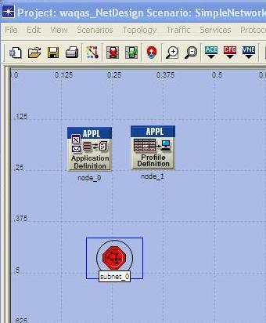

3. Close the Object Palette dialog box and save your project.

Configure the Services:
- Right-click on the Application Config node ⇒ Edit Attributes ⇒Change the name attribute to Applications ⇒ Change the Application Definitions attribute to Default ⇒ Click OK.

- Right-click on the Profile Config node ⇒ Edit Attributes ⇒ Change the name attribute to Profiles ⇒

Change the Profile Configuration attribute to Sample Profiles ⇒ Click OK.

Sample Profiles provides patterns of applications employed by users such as engineers, researchers, salespeople, and multimedia users.

Configure a Subnet:
- Right-click on the subnet node ⇒ Edit Attributes ⇒ Change the name attributes to Engineering and click OK.

- Double-click on the Engineering node. You get an empty workspace, indicating that the subnet contains no objects.

- Open the object palette and make sure it is still set to internet_toolbox.

- Add the following items to the subnet workspace: 10BaseT LAN, ethernet16 Switch, and a 10BaseT link to connect the LAN with the Switch ⇒ close the palette.

- Right-click on the 10BaseT LAN node ⇒ Edit Attributes ⇒ Change the name attribute to LAN ⇒ Observe that the Number of Workstations attribute has a value of 10. Click in the Value column for the Application: Supported Profiles attribute, and select Edit. You should get a table in which you should do the following:

- Set the number of rows to 1.

- Set the Profile Name to Engineer. Note: Engineer is one of the “sample” profiles provided within the Profile Config object.

- Click OK twice.

The object we just created is equivalent to a 10-workstation star topology LAN. The traffic generated from the users of this LAN resembles that generated by “engineers.”

- Rename the ethernet16 Switch to Switch.

- The subnet should look like the shown one.
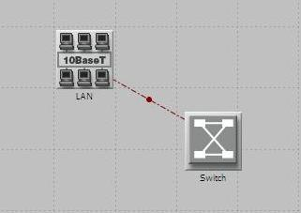

8. Save your project.

Configure All Departments:
- Now you have completed the configuration of the Engineering department subnet. To go back to the main project space, click the Go to the higher level button. The subnets of the other departments in the company should be similar to the engineering one except for the supported profiles.

- Make one copy of the Engineering subnet we just created: Click on the Engineering node ⇒ From the Edit menu, select Copy ⇒ From the Edit menu, select Paste, placing the subnet in the workspace after each, to create the new subnet.

- Rename (right-click on the subnet and select Set Name) the subnet as Research.

- Double-click the Research subnet ⇒ Edit the attributes of its LAN ⇒ Edit the value of the
Application: Supported Profiles attribute ⇒ Change the value of the Profile Name from Engineer to

Researcher ⇒ Click OK twice ⇒ Go to the higher level by clicking the button.

- Save your project.

Configure the Servers:
- Open the Object Palette and add a new subnet ⇒ Rename the new subnet to Servers ⇒ Double-click the Servers node to enter its workspace.

- From the Object Palette, add one ethernet_servers, one Ethernet 16_switch, and three 10BaseT links to connect the server with the switch.

- Close the Object Palette.

- Rename the Server as Web_Server, and the switch as Servers_Switch.

- Right-click on Web_server and Edit the value of the Application: Supported Services attribute.

a. For the Web Server add four rows to support the following services: Web Browsing (Light

HTTP1.1), Web Browsing (Heavy HTTP1.1), Email (Light), and Telnet Session (Light).

Go back to the project space by clicking the Go to the higher level button.

7. Save your project.

Connect the Subnets:
Now all subnets are ready to be connected together.

- Open the Object Palette and add four 100BaseT links to connect the subnets of the departments to the

Servers subnet. As you create each link, make sure that it is configured to connect the “switches” in both subnets to each other.

- Close the Object Palette.

- Now your network should resemble the following one:

- Save your project.
Choose the Statistics:

To test the performance of our network we will collect one of the many available statistics as follows:
- Click DES ⇒ Choose individual statistics.
- Expand global statistics and choose HTTP ⇒ Traffic Received (Bytes/S) and Traffic Sent

(Bytes/S).
- Click OK and save

Running Simulation:
- Click DES ⇒ Choose individual statistics.

- Change duration to 30 Sec.
- Click on Run to simulate the scenario.

- Click DES ⇒ Results ⇒ View Results to check the obtained results
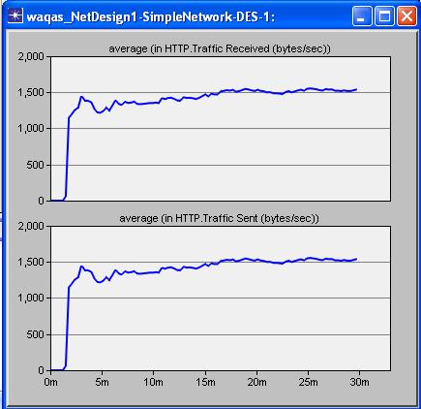

Lab Task:
Perform the above mentioned steps in OPNET and attach the output

Conclusion:
________________________________________________________________________________________________________________________________________________________________________________________________________________________________________

