Lab 7

For loop

For Loop

For loops are used for sequential traversal. For example: traversing a list or string or array etc. In Python, there is no C style for loop, i.e., for (i=0; i<n; i++). There is “for in” loop which is similar to for each loop in other languages. Let us learn how to use for in loop for sequential traversals.

Syntax of While Loop

for var in iterable:
statements

Flow Chart for Loop

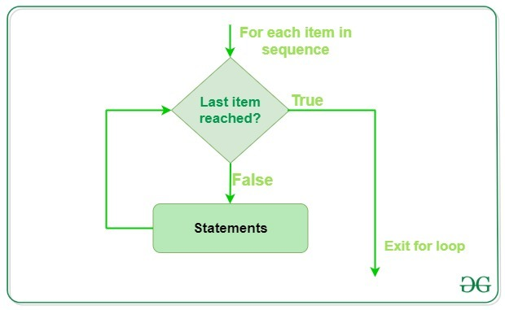

Program 1

numbers = [6, 5, 3, 8, 4, 2, 5, 4, 11]

# variable to store the sum
sum = 0

# iterate over the list
for val in numbers:
sum = sum+val

print("The sum is", sum)

Output of Program 1

Loop Control Statements

Loop control statements change execution from its normal sequence. When execution leaves a scope, all automatic objects that were created in that scope are destroyed.
The Python break statement immediately terminates a loop entirely. Program execution proceeds to the first statement following the loop body.
The Python continue statement immediately terminates the current loop iteration. Execution jumps to the top of the loop, and the controlling expression is re-evaluated to determine whether the loop will execute again or terminate.

Syntax

for var in iterable:
statement(s)
if expression:
break/continue

Program 2 break Statement

for i in range(1,10):
if i == 3:
break
print i

Output of Program 2

Program 3 continue Statement

for i in range(1,10):
if i == 3:
continue
print i

Output of Program 3

The else Statement

A for loop can have an optional else block as well. The else part is executed if the items in the sequence used in for loop exhausts.
The break keyword can be used to stop a for loop. In such cases, the else part is ignored.
Hence, a for loop's else part runs if no break occurs.

Syntax

for var in iterable:
statement(s)
else expression:
statement(s)

Program 4:

digits = [0, 1, 5]

for i in digits:
print(i)
else:
print("No items left.")

Output of Program 4

LAB TASKS

Q No 1

Display a message “Done” after successful execution of for loop

Q No 2

Display -10 to -1 using for loop

