Utilizing Star Topology through OPNET Network Simulator

Objective:
__________________________________________________________________________________________________________________________________________________________________________________________________________________________________________
Apparatus:

Procedure:
Create a New Project:
To create a new project for the Ethernet network:

- Start OPNET Modeler 14.5⇒Choose New from the File menu.

- Select Project ⇒ Click OK ⇒ Name the project <your initials>_Ethernet, and the scenario Coax ⇒ Click OK.

- In the Startup Wizard: Initial Topology dialog box, make sure that Create Empty Scenario is selected ⇒ Click Next ⇒ Choose Office from the Network Scale list ⇒ Click Next ⇒ Assign
- to X Span and keep Y Span as 100 ⇒ Click Next twice ⇒ Click OK.

- Close the Object Palette dialog box.
Create the Network:
To create our coaxial Ethernet network:

- To create the network configuration, select Topology ⇒ Rapid Configuration. From the drop-down menu choose Bus and click Next.

- Click the Select Models button in the Rapid Configuration dialog box. From the Model List drop-down menu choose ethcoax and click OK.

- In the Rapid Configuration dialog box, set the following eight values and click OK.

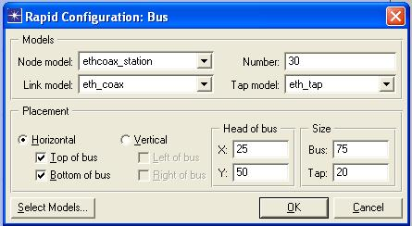

- To configure the coaxial bus, right-click on the horizontal link ⇒ Select Edit Attributes (Advanced) from the menu:

a. Click on the value of the model attribute ⇒ Select Edit from the drop-down menu ⇒ Choose the eth_coax_adv model.

b. Assign the value 0.05 to the delay attributes (propagation delay in sec/m). c. Assign 5 to the thickness attribute.

d. Click OK.

- Now you have created the network. It should look like the network below.

- Make sure to save your project.
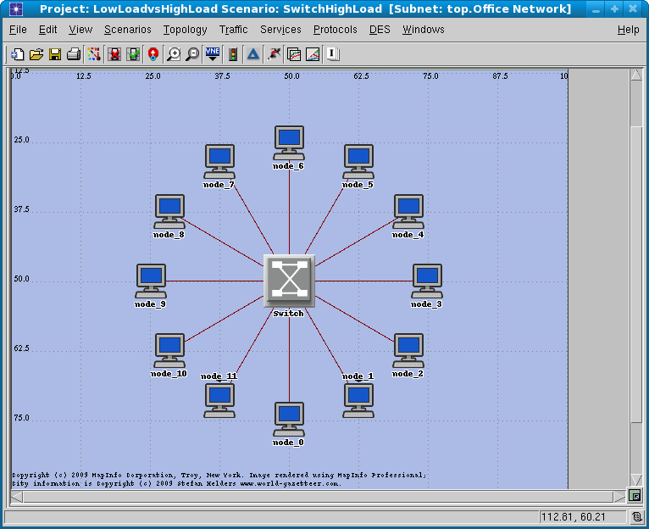
To configure the traffic generated by the nodes:

- Right-click on any of the 30 nodes ⇒ Select Similar Nodes. Now all nodes in the network are selected.

- Right-click on any of the 30 nodes ⇒ Edit Attributes.

- Check the Apply Changes to Selected Objects check box. This is important to avoid reconfiguring each node individually.

- Expand the Traffic Generation Parameters hierarchy:
a. Change the value of the ON State Time to exponential (100) ⇒ Change the value of the OFF State Time to exponential (1).(Note : Packets are generated only in the “ON” state.)

- Expand the Packet Generation Arguments hierarchy:
a. Change the value of the Packet Size attribute to constant (1024).

- Click OK to return back to the Project Editor.

- Make sure to save your project.

Configure Statistics:
To choose the statistics to be collected during the simulation:

- Select DES ⇒ Choose Individual Statistics ⇒ Expand Global Statistics.

- Expand the Traffic Sink hierarchy ⇒ Click the check box next to

- Traffic Received (packets/sec) (make sure you select the statistic with units of packets/sec).

- Expand the Traffic Source hierarchy ⇒ Click the check box next to

- Traffic Sent (packets/sec).

- Click OK.

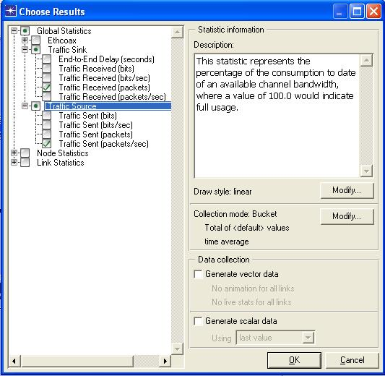

Configure/Run the Simulation:
In order to run the Simulation:

- Select DES⇒ Configure Run Discrete Event Simulation. Select the Simulation Duration to 30 Minutes.

- Apply the Changes and Select RUN.

- To check the Results select DES ⇒ Results ⇒ View Results.
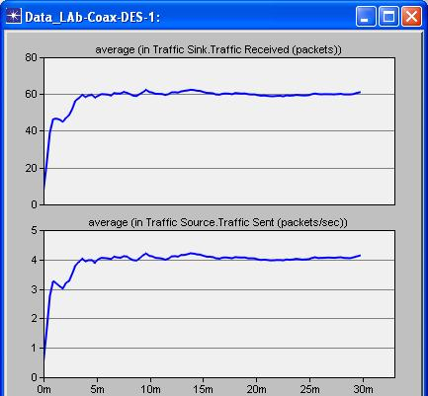

Lab Task:
Perform the above mentioned steps in OPNET and attach the output

Conclusion:
__________________________________________________________________________________________________________________________________________________________________________________________________________________________________________

