Experiment: Implementation of Network through OPNET Network Simulator.
Software: OPNET 14.5 /17.5
Apparatus:
Personal Computer / Laptop
OPNET 14.5 /17.5
Introduction:
OPNET stood for Optimized Network Engineering Tools. OPNET Network simulator is a tool to simulate the behavior and performance of any type of network. The main difference Opnet Network Simulator comparing to other simulators lies in its power and versatility.
Procedure:
1. Start OPNET Modeler 14.5 ⇒ Choose New from the File menu.
2. Select Project and click OK ⇒Name the project <your initials>_SN, and the scenario Simple Network ⇒ Click OK.
3. In the Startup Wizard: Initial Topology dialog box, make sure that Create Empty Scenario is selected ⇒ Click Next ⇒ Choose World ⇒ Click Next twice ⇒Click OK.
- Create a new Project.
- Initialize the Network
- Application and profile Configuration
- Developing Traffic.
- Collect Statics.
TASK:
Perform the above mentioned steps in detail through OPNET Network Simulator & record the results.
After performing this experiment the students will understand how a network will be implemented through an OPNET Network Simulator.

Implementation of Network through OPNET
Objective:
__________________________________________________________________________________________________________________________________________________________________________________________________________________________________________Apparatus:

Procedure:
- Start OPNET Modeler 14.5 ⇒ Choose New from the File menu.
- Select Project and click OK ⇒Name the project <your initials>_SN, and the scenario Simple Network ⇒ Click OK.
- In the Startup Wizard: Initial Topology dialog box, make sure that Create Empty Scenario is selected ⇒ Click Next ⇒ Choose World ⇒ Click Next twice ⇒Click OK.

Initialize the Network:
- The Object Palette dialog box should be now on the top of your project space. Make sure that the internet_toolbox is selected from the pull-down menu on the object palette.

- Add to the project workspace the following objects from the palette: Application Config, Profile
Config, PPP_Server, PPP_wkstn, IP32_Cloud.

- Connect PPP_Server and PPP_wkstn via ip32_Cloud using PPP_DS3 cable.
a. To add an object from a palette, click its icon in the object palette ⇒ Move your mouse to the workspace ⇒ Left-click to place the object. Right-click when finished. The workspace should contain the following three objects:
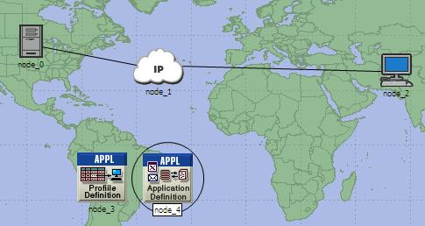

Application and Profile Configuration:
1. Right-click on the Application Config node ⇒ Edit Attributes ⇒Change the name attribute to
Applications_Config. Click on the tab in front of Application Definitions and select Edit ⇒ Rows ⇒ 1.

Under the Name ⇒ FTP_Application, under the description select Edit ⇒ FTP ⇒ High Load. Press OK three times.

2. Right-click on the Profile Config node ⇒ Edit Attributes ⇒ Change the name attribute to Profiles_Config. Click on the tab in front of Profile Configuration and select Edit. Under the Profile Name ⇒ FTP_Profile, Under Applications select Edit ⇒ Name ⇒ FTP_Application. Click OK three times.
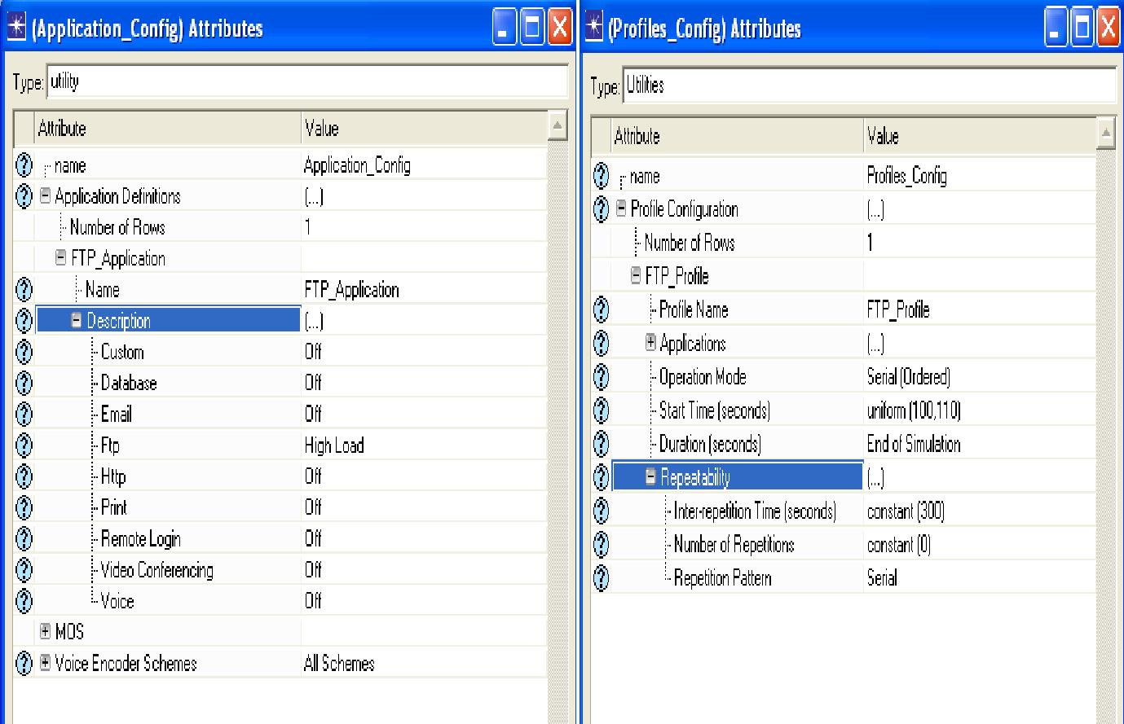

Deploying Traffic:

To deploy the configured profile to the network, follow the following procedure.
- Protocol ⇒ Applications ⇒Deploy Defined Applications.

- Select all mobile nodes and transfer to sources under your profile.
- Select the server and transfer to server under application: FTP_Application.

- Click Apply and then OK to complete the deployment.

Collect Statistics:

The following procedure should be followed to collect global statistics for all the nodes.
- Click DES ⇒ Choose individual statistics.

- Expand global statistics and choose FTP ⇒ Traffic Received (Bytes/S) and Traffic Sent

(Bytes/S).
3. Click OK and save
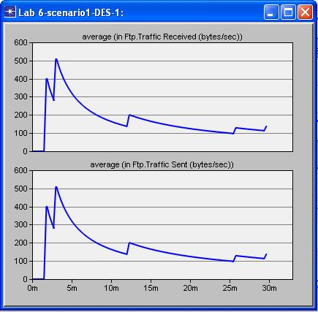

Lab Task:
Perform the above mentioned steps in OPNET and attach the output

Conclusion:
__________________________________________________________________________________________________________________________________________________________________________________________________________________________________________

