Lab#2
Practical analysis of the thyristor to turn on and turn off by applying gate voltage
Objective
- What is thyristor and its uses
- How we can turn on and off the thyristor
- Why thyristor start conduction when positive signal is provided across the gate gate terminal
- How many junction in thristor
- How many layer in thyristor
Apparatus use
- Dc power supplies
- Thyristor
- Single pole single throw
- Dc lamp
Theoretical back ground
A thyristor is a solid-state semiconductor device with four layers of alternating P- and N-type materials. It acts exclusively as a bistable switch, conducting when the gate receives a current trigger, and continuing to conduct until the voltage across the device is reversed biased, or until the voltage is removed (by some other means). There are two designs, differing in what triggers the conducting state. In a three-lead thyristor, a small current on its Gate lead controls the larger current of the Anode to Cathode path. In a two-lead thyristor, conduction begins when the potential difference between the Anode and Cathode themselves is sufficiently large (breakdown voltage).Some sources define silicon-controlled rectifier (SCR) and thyristor as synonymous.Other sources define thyristors as more ornately constructed devices that incorporate at least four layers of alternating N-type and P-type substrate.The first thyristor devices were released commercially in 1956. Because thyristors can control a relatively large amount of power and voltage with a small device, they find wide application in control of electric power, ranging from light dimmers and electric motor speed control to high-voltage direct-current power transmission. Thyristors may be used in power-switching circuits, relay-replacement circuits, inverter circuits, oscillator circuits, level-detector circuits, chopper circuits, light-dimming circuits, low-cost timer circuits, logic circuits, speed-control circuits, phase-control circuits, etc. Originally, thyristors relied only on current reversal to turn them off, making them difficult to apply for direct current; newer device types can be turned on and off through the control gate signal. The latter is known as a gate turn-off thyristor, or GTO thyristor. A thyristor is not a proportional device like a transistor. In other words, a thyristor can only be fully on or off, while a transistor can lie in between on and off states. This makes a thyristor unsuitable as an analog amplifier, but useful as a switch.
Block diagram of thyristor
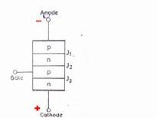
Electronic symbol of thyristor

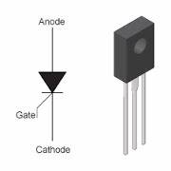
Procedure
- Connect the dc power supplies to switch
- Connect the switch to scr
- Connect the cathode portion to another switch
- Also connect the scr to the lamp
- Ground the circuit
Turning on circuit of the thyristor
By pressing button to turn on the circuit

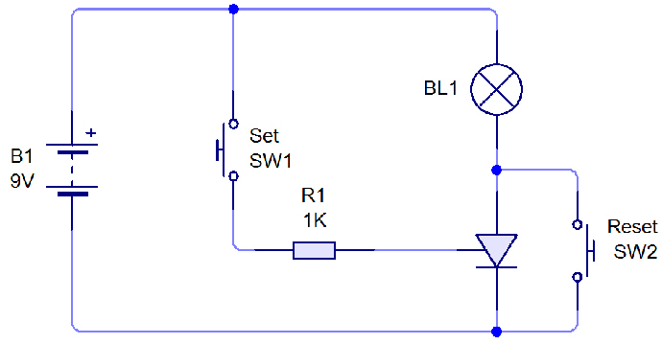
Turning off the circuit of the thyristor
Bu releasing the button to turn off the circuit

Conclusion
we concluded that thyristors relied only on current reversal to turn them off, making them difficult to apply for direct current; newer device types can be turned on and off through the control gate signal. The latter is known as a gate turn-off thyristor, or GTO thyristor. A thyristor is not a proportional device like a transistor. In other words, a thyristor can only be fully on or off, while a transistor can lie in between on and off states. This makes a thyristor unsuitable as an analog amplifier, but useful as a switch.
Review questions
1)What is thyristor and its uses?
A thyristor is a solid-state semiconductor device with four layers of alternating P- and N-type materials. It acts exclusively as a bistable switch, conducting when the gate receives a current trigger, and continuing to conduct until the voltage across the device is reversed biased, or until the voltage is removed (by some other mean. Thyristors may be used in power-switching circuits, relay-replacement circuits, inverter circuits, oscillator circuits, level-detector circuits, chopper circuits, light-dimming circuits, low-cost timer circuits, logic circuits, speed-control circuits, phase-control circuits etc.
2) How we can turn on and off the thyristor?
The above circuit diagram is given to turn on and turn off the thyristor.
3) Why thyristor start conduction when positive signal is provided across the gate gate terminal?
Positive signal give to thyristor to turn on the thyristor operation.
4) How many junction in thyristor?
There are three junctions in thyristor
5) How many layer in thyristor?
A thyristor is a solid-state semiconductor device with four layers of alternating P- and N-type materials

