Week 2
Experiment: - Building a switch based Network
Procedure:
- Identify the proper Ethernet cable and connect the two PCs to the switch
- Verify the physical connection
- Access the IP settings window
Windows XP users should do the following:
Click on Start > Settings > Control Panel and then click the Network Connection icon.

Select the Local Area Network Connection and click on Change settings of this connection.
Select the TCP/IP protocol icon that is associated with the NIC on this PC.
Click on Properties and click on Use the following IP address.
- Configure TCP?IP Settings for the different PC’S
- Verifying that the PC’s can communicate.
- Restore the Pcs to their original Settings.

After performing this Experiment the students will be ready to build a network.

Building a switch based network

Objective:
__________________________________________________________________________________________________________________________________________________________________________________________________________________________________________Apparatus:
- Personal computer.
- Ethernet Connection.
Procedure:
Step 1:
Identify the proper Ethernet cable and connect the two PCs to the switch

The connection between the two PCs and the switch will be accomplished using a Category 5 or 5e straight through patch cable. Locate two cables that are long enough to reach from each PC to the switch. Attach one end to the NIC and the other end to a port on the switch. Be sure to examine the cable ends carefully and select only a straight-through cable.

- What kind of cable is required to connect from NIC to switch? __________________

- What is the category rating of the cable? ____________________________________

Step 2:
Verify the physical connection

Plug in and turn on the computers. To verify the computer connections, insure that the link lights on the both PC NICs and the switch interfaces are lit. Are all link lights lit? ________________

Step 3:
Access the IP settings window

Note: Be sure to write down the existing IP settings, so that they can be restored at the end of the lab. These include IP address, subnet mask, default gateway, and DNS servers. If the workstation is a DHCP client, it is not necessary to record this information.

Windows XP users should do the following:
- Click on Start > Settings > Control Panel and then click the Network Connection icon.

- Select the Local Area Network Connection and click on Change settings of this connection.
- Select the TCP/IP protocol icon that is associated with the NIC on this PC.

- Click on Properties and click on Use the following IP address.

See the example below:

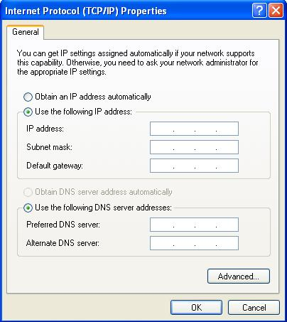

Step 4:

Configure TCP/IP settings for the two PCs
- Set IP addresses of both the PCs, in such a way that they have Class C IP address, with the first two octets 192.168.

- Host number of the PCs shall be different.

- Subnet Mask must be a Class C subnet mask.

- Ignore Default Gateway.

Why don’t we require Default Gateway in this case:

______________________________________________________________________________

______________________________________________________________________________

Step 5:

Verify that the PCs can communicate

- Test connectivity from one PC to the other through the switch by pinging the IP address of the opposite computer. Use the following command at the command prompt.

C:>ping Given IP

- See if the Ping Works. If not, check the PC connections and TCP/IP settings for both PCs. What was the ping result?

______________________________________________________________________________

Step 6:

Restore the PCs to their original Settings.

Step 7:

Which Cable is required if we need to connect two PCs directly?

Conclusion:
_________________________________________________________________________________________________________________________________________________________________________________________________________________________________________

