Online Lab Plan Report
Instructor:Rashid Aleem
Lab:Electronic Circuit Design
Week 1
Experiment :- Practical analysis of inverting amplifier using operational amplifier using multisim software
Software used:-Multisim 11.0
Procedure:-Inverting operational amplifier was used in breadboard of multisim software and the circuit diagram was given in the manual and the output was observed in the oscilloscope. The oscilloscope was clearly showing that how an inverting amplifier inverts the given signal.
Steps:-
(1)Right click on the breadboard and select place components. Then select all groups.
(2)Select Op-amp and in Op-amp section select 741.
(3)Click on place components and then select sources and in sources section select ground.
(4)For resistors select basics and then select resistor and give desired value.
(5)Select function generator for source and drag it on breadboard.
(6)The positive pin of the operational amplifier should be connected with the ground.
(7)Connect the oscilloscope with the circuit and check the desired output.

After performing this experiment on multisim software students were able to understand the basic concept of inverting amplifier. They understood that signal was inverted and amplified as well.
Recommendations:-Students are not familiar with the online system and most of the students live in remote areas where internet is not available. So the time frame for the tasks should relaxed for students. Over time with more use and better understanding of the online system by the students and better internet facilities these issues can be resolved.

Online lab plan report
Week 2
Experiment:-Practical analysis of non-inverting operational amplifier using multisim software
Software used:-Multisim 11.0
Procedure:-Non-inverting operational amplifier was used in breadboard of multisim software and the circuit diagram was given in the manual and the output was observed in the oscilloscope. The oscilloscope clearly showed that signal was not inverted given.
Steps:-
(1)Right click on the breadboard and select place components. Then select all groups.
(2)Select Op-amp and in Op-amp section select 741.
(3)Click on place components and then select sources and in sources section select ground.
(4)For resistors select basics and then select resistor and give desired value.
(5)Select function generator for source and drag it on breadboard.
(6)The positive pin of the operational amplifier should be connected with the function generator.
(7)Connect the oscilloscope with the circuit and check the desired output.

After performing this experiment on multisim software students were able to understand the basic concept of inverting amplifier. They understood that signal was not inverted and amplified as well.
Recommendations:-Students are not familiar with the online system and most of the students live in remote areas where internet is not available. So the time frame for the tasks should relaxed for students. Over time with more use and better understanding of the online system by the students and better internet facilities these issues can be resolved.

Online lab plan report
Week 3
Experiment:-Practical implementation of voltage comparator using multisim software
Software used:-Multisim 11.0
Procedure:-741operational amplifier was used in breadboard of multisim software and the circuit diagram was given in the manual and the output was observed in the DMM.A voltage comparator compares two input voltages and let us knows that which of the two is greater.
Steps:-
(1)Right click on the breadboard and select place components. Then select all groups.
(2)Select Op-amp and in Op-amp section select 741.
(3)Click on place components and then select sources and in sources section select ground.
(4)The positive pin of the operational amplifier should be connected with Vin.
(5)The negative pin of the operational amplifier should be connected to Vref.
(6)The difference in voltage will be observed in DMM.

After performing this experiment on multisim software students were able to understand the basic concept of voltage comparator. They understood that how comparison between voltages was done by operational amplifier. The output was checked with different voltages.
Recommendations:-Students are not familiar with the online system and most of the students live in remote areas where internet is not available. So the time frame for the tasks should relaxed for students. Over time with more use and better understanding of the online system by the students and better internet facilities these issues can be resolved.

LAB NO: 6
“Practical analysis of inverting operational amplifier”

Objective:
____________________________________________________________________________________________________________________
Apparatus:
- OP-Amp UA 741CP
- Resistors
- Power supplies
- Oscilloscope
- Breadboard
Theory:
These ICs consist of 8 pins. To count the pins of UA741CP, there will be a small notch or dot. Place the notch or dot toward your left handed side and start counting. So the extreme left pin will be considered as a pin number 1 and bottom left will be considered as a pin number 4. The opposite pin to the pin number 4 is pin “5” and the pin opposite to the pin “1” is considered to be pin “8”. Pin “2” is the inverting input, pin “3” is non-inverting input, pin “4” is Vcc- , pin “6” is output and pin “7” is Vcc+ &Vcc- is used to energize the IC.
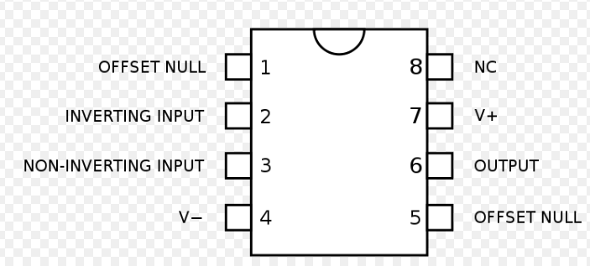

Circuit Diagram:
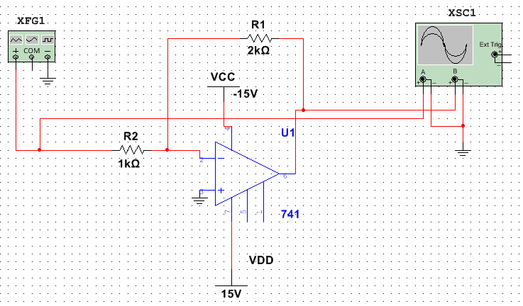
Procedure:
________________________________________________________________________________________________________________________________________________________________________________________________________________________________________________________________________________________________________________________________________________________________________________________________________________________________________________________________________________________________________________________________________________________________________________________________________________________________________________________________________________________________________________________________________________________________________________________________________________________________________________________________________________________________________________________________________________________________________

LAB NO: 7
“Practical analysis of non-inverting operational amplifier”

Objective:
____________________________________________________________________________________________________________________
Apparatus:
- OP-Amp UA 741CP
- Resistors
- Power supplies
- Oscilloscope
- Breadboard
Theory:
These ICs consist of 8 pins. To count the pins of UA741CP, there will be a small notch or dot. Place the notch or dot toward your left handed side and start counting. So the extreme left pin will be considered as a pin number 1 and bottom left will be considered as a pin number 4. The opposite pin to the pin number 4 is pin “5” and the pin opposite to the pin “1” is considered to be pin “8”. Pin “2” is the inverting input, pin “3” is non-inverting input, pin “4” is Vcc- , pin “6” is output and pin “7” is Vcc+ &Vcc- is used to energize the IC.

Circuit Diagram:
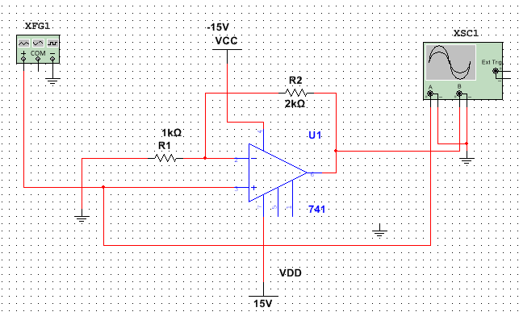
Procedure:
________________________________________________________________________________________________________________________________________________________________________________________________________________________________________________________________________________________________________________________________________________________________________________________________________________________________________________________________________________________________________________________________________________________________________________________________________________________________________________________________________________________________________________________________________________________________________________________________________________________________________________________________________________________________________________________________________________________________________

Conclusion:
________________________________________________________________________________________________________________________________________________________________________________________________________________________________________

LAB NO: 8
“Practical implementation of voltage comparator”

Objective:
________________________________________________________________________________________________________
Apparatus:
- Power supplies
- DMM
- IC of serial No UA741CP.

Theory:
A voltage comparator is an electronic circuit that compares two input voltages and let us knows which of the two is greater. It is east to create a voltage comparator from an op amp because the polarity of the op amp’s output circuit depends upon the polarity of the difference between the two input voltages
In the voltage comparator circuit, first a reference voltage is applied to the inverting input. Then the voltage to be compared with the reference voltage is applied to the non-inverting input. The output voltage depends upon the value of the input voltage relative to the reference voltage as follows:

Input voltage | Output voltage
Less than reference voltage | Negative
Equal to reference voltage | Zero
Greater than the reference voltage | Positive

Circuit Diagram:
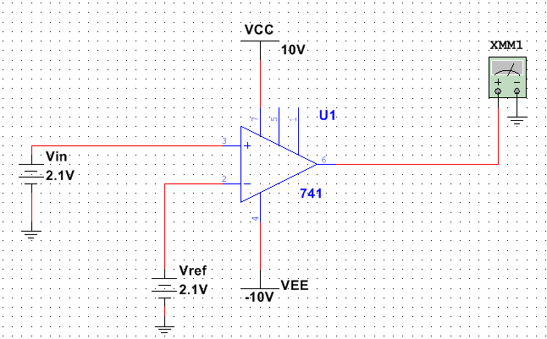
Procedure:
____________________________________________________________________________________________________________________________________________________________________________________________________________________________________________________________________________________________________________________________________________________________________________________________________________________________________________________________________________________________________________________________________________________________________________________________

Observation:

S.No | V_{cc} = 10v  V_{EE} = -10v
 | V_{in} | V_{ref} | V_{o}
1
2
3

